Implementation of Flipped Classroom in Microeconomics Classes during the COVID-19 Lockdown at Chongqing University, China: A Case of Continuous Quality Education

Yao Zhuanhua¹
Chongqing Finance and Economics College, China
724130694@qq.com

Ng Soo Boon²
SEGi University Malaysia
ngsooboon@segi.edu.my

Correspondence Email: 724130694@qq.com

Abstract
The lockdown during the Covid-19 lockdown prevented students from receiving quality face-to-face instruction in the traditional classroom. Given that the sustainability of quality education always is students’ right, innovation in the teaching context during the special time needs to be considered seriously. One feasible choice is the flipped classroom (FC). This was implemented during the Covid-19 lockdown in a Microeconomics course at Chongqing University, China. The teacher in the FC prepared online courses in advance, and uploaded them to Zhidao Apps, while students were instructed to access this online course through Zhidao Apps in their own learning space and time before class. During the class, the teacher guided the students to apply knowledge. To examine the implementation of FC, a mixed method was carried out. The research questions focused on determining students’ engagement, deep learning, and learning outcome and exploring students’ perceived experience of the FC. The findings were that the FC has the advantages of improving students’ engagement, deepening their understanding, and developing their self-learning ability. Students appreciated the active classroom atmosphere, the opportunity to watch videos, and their increased engagement. However, they also mentioned experiencing too many tasks, heavy learning pressure, and significant challenges in keeping up with the lesson.
Keywords—Flipped Classroom; Student Engagement; Deep Learning; Learning Outcome
- Introduction
The flipped classroom (FC) basically refers to a classroom where activities “which is traditionally done in class is now done at home, and that which is traditionally done at home is now completed in class” (Bergmann & Sams, 2012, p. 13). However, there is more to FC than just this reversal of roles. FC is also a learning modality that provides a student-centered learning environment (Satparam & Apps, 2022; Tran, 2020). Hernández Guerra Manuel et al. (2021) described FC as a learning platform where students actively practice personal control and choice, share and explore information, build knowledge, and engage in social interaction in a learner-centered environment.
Since the COVID-19 outbreak in 2020, home quarantine has become a regular occurrence. This posed a significant challenge for traditional education at the time, and so educators had to explore and adopt online teaching methods, through which students can undoubtedly continue learning. But there is still doubt about its effectiveness. Therefore, teachers began exploring an alternative: the FC, as FC combined physical and online learning. When the situation allows, students, after they finish online learning on their own time, will return to class (either physically or virtually) and carry out activities under the guidance of teachers. This could promote students’ understanding of knowledge and learning effect.
This study focuses on how Microeconomics FC was implemented in a private university in Chongqing, China, and reports on students’ engagement, deep learning, learning outcomes, and students' evaluation of flipped classrooms. A study such as this is essential as it explores how the best flipped classroom can be conducted and its benefits.

- Literature Review
In 2007, Jonathan Bergmann and Aaron Sams (2012) from Woodland Park High School recorded lectures and posted them on the website for students who missed class. Unexpectedly, students liked this approach. In the 2007–08 school year, Jonathan Bergmann and Aaron Sams (2012) pushed forward with this new pedagogical idea and took an initial step — they had all lessons prerecorded. Then, they assigned these videos as students' "homework" to help them prepare for interactive learning in class. Teachers in the classroom acted as coaches, helping students understand concepts they did not understand. Thus, the concept of an FC was born, where activities traditionally done in class are now done at home, and what is traditionally done at homework is now completed in class (Jonathan & Sams, 2012). Moreover, Jonathan Bergmann and Aaron Sams (2012) also reminded us that there is more to an FC than this reversal of the teaching and learning process.
Meanwhile, the Khan Academy, founded in 2006 by MIT alumnus Salman Khan, released a library of 3,200 videos and 350 exercises in 2012 on its website. Its mission: to provide free, world-class education to anyone anywhere in the world (Vidergor & Ben-Amram, 2020; Zengin, 2017). This is an attempt made to combine online video with a traditional classroom to form an FC teaching model to promote students' learning (Cabı, 2018). Since then, the "flipped classroom" has become the focus of educators worldwide, and the FC teaching model has been widely disseminated (Campillo-Ferrer & Miralles-Martínez, 2021; Divjak et al., 2022; Tang et al., 2023).
2.1 Students’ Engagement
At the beginning of the 21st century, students' engagement focused on actively improving learning methods, namely helping students understand how they learn best (Goodman, 2016). The researchers set out to analyze student engagement as an approach to improve students' overall performance including participation and establish students' emotional predispositions to their learning (Goodman, 2016). Some researchers believe that student engagement is a great and necessary predictor of student achievement (Appleton et al., 2006; Coristine et al., 2022). Later, students’ engagement has been further elaborated by different researchers in the form of behavioral engagement, emotional engagement, cognitive engagement, affective engagement, agentic engagement, and psychological engagement.
Appleton & Christenson (2006) envisaged student engagement from two dimensions: cognitive and psychological. They developed the Appleton and Christenson Student Engagement Scale (Table 1). Cognitive engagement is regarded as the “less observable, more internal indicators, such as self-regulation, the relevance of schoolwork to future endeavors, the value of learning, and personal goals and autonomy. Psychological engagement relates to the feeling of identification or belonging and relationships with teachers and peers” (Appleton & Christenson, 2006, p. 429).

Table 1: Appleton and Christenson Student Engagement Scale
Definition | Dimensions | Items
Student engagement  (Appleton & Christenson, 2004) | Psychological Engagement | - Teacher–Student Relationship  - Peer Support for Learning  - Family Support for Learning
Student engagement  (Appleton & Christenson, 2004) | Cognitive engagement | - Control and Relevance of School Work  - Future Aspirations and Goals  - Extrinsic Motivation

2.2 Deep learning
Deep learning as a concept of pedagogy has a long history. Early in 1976, Marton and Säljö (1976) carried out a series of experimental studies of the learning process, reporting that the way learners acquire and process information is divided into deep and surface approaches. They characterized a deep approach as how the learners focused on comprehending and understanding. Under a deep approach, students can relate various aspects of the content, form assumptions or beliefs about the problem, and concern themselves more about gaining an intrinsic interest in learning and understanding (Marton & Säljö, 1976). Later, some researchers believe the deep approach relates to high-quality learning outcomes (Biggs, 1987; Kevser, 2021; Le Roux & Nagel, 2018).
The National Survey of Student Engagement (NSSE) from America annually surveyed first-year and fourth-year students in colleges and universities to measure students' participation in their study experience. Table 2 shows the dimensions of the NSSE Deep Learning Scale. Thomas et al. (2008) used 2004 and 2005 data from NSSE to examine students’ deep learning. This study confirmed that some scales in NSSE can be used to assess deep learning.

Table 2: Deep Learning Scale in NSSE
Definition | Dimensions
Deep Learning Scale  (Thomas et al. 2008; NSSE) | Higher-Order Learning
Deep Learning Scale  (Thomas et al. 2008; NSSE) | Integrative Learning
Deep Learning Scale  (Thomas et al. 2008; NSSE) | Reflective Learning
2.3 Learning Outcomes
It is generally acknowledged that learning outcomes are affected by the learning approach. Biggs (1993) created the Presage–Process–Product (3P) model, and generalized that the product is the subsequent outcome of the 'process,' which is influenced by 'presage.' The product can be measured through traditional assessments as well as a measure of emotional impact. Paul et al. (2014) explained the utility of the 3P Model in their study, which is reflected in Figure 1.

Figure 1. 3P Model

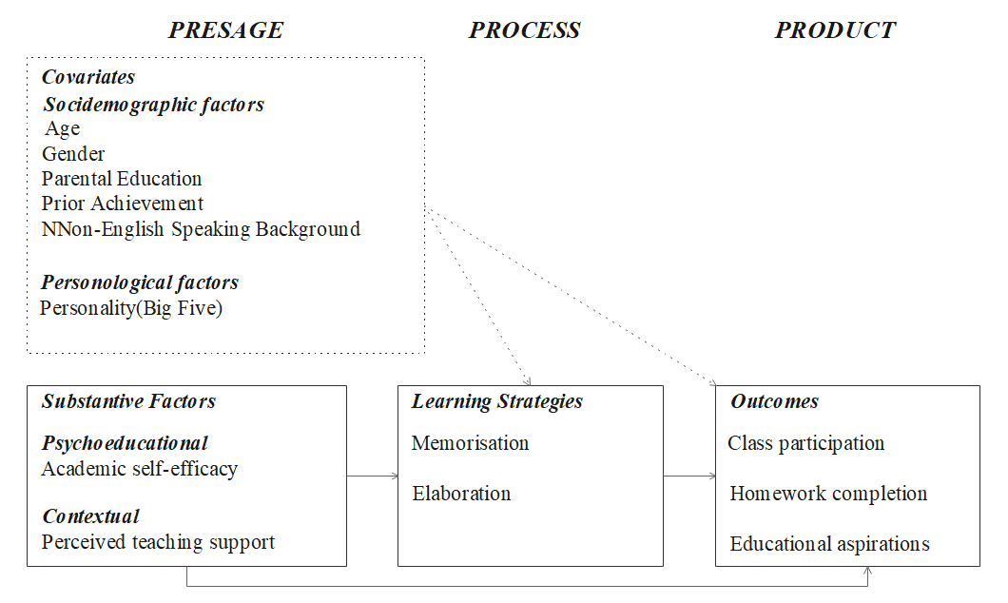
Source: Paul et al. (2014)

Nelson Laird et al. (2008) analyzed learning outcomes from personal and intellectual development gains, grades, and satisfaction. The first aspect focuses on the learner's ability to establish personal values and moral standards, to contribute to the community, to know himself/herself better, to solve problems, to cooperate with others effectively, to effectively express his/her critical and analytical thinking, to obtain related knowledge and skills, and similar aspects. Grades include course performance scores, quiz scores, and test scores. Satisfaction refers to how students evaluate their learning. Both Paul et al. (2014) and Nelson Laird et al. (2008) measured learning outcomes not only from grades and marks but also from satisfaction, participation, and values.
2.4 Learner-centered Theory in FC
The learner-centered theory is a set of theories that focuses on the learner. In the learner-centered environment, students’ individual choices, needs, abilities, and learning styles will be valued and they will be encouraged to construct knowledge (Kerimbayev, et al. ,2023; Bremner, Sakata & Cameron,2022; Yilmaz, Kaya 2008). The learner-centered environment allows students to actively seek and share information, engage, and generate social interaction.
Bishop and Verleger (2013) reiterated that FC centers around the students, and its learning should focus on learning-centered theories. Related learning-centered theories include theories of active learning, collaborative learning, and peer-assisted learning. Active learning is when students engage in learning (Prince, 2004); collaborative learning means that learners interact and learn collaboratively (Dillenbourg, 1999); peer-assisted learning is gaining knowledge and skills through the help and peer support (Kerimbayev, et al. ,2023). In the FC, students experience active learning and perform higher-order thinking (Roehl et al., 2013), small-group activities allow students to experience collaborative learning (Bergmann & Sams, 2012), and peer-assisted learning works through solving problems collaboratively, completing projects cooperatively, and discussing existing problems in FC, as declared by Nederveld and Berge (2015). Figure 2 is formulated based on this understanding of learner-centered theory. In such a learner-centered environment as FC, students' learning is active. They help each other and form cooperative learning. Students develop social skills and learn more (Kreijns, Kirschner, & Jochems, 2003).

Figure 2. Venn diagram of several learner-centered learning theories in the flipped classroom
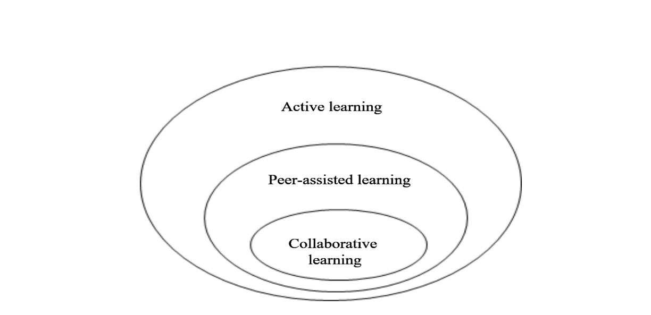
Source: Bishop and Verleger (2013)

2.5 Expectancy-value Theory
The expectancy-value theory analyzes the reasons behind personal performance and choices from two aspects: expectation and subjective value (Xiu, 2018). Expectation is related to personal expectations, confidence in the task's success, and the degree to which they believe they can perform an activity within their capabilities (Eccles & Wigfield, 2020). But an individual capable of doing something may be unwilling to do it. Then, subjective values consider the reasons and beliefs influencing individuals' choices to engage in activities.
The expectancy-value Model most directly relates people's behavior, choices, and adherence to individual expectations and value beliefs, such as learning control, intrinsic motivation, extrinsic motivation, and task value (Xiu, 2018). In Xiu’s study, the researcher surveyed students' motivation, perspectives, and learning in FC. As there are many tasks to do before or during the flipped classroom, learning outcomes are related to student engagement and deep learning. Student engagement includes psychological and cognitive engagement, which are learners' beliefs. Deep learning is a kind of learning control.

2.6 Conceptual Framework of the Study
The conceptual framework of this study is shown in Figure 3; the purpose is to study the impact of Student Engagement (SE) and Deep Learning (DL) on Learning Outcomes (LO). It is supported by the Learner-centered theory (J. H. D., & Harbaugh, A. P.,2010; Maryellen Weimer, 2012; Amy Roehl et al., 2013; Bishop & Verleger, 2013; Jenna, 2016; Nederveld & Berge, 2015) and expectancy-value theory (Eccles & Wigfield, 2002; Xiu,2018). SE and DL are considered as a direct effect of learner-center theory as it is only through learner center pedagogy that SE is positive and DL will occur. However, at the same time, expectancy-value theory tells us that personal expectations and confidence in the task's success and the degree to which they believe they can perform an activity within their capabilities are essential for DL and SE. Figure 3 reflects the theoretical foundation of this study where in the implementation of FC, the outcome of students’ learning and performance is influenced by how learning takes place (Is it learner-centered?) as well as the personal expectations and confidence of the students (the extent of the students’ expectancy of themselves.). In short, it is postulated that the success of FC manifested through high SE and DL hinges on the interaction between learner-centered theory and expectancy-value theory.

Figure 3. Conceptual framework of this study
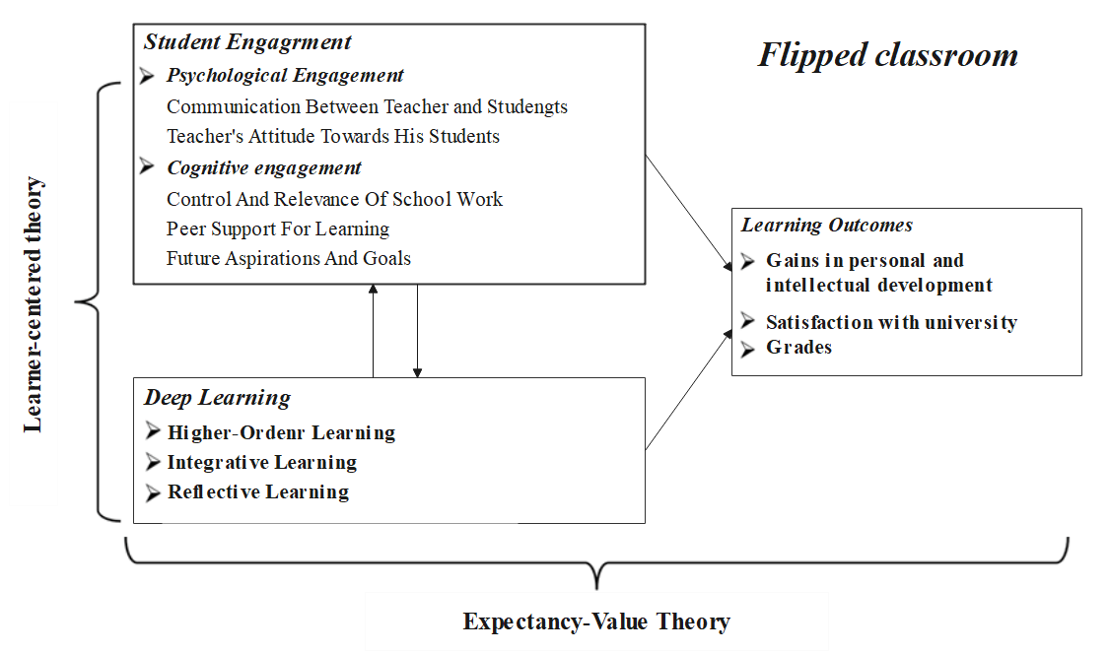
The Research Questions of this study are concerned with implementing flipped Microeconomics class in a private university in Chongqing, China.
RQ1: How is a flipped classroom implemented in Microeconomics?
RQ2: What is the level of students’ engagement, deep learning, and learning outcomes in a flipped Microeconomics classroom?
RQ3: What are students' views on flipped classrooms?
This paper only reports on the implementation of flipped classrooms and describes the level of three variables and students’ views, in an effort to explore the student's continuous learning in FC.
- Research Methodology
  - Research Setting
Some courses studied in this research setting, a private university in Chongqing, China, have been practiced in the flipped classrooms model in recent years before the Covid-19 lockdown. One such course is Macroeconomics which was entirely run in the flipped classroom model during the lockdown. Data was gathered from students involved in the Microeconomics class, which was conducted via flipped classroom (FC).
3.2 Instrument
The instrument is a questionnaire adapted from literature and an in-depth interview protocol. Three questionnaires were used for this study. They are Student Engagement Scale (SES), Deep Learning Scale (DLS), and Learning Outcomes (LO). The Student Engagement Scale was adapted from Appleton & Christenson (2004). Deep Learning and Learning Outcomes instruments were adapted from Thomas et al. (2008). Questionnaires were sent to 110 students taking a course in Macroeconomics from three separate flipped classes, and 107 returned the questionnaires.
3.3 Sample Profile
The demographics of 107 respondents are shown in Table 3. The number of females (73) is more than that of males (34), which reflects the actual gender ratio of undergraduates in this university. Students majoring in Economics in Class A account for 44.86%. About 38% of the students are from Class B, majoring in Finance. The lowest proportion of the students is from Class C, majoring in Chartered Financial Analyst, with only 18%, because there are only 20 students in this class. All these classes take the course in ‘Microeconomy’ in the form of a flipped classroom.
Table 3: Demographics of Respondents
Category | Sub-category | Frequency | Percent
Gender | Male | 34 | 31.78%
Gender | Female | 73 | 68.22%
Major | Economics | 48 | 44.86%
Major | Finance | 41 | 38.32%
Major | Chartered Financial Analyst | 18 | 18.69%
Class | Class A | 48 | 44.86%
Class | Class B | 41 | 38.32%
Class | Class C | 20 | 18.69%

- Results and Discussion
4.1 The Implementation Process of FC
During the lockdown period of Covid-19, FC was implemented in the Microeconomics classes in Chongqing University, China. There were three settings: Zhidao APP, QQ group, and physical classroom, as is shown in Figure 4. The teacher prepared the online courses and uploaded them to Zhidao Apps. Students were then instructed to access these learning resources in their own learning space and time. As the teacher could obtain data about students' online learning progress from the Zhidao app, he/she monitored students’ learning progress and reminded those who still needed to complete their study tasks before they moved to the next chapter. The teacher also shared some documents and communicated with students through the QQ chat group. In the class (physical class when the lockdown was uplifted and virtual class during lockdown), the teacher answered students' questions, explained key concepts, carried out class tests, guided students in case analysis, among other activities
The Mmicroeconomics online course was designed on the Zhidao platform. There are six chapters, including 47 online video courses. Each video is less than 10 minutes. After completing learning a chapter, there are 10-25 objective questions to be answered by students. These are multiple-choice and evaluation questions.
A QQ chat group is formed for each class; teacher Pan (acronym) is the teacher of the flipped Microeconomic class. In this QQ chat group, she also posted lecture instructions, reading documents, online course progress, or quiz answers, the similar to what was uploaded in the Zhidao platform. There are so far 55 documents shared in QQ. This chat group provided materials and channel for teachers and students to communicate effectively and promptly at any time.
Figure 4. The Three Settings in Microeconomics Flipped Classroom
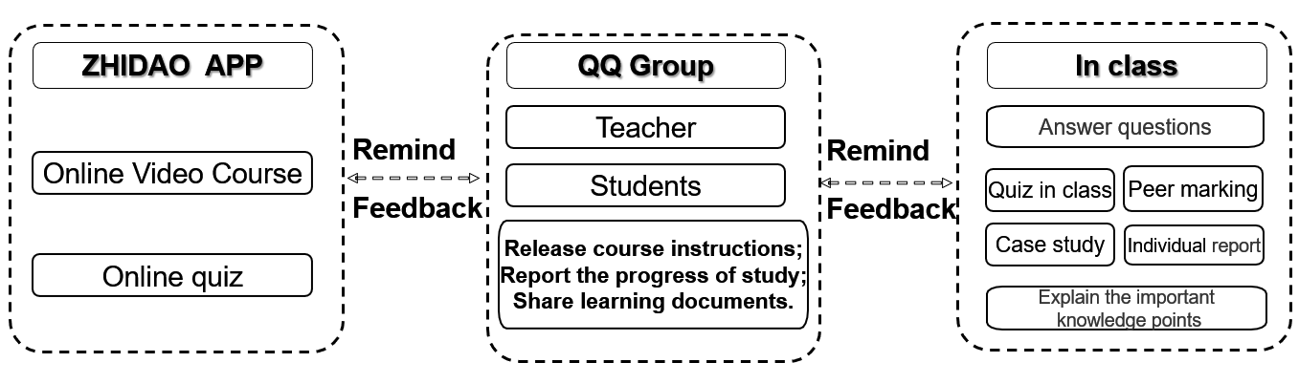
4.2 Student Engagement (SE)
There is a total of 63 items in all the questionnaires. Responders choose the answers to the items based on a 4-Likert scale, defined as 1=strongly disagree, 2=disagree, 3=agree, and 4= strongly agree. In this study, a mean of 1-2 is considered low, 2-3 moderate and 3 – 4 high. SPSS 22.0 was used to analyze the data.
Table 4 shows the mean levels of student engagement (SE), deep learning (DL), and learning outcomes (LO), which are 3.47, 3.44, and 3.20, respectively.These three values are considered as high. And the highest among these three variables is the level of SE. Table 4 also shows that the “teacher’s attitude towards his students” is the highest, reaching 3.59 in SE. The “gains” in LO are the lowest, only at 3.00.
Table 4: Level of SE, DL, and LO
Instruments | Mean | Constructs | Mean
Student Engagement (SE)  Adapted from the Student Engagement Instrument (SEI) (Appleton & Christenson, 2004) | 3.47 | Communication between teacher and students | 3.51
 | 3.47 | Teacher's attitude towards his students | 3.59
 | 3.47 | Control and relevance of schoolwork | 3.44
 | 3.47 | Peer support for learning | 3.34
 | 3.47 | Future aspirations and goals | 3.48
Deep Learning(DL)  Adapted from Deep Approaches to Learning Scales From the National Survey of Student Engagement(NSSE)  (Thomas F. Nelson Laird, 2005) | 3.44 | Higher-Order Learning | 3.40
 | 3.44 | Integrative Learning | 3.43
 | 3.44 | Reflective Learning | 3.48
Learning Outcomes (LO)  Adapted from Outcomes Scales  (Thomas F. Nelson Laird et al., 2008) | 3.20 | Gains | 3.00
 | 3.20 | Grade | 3.33
 | 3.20 | Satisfaction1 | 3.06
 | 3.20 | Satisfaction2 | 3.42
4.3 Deep Learning (DL)
Deep Learning (DL) reflects the depth of higher-order thinking, integrative thinking, and reflective learning. Table 5 presents details of students' deep learning in the flipped classroom.

Table 5: Level of Higher-Order Learning
Items | Mean
I can apply the theories, methods, and exercises learned in the flipped class to practical problems and new situations. | 3.36
By completing the study task in the flipped classroom, I can analyze some problems and phenomena and make a deduction under the condition of mastering the basic knowledge. | 3.37
In the flipped classroom, I judge the views, arguments, or phenomena raised by the teacher or classmates. | 3.40
I can synthesize and organize different information into new ideas or understandings in the flipped classroom. | 3.46
In the flipped classroom, my innovation ability was demonstrated and improved. | 3.42
In the flipped classroom, I can study and complete the learning task independently. | 3.40
Mean of Higher order thinking | 3.40

In higher-order learning, the highest mean value is 3.46, which indicates that in the flipped classroom, students think, synthesize and organize different information through their thinking, and then form new ideas or understandings. This is very beneficial to the student's sustainable learning as they can form their own ideas.
Table 6: Level of Integrative Learning
Items | Mean
In flipped classroom learning activities, I can relate what I learn to social problems or events. | 3.46
In the flipped classroom, diverse perspectives of different gender, ethnic groups, regions, and cultural environments are applied to class discussions or other learning activities. | 3.44
When completing the task of the flipped classroom, I will combine the knowledge of other chapters or other courses. | 3.47
In the flipped classroom, I studied with my group to complete tasks together. | 3.35
My teamwork ability has improved. | 3.40
After class, I will discuss some problems or ideas related to the course with the teacher. | 3.43
After class, I will discuss some problems or ideas related to the course with my classmates. | 3.46
The meaning of Integrative thinking | 3.43

In integrative learning (Table 6), the highest mean is related to the ability to combine learned knowledge with that of other chapters or other courses, indicating the success of flipped classrooms in integrating learning to achieve the goal of deep learning.
Table 7: Level of Reflective Learning
Items | Mean
In the flipped classroom, I examine the strengths and weaknesses of my opinion on a topic or issue. | 3.45
In the learning activities of the flipped classroom, I better understand someone else's views by imagining how an issue looks from his or her perspective. | 3.48
In the flipped classroom, I learned something that changed the way I understand an issue or concept. | 3.47
I learned something from the flipped classroom after discussing questions with no clear answers in group discussions or other learning activities. | 3.50
Among the learning tasks in the flipped classroom, completing a task that requires a lot of thinking and mental effort will satisfy me. | 3.52
Mean of Reflective Learning | 3.48

The value of reflective learning is the highest in the constructs of the DL. This illustrates that reflective learning works best in deep learning. The highest value, 3.52, shows that students are satisfied with their learning, which will likely increase students' motivation to continue learning.
4.4 Learning Outcomes (LO)
LO measures gains, grades, and satisfaction. The mean of overall LO is 3.20. The value of gains, 3.0, is the lowest in the 3 constructs of LO while the grade value has a mean of 3.33. The items of satisfaction are related to students' acceptance of flipped classrooms. According to Tabel 8, over 77% of students think their performance is either good or even excellent (48.6%+28.97%). Furthermore, more than 90% (40.19%+51.4%) of students want to participate in the flipped classroom again. This is an excellent signal to promote flipped classrooms.
Table 8. Satisfaction 1 & 2
Satisfaction | % (Frequency)
Item | Poor | Fair | Good | Excellent
How would you evaluate your performance in this flipped classroom? | 0.93% (1) | 21.5% (23) | 48.6% (52) | 28.97% (31)
Item | Deﬁnitely no | Probably no | Probably yes | Deﬁnitely yes
If you take this class again, would you want it to be a flipped class? | 0.93% (1) | 7.48% (8) | 40.19%(43) | 51.4% (55)

4.5 Benefits of FC from the Perspective of Students
Analysis of online and offline interviews with 10 students revealed three key benefits of the flipped classroom: increased classroom participation, a stronger teacher-student relationship, and improved learning ability. Table 9 presents sample codes generated through thematic analysis of the interview transcripts.
Table 9: Benefits of the FC
Codes | Subcodes | Sample of Excerpts
Classroom participation | Interactivity | Students have answered questions more frequently, and students have become more involved. (Student D)
Classroom participation | Class activities | The teacher will recommend we watch some videos and then give feedback to the teacher on some phenomena we learned in the video. In class, after learning a knowledge point, we will use relevant example questions to practice and consolidate the knowledge. (Student B)
Teacher-student relationship | Thought collision | I think that questioning is a one-way street in the traditional classroom. If you flip the classroom, students are in an equal state. He will dare to question it, and then if your ideas can convince me, I agree with your idea, if you can not convince me, I may put forward different ideas from you to question you. (Student F)
Teacher-student relationship | Mutual communication and learning | If the students communicate with each other, they will put forward something related to their life circle or their era. Teachers can also learn the ideas of the young people. That is, it may promote learning for both teacher and students. (Student F)
Teacher-student relationship | Mutual respect | To treat people politely, there is also a thing to learn to respect the students, respect the teachers' views, respect what they say about some theoretical knowledge, and so on. (Student Z)
Learning ability  Learning ability | Combination of theory and practice | In our flipped classroom, we taught ourselves, then took the test…. Then, with the teacher's help, it is like our feelings are at the tip of the iceberg, and then we know the meaning behind that. So I think our later development of learning is some better. (Student L)
Learning ability  Learning ability | Self-discipline | If the traditional teaching is like designing a building, then the flipped classroom is more like designing a building and writing on the drawings why this design was done. At the same time, we will carry out the relevant design and give an example. In contrast, in the traditional teaching context, more students are asked to look at the teacher's design, rather than draw a framework themselves, like what they do in a flipped classroom where the teacher granted students higher autonomy. The teacher in a flipped classroom is also strict with students in the learning of recorded video tasks before class. But the time before class should be given certain flexible management." (Student A)
Learning ability  Learning ability | Logical thinking | You see a social phenomenon, and you know that the reason for this can be comprehensively explained by some books..….. more logical thinking is developed. (Student Z)
Learning ability  Learning ability | Thinking about learning | The flipped classroom is more about the students thinking about their learning and teacher creating a good learning atmosphere. And those who actively answer questions and express themselves can also exercise their expression skills. The traditional classroom is just about the teacher on the platform telling the students to listen to the class, and that will not be so good. (Student C)

4.6 Challenges of FC
In addition to the many benefits of the flipped classroom, students also complained about some problems, as shown in Table 10.
Table 10: Challenges of the FC
Codes | Subcodes | Samples of Excerpts
High requirements for students | Requirements before class | Some students can’t finish the pre-class task. Higher requirements of students may need a little supervision from the teacher. (Student L)
High requirements for students | Requirements after class | After-class requirements are higher than that of the traditional class, and some students may not adapt to them. (Student L)
Poor learning ability | Poor learning effect | Students may not understand the video after watching it alone at home, before the class. (Student F)

4.7 Discussion
The purpose of this study was to explore the implementation of FC in the flipped Microeconomics Class at a private university in Chongqing China. This study also examined the level of students’ engagement (SE), deep learning (DL) and learning outcome (LO), and students' views on the flipped classroom.
The results of the quantitative descriptive analysis found that SE, DL, and LO among students are high. This finding was triangulated with qualitative interview data. Excerpts from interview transcripts provided a deeper description of SE and DL, attested to high SE and high DL among respondents of this study. This finding is aligned with that of Xiu (2018) and Bergmann & Sams (2012): students have a positive attitude towards flipped classrooms (FC). Bergmann & Sams (2012) described FC as the one providing a positive environment where students interacted with each other and learned more deeply (Bergmann & Sams, 2012).
Jenna (2016) found that students achieved learning outcomes at a significantly higher rate in FC. This finding is also reflected in the current study. As measured by course grades, students' learning performance improved in FC, compared to the traditional classroom (Xiu. 2018). FC increased the probability of reaching superior grades, improved class attendance, and higher student satisfaction (Hernández Guerra Manuel et al. 2021).
Qualitative data analysis revealed that respondents were optimistic about the effect of FC; they expressed how classroom participation, teacher-student relationship, and learning abilities have been enhanced. However, although FC brings many benefits to students, it also places much pressure on the teacher. In the implementation process of FC, how to reduce the pressure brought by FC and make students learn in a better state can be the direction of further exploration of FC in the future.
5. Conclusion and Implications
The Flipped Classroom (FC) model emerged as a valuable tool during the COVID-19 pandemic, when traditional face-to-face teaching was limited due to lockdowns. In this study, the FC approach utilized the Zhidao platform for students to access learning materials and complete tasks independently in their own time and space. Following this self-learning phase, the teacher facilitated discussions with students either in a physical classroom or an online virtual platform, depending on the pandemic situation. This approach minimized physical contact and reduced the risk of COVID-19 transmission compared to traditional classrooms. The study's findings demonstrate that FC promotes student engagement and fosters deep learning, ultimately leading to more sustainable and impactful learning outcomes.

References
Appleton, J. J., & Christenson, S. L., & Kim, D., & Reschly, A. L.(2006). Measuring cognitive and psychological engagement: Validation of the Student Engagement Instrument. Journal of School Psychology, pp. 44, 427–445.
Bergmann, J., & Sams, A. (2012). Flip Your Classroom: Reach Every Student in Every Class Every Day. International Society for Technology in Education.
Biggs, J. (1987). Student approaches to learning and studying. Melbourne: Australian Council for Educational Research.
Biggs, J. B. (1993a). From theory to practice: A cognitive systems approach. Higher Education Research and Development, 12, 73–86.
Bishop, J. L., & Verleger, M. A. (2013), “The flipped classroom: a survey of the research", ASEE National Conference Proceedings, Atlanta, GA, available at: http://faculty.up.edu/vandegri/ FacDev/Papers/Research_flipped_classroom.pdf
Bremner, N., Sakata, N., & Cameron, L. (2022). The outcomes of learner-centred pedagogy: A systematic review. International Journal of Educational Development, 94, 102649. https://doi.org/10.1016/j.ijedudev.2022.102649.
Cabı, E. (2018). The impact of the flipped classroom model on students' academic achievement. International Review of Research in Open and Distributed Learning, 19(3).
Campillo-Ferrer, J. M., & Miralles-Martínez, P. (2021). Effectiveness of the flipped classroom model on students’ self-reported motivation and learning during the COVID-19 pandemic. Humanities and Social Sciences Communications, 8(1), 1-9.
Coristine, S., Russo, S., Fitzmorris, R., Beninato, P., & Rivolta, G. (2022). The importance of student-teacher relationships. Classroom Practice in 2022. Retrieved [2022，August1], from https://ecampusontario. pressbooks. pub/ educ5202/chapter/the-importance-of-student-teacher-relationships/.
Cornelius-White, J. H. D. & Harbaugh, A. P. (2010). Learner-centered instruction: Building relationships for student success. Thousand Oaks, CA: Sage.
Dillenbourg, P. (1999). What do you mean by collaborative learning? In P. Dillenbourg (Ed.). Cognitive and computational approaches (pp. 1–19). Oxford, UK: Elsevier.
Divjak, B., Rienties, B., Iniesto, F., Vondra, P., & Žižak, M. (2022). Flipped classrooms in higher education during the COVID-19 pandemic: Findings and future research recommendations. International Journal of Educational Technology in Higher Education, 19(1), 1-24.
Eccles, J. S., & Wigfield, A. (2020). From expectancy-value theory to situated expectancy-value theory: A developmental, social cognitive, and sociocultural perspective on motivation. Contemporary Educational Psychology, 61, Article 101859. https://doi.org/10.1016/j.cedpsych.2020.101859
Hernández Guerra Manuel, & Quintero Enrique, & Morales Arráez Dalia Elena, & Carrillo Pallarés Angel, & Nicolás Pérez David, & Carrillo Palau Marta. & Marina Nephtali.(2021).Comparison of flipped learning and traditional lecture method for teaching digestive system diseases in undergraduate medicine: A prospective non-randomized controlled trial. Medical Teacher(4), doi:10.1080/0142159X.2020.1867312.
Jenna Van Sickle. (2016). Discrepancies between Student Perception and Achievement of Learning Outcomes in a Flipped Classroom. Journal of the Scholarship of Teaching and Learning, Vol. 16, No. 2, April 2016, pp. 29-38. doi: 10.14434/josotl.v16i2.19216.
Johnson, L., & Renner, J. (2012). Effect of the flipped classroom model on secondary computer applications course: student and teacher perceptions, questions and student achievement (Doctoral Dissertation, University of Louisville).
Kerimbayev, N., Umirzakova, Z., Shadiev, R. et al. (2023). A student-centered approach using modern technologies in distance learning: a systematic review of the literature. Smart Learn. Environ. 10(61). https://doi.org/10.1186/s40561-023-00280-8
Kevser, H. (2021). The effects of the flipped classroom on deep learning strategies and engagement at the undergraduate level. Participatory Educational Research, 8(1), 379-394.
Kreijns, K., & Kirschner, & P. A., & Jochems, W. (2003). Identifying the pitfalls for social interaction in computer-supported collaborative learning environments: A review of the research. Computers in Human Behavior, 19(3), 335–353.
Le Roux, I., & Nagel, L. (2018). Seeking the best blend for deep learning in a flipped classroom–viewing student perceptions through the Community of Inquiry lens. International Journal of Educational Technology in Higher Education, 15(1), 1-28.
Marton, F. (1984). Approaches to learning. In The experience of learning, ed. F. Marton, D. Hounsell, and D. N. Entwistle, 39–58. Edinburgh: Scottish Academic Press.
Marton, F., & R. Säljö. (1976). On qualitative differences in learning: Outcome as a function of learners’ conception of task. British Journal of Educational Psychology, 46: 115–27.
Nederveld, A., & Berge, Z. L. (2015). Flipped learning in the workplace. Journal of Workplace Learning, 27(2), 162–172.
Nelson Laird, & Thomas & Shoup, Rick & Kuh, George & Schwarz, Michael. (2008). The Effects of Discipline on Deep Approaches to Student Learning and College Outcomes. Research in Higher Education. 49. 469-494. 10.1007/s11162-008-9088-5.
Paul Ginns, Andrew J. Martin & Brad Papworth. (2014). Student Learning Theory goes (back) to (high) schoolmaster Sci (2014) 42:485–504.
Prince, M. (2004). Does active learning work? A review of the research. Journal of Engineering Education, 93(3), 223–231.
Roehl, A., & Reddy, S. L., & Shannon, G. J. (2013). The flipped classroom: An opportunity to engage millennial students through active learning. Journal of Family and Consumer Sciences, 105(2), 44–49.
Satparam, J., & Apps, T. (2022). A Systematic Review of the Flipped Classroom Research in K-12: Implementation, Challenges and Effectiveness. Journal of Education, Management and Development Studies, 2(1), 35-51. https://doi.org/DOI: 10.52631/jemds.v2i1.71
Tang, T., Abuhmaid, A. M., Olaimat, M., Oudat, D. M., Aldhaeebi, M., & Bamanger, E. (2023). Efficiency of flipped classroom with online-based teaching under COVID-19. Interactive Learning Environments, 31(2), 1077-1088.
Thomas M. Duffy & Jamie R. Kirkley (2003)- Learner-Centered Theory and Practice in Distance Education_ Cases From Higher Education-Routledge. London: LAWRENCE ERLBAUM ASSOCIATES, PUBLISHERS.
Tran, A. (2020). Flipped Classroom Model in Nurse Anesthesia Programs: An Exploration of Prevalence, Students’ Satisfaction, and Receptiveness. Georgetown University.
Vidergor, H. E., & Ben-Amram, P. (2020). Khan academy effectiveness: The case of math secondary students' perceptions. Computers & Education, 157, 103985.
Xiu, Y. (2018). Students' motivation, perspectives, and learning in flipped university classrooms (OrderNo.10793774). Available from Education Collection. (2196813160).Retrieved fromhttps://elib.segi.edu.my:2125/docview/2196813160?accountid=50955
Yilmaz & Kaya. (2008). Social Studies Teachers’ Views of Learner-Centered Instruction. European Journal of Teacher Education, 31(1): 35–53.
Zengin, Y. (2017). Investigating the use of the Khan Academy and mathematics software with a flipped classroom approach in mathematics teaching. Journal of Educational Technology & Society, 20(2), 89-100.

