The Design and Development of 'Fitmy App': The Ultimate Technology to Help Students Maintain a Healthy Lifestyle

Errissa Kystiena Yahya*,
Faculty of Education,
Universiti Teknologi MARA, Puncak Alam, 42300, Selangor.
Email: errissa.kystiena@gmail.com

Roslaili Anuar,
Faculty of Education,
Universiti Teknologi MARA, Puncak Alam, 42300, Selangor.
Email: rosla206@uitm.edu.my

Abstract

Physical activities have scientifically been proven to improve health and overall quality of life. It has been reported that many university students are physically inactive with a sedentary lifestyle. With the advent of wireless technology, the presence of various mobile applications is considered a promising tool for promoting physical activities to university students. This study aims to educate and assist university students about health and fitness through using the FitMy App, which offers multiple benefits, including generating suitable physical activities and exercises for every individual's present condition. The design and development of the FitMy App are directed towards the intention of educating and assisting university students in maintaining a healthy lifestyle. The analysis further identifies the university students' health consciousness and the usability of the FitMy App in educating and assisting university students in maintaining their health. Employing a quantitative research approach, a set of questionnaires is used as the research instrument, comprising forty questions categorised into four sections and distributed to 200 university students as respondents. Data was analysed using the Statistical Package for Social Sciences (SPSS) version 23. Results revealed that the respondents highly liked the user interface design and user experiences of the FitMy App, and all of them would like to use the application again. The overall positive feedback gathered from the participants revealed that the FitMy App is significantly effective and useful towards educating and assisting university students in maintaining a healthy lifestyle.

Keywords: FitMy App; Health and Fitness; Healthy Lifestyle; Mobile Application; Physical Inactivity

1 Introduction

Wireless technology has perceptibly progressed most rapidly by the second decade of the 21st century. It eventually propels society towards establishing a learning environment that engenders effective and knowledge-based citizens espoused by technology (Buabeng Andoh et al., 2018). The use of technology has essentially become indispensable in solving various problems and fulfilling different daily human needs (Kushendriawa et al., 2021), including lifestyle and health.

The development of mobile applications is valuable as support in managing health and fitness. The utilisation of mobile applications not only educates users on health and fitness but is also instrumental in monitoring an individual's well-being. Campus life can be challenging for university students, especially with the multitude of academic demands causing many to neglect their personal health and fitness. As mentioned by Silva et al. (2022), campus life is a very competitive environment where university students change physically and mentally, especially in the first year, which contributes to weight gain, unhealthy eating, sleep problems, and lack of physical activity. Consequently, they may not get actively involved in physical activities or exercise regularly. Such a case threatens general health with implications to increased high-risk factors, while further inference revealed that inactive physical exercise is the most fought back and the lead cause of global fatality rate (Alias et al., 2022). Data from the World Health Organisation (WHO) also revealed that an estimated 1.4 billion adults in the world's population failed to achieve the recommended health scale based on the discernible statistics of physical and sedentary behaviour (WHO, 2020).

Many studies have shown a decrease in physical activity worldwide and an increase in inactive and obese countries, including Malaysia. In the 2019 National Health Morbidity Survey (NHMS, 2019), it was identified that 25.1% of Malaysians are physically inactive, which contributed 16.4% to the mortality rate in the country. There is no exception that university students are also physically inactive, whereby the likelihood of university students being physically inactive is conceivable as they would rather spend more time on their studies than participating in any physical activities (Anuar et al., 2021). Meanwhile, Sandu et al. (2018) believed that the lack of students' involvement in physical activities could increase the risk of contracting various illnesses, including cardiovascular disease, cancer, and irrepressible obesity. Essentially, it is necessary to educate and assist university students in managing their health and fitness with the ease of mobile applications to regulate and monitor their physical activities.

1.1 Research Background

Inactive physical activity and unhealthy lifestyles could affect many different aspects of a student's life. Many of them would only take up the challenges to perform health and fitness for external gains. According to Edelmann et al. (2022), university students who are inactive physically and have sedentary behaviour are risk factors that contribute to an unhealthy lifestyle. Meanwhile, Tan (2019) suggested a healthy lifestyle that includes physical exercise would encourage a decline in the risk of non-communicable diseases among university students. Hence, digital applications that assist in monitoring physical exercises would be advantageous for university students who are always occupied with various activities (Angosto et al., 2020).

This study focuses on designing, developing, and evaluating the health fitness mobile application to increase the number of university students performing physical activities while educating and assisting them to keep fit and healthy. As for current life, mobile application has been used widely due to the growth of technology, and many things have become simpler and easier. Thus, the presence of numerous mobile applications with practical usage and technological functions are valuable for university students to maintain their healthy lifestyle.

1.2 Research Problem

Although physical activities are scientifically proven to benefit health and the quality of life, performing fitness activities can be challenging for many. Most who are physically inactive would relate that different lifestyle, being too occupied with work, or being tied up with multiple daily chores affect their capacity to exercise or to get involved in any physical activities. Hence, the mobile application developed in this study focuses on university students in an effort to improve their health and fitness choices.

A Malaysian survey conducted by the National Health and Morbidity Survey (NHMS, 2019) identified that one in four Malaysian adults between 16 and beyond do not exercise, and 39% of them are students. Additionally, research by Anuar et al. (2021) also distinguished several main obstacles that impede university students' active involvement in exercising. The researchers pointed out that such impediments include the lack of resources, support, and time to participate in daily physical activities. Nevertheless, Saleem et al. (2018) highlighted that although Malaysian university students are interested in physical activities, they are encumbered by a lack of knowledge about how and when to start. Another research by Kljajevic et al. (2021) revealed some common constraining external factors towards university students' involvement in exercising, which include the lack of free time due to their academic demands and obligations in social and family life.

Furthermore, the lack of knowledge and awareness on the right and appropriate way of doing physical activities are common causes for students to be oblivious to the importance of preventing them from contracting severe illnesses. It is substantiated by studies by Nobles et al. (2020) and Pan et al. (2022) that inadequacy of knowledge and preconceptions on the appropriate method to do physical activities are the salient causes for students to neglect exercising. Therefore, it is fitting that the development and utilisation of the FitMy App contribute to fulfilling the gaps and could improve university students' management in maintaining their fit and healthy lifestyle.

1.3 Research Objective

The following are three objectives of the present study:

To identify the health consciousness of university students in maintaining a healthy lifestyle.

To design and develop the FitMy App to educate and assist university students in maintaining a healthy lifestyle.

To examine the usability of the FitMy App in educating and assisting university students in maintaining a healthy lifestyle.

2 Literature Review

2.1 Mobile Application

The term mobile application refers to a system or software application operating on a mobile device and performing some particular user tasks. According to Phongtraychack and Dolgaya (2018), a mobile application is designed and made specifically to run on personal mobile devices such as smartphones and tablets. The mobile application initially appears as the simplest replacement for early cell phones, such as alarm clocks and currency calculators. However, cutting-edge development has intensified the use of mobile applications for various purposes, including easy access to the Internet, communication, social media, and entertainment. The proliferation of mobile gadgets and easy access to the Internet has also intensified the design and development of mobile applications with multiple purposes. It was noted by Raja and Nagasubramani (2018) that the increase in demand for cutting-edge mobile applications gradually developed with advances in Information and Communication Technology (ICT). The advancement of ICT has created the existence of mobile applications that have influenced and impacted all fields and sectors, including education, and are currently undergoing a transformation period as the 'mobile era' (Jayatilleke et al., 2018). Nugroho et al. (2022) also mentioned that ICT plays a vital role in providing changes for users, and many mobile applications have been downloaded and used to make work easier for users. With developments in digital gadgets, users have become more reliant on mobile applications that are accessible and portable for any location and at any time. Importantly, Pires et al. (2020) highlighted that a mobile application can assist personal activities in different locations at any time with extensive integration into users' lifestyles.

Moreover, as Huang and Ren (2020) mentioned, mobile applications are useful tools for administering users in life, such as health interventions that help change user behaviours in key lifestyle areas like physical activity. Mobile devices and applications are increasingly becoming a fundamental part of an individual's self-identity, and as a result, this phenomenon affects people's daily lives, decisions, and behaviour (Balapour et al., 2019). Hence, contemporary society can be considered to be heavily reliant on mobile devices and applications; thus, technology has influenced all aspects of human life. Reportedly, nearly half of the world's 3.8 billion smartphone users could not live without their smartphones (Yang & Koenigstorfer, 2021).

With new developments in digital technology and easy access to the internet connection, more up-to-date mobile applications are designed and developed to help its users with their daily routines. Work can be performed, and communication is made possible even remotely. Statistics gathered between 2016 to 2021 by Statista (2022) revealed that from 2016 onwards, the number of mobile app downloads steadily increased from 140.7 billion to 230 billion in 2021. It can be seen the increasing number of people downloading many mobile applications over the past few years. From Figure 1, a significant increase of 63% in mobile app downloads suggests that the use of mobile apps is incessantly imperative in society.

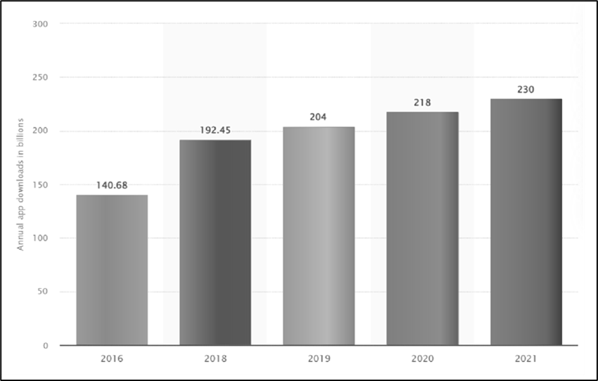
Figure 1. Statistic of Annual App Downloads in Billions
Sources: Annual number of mobile app downloads worldwide in 2021. Statista. (2022).

This research aims to design and develop a mobile application as an effective approach and useful for users in maintaining their health. It can be achieved by following the various steps in doing physical activities and exercises through the mobile application. Referring to Yang and Koenigstorfer (2021), mobile applications for health and fitness are considered promising tools for promoting physical activities as it could encourage the intention of being physically active in daily life. It is significant as part of the present study towards educating and assisting users with knowledge about health and fitness in maintaining a healthy lifestyle.

2.2 Physical Inactivity among Malaysians

Physical inactivity is a major contributing factor in the increase of health risks globally. It has been identified to be one of the major causes of obesity, cancer, and heart disease. According to the most recent statistic reported by the World Health Organisation (WHO, 2022), 81% of adolescents and one in four (1:4) adults worldwide do not sufficiently engage in physical activities. Concerningly, the increase in sedentary behaviours also elevated the levels of inactivity as high as 70 percent. The increased levels of physical inactivity have detrimental effects on the health systems, community well-being, and quality of life. WHO also reported that physical inactivity contributes to around 1.9 million deaths each year, with those who are insufficiently active have a 20% to 30% higher risk of death compared to those who are adequately active.

Without exception, Malaysia also shares the adverse effects of a physically inactive society and those who choose to lead a sedentary lifestyle. Reportedly, WHO had detected that 61.4% of Malaysians aged fifteen and above were physically inactive, which put Malaysia among the ten least physically active nations in Asia; it is also perturbing that Malaysians, in general, do not meet the recommended regular levels and appropriate physical activity. This subsequently leads to increased risks of many health problems and weight gain regardless of age, whether young or adult. According to the National Health Morbidity Survey (NHMS, 2019), 25.1% of Malaysians are physically inactive, accounting for 16.4% of the national total deaths. Overweight and obesity have not only become common infliction in Malaysia but have developed as a widespread threatening disease within the society in the past few decades (Lee & Muda, 2019). Although poor dietary choices may cause obesity and other non-communicable diseases, attention has now shifted to insufficient physical activity as another major contributing factor. More rigorous efforts need to be established since obesity can also contribute to health problems and negatively impact the quality of life (Muhammad et al., 2020).

2.3 Physical Inactivity among University Students

Weight-related health problems have become more prevalent among university students in Malaysia. A study by Alias et al. (2022) has identified that students are recurrently the most physically inactive group compared to other occupational groups. The findings also indicated that students at the tertiary level are the least physically active compared to when they were in school, which corresponds to the literature review of the study (Alias et al., 2022).

In the Portal MyHealth annual report (2021), it was indicated that 27.2% of Malaysians who are over 18 years old were classified as obese, and 33% were pre-obese. The risk of obesity can cause major health implications that could increase the number of students getting various types of diseases. Mohd Hakim et al. (2021) claimed that the least physical activity patterns among university students had significantly contributed to poor body mass indexes. Figure 2 shows that obesity can be classified in the following formula based on Body Mass Index (BMI);

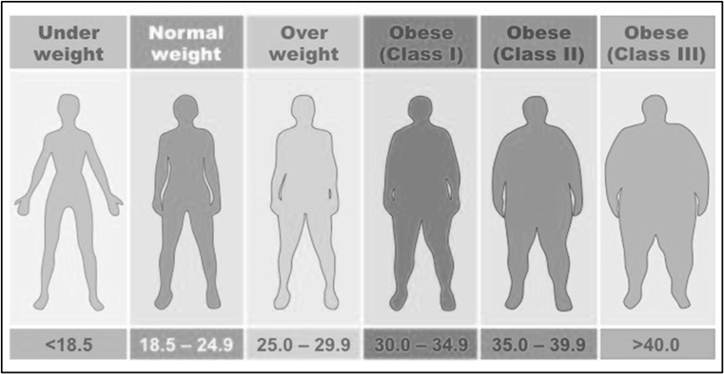
Figure 2. Classification Weight by BMI (kg)
Sources: Body mass index (BMI): Calculation and Importance. WeCapable. (2021)

Many factors impede university students' physical activity. Among the key factors include a pressing academic schedule that is exhaustive, which leads to university students opting out from engaging in any physical activities or making any attempt to exercise (Saleem et al., 2018). The lack of free time during the day also obscures the encouragement of students for a more physically active routine. Therefore, time management is a crucial factor in supporting students in continued physical activity.

2.4 FitMy App

The inclusion of physical activities as part of an important daily routine could develop an interest in improving and maintaining good health, which would greatly reduce the hazards of obesity and any further health risks. However, university students prefer to spend more time studying rather than performing physical activities. A recent study has shown that many barriers lead to the lack of university students' engagement in physical activities (Anuar et al., 2021). In a prior study, Saleem et al. (2018) highlighted that the barrier that affects students the most is due to the lack of energy or exhaustion caused by a very demanding academic schedule. Consequently, students lost interest in participating in any physical activities. Additionally, some students lack knowledge of the importance of doing physical activity and fail to adhere to the guidelines (Nobles et al., 2020). To overcome all the issues of students being physically inactive, the FitMy App was designed and developed to educate and assist university students in maintaining their health.

Figure 3 illustrates that in designing and developing the interface of the FitMy App, understanding the concept of User Experience (UX) and User Interface (UI) must be emphasized, as suggested by Sadia (2023). The design and development of the FitMy App need to use the criteria of UX and UI that focus on what users of the application would need to do to ensure the interface has the right elements of ease of use and enable users to comprehend the interface effortlessly.

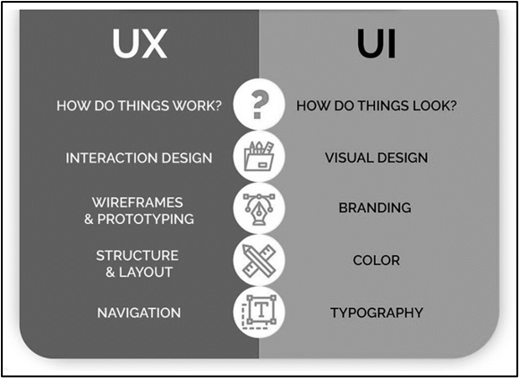
Figure 3. Concepts of UX and UI
Sources: UI/UX branding: Key player in creating brand identity. InvoZone. (2023)

2.5 User Experience
User experience (UX) refers to Human-Computer Interaction that involves users' experience when using a digital application, including that of a mobile application. As stated by Guo et al. (2020), UX in a mobile application is the ability for users to navigate the content without getting lost easily. User experience is the most important factor that reflects how users feel when using a mobile application (Yu et al., 2018). It provides meaningful and relevant experiences for the users with the entire process of the usability, value, and desirability of the mobile application, including the interaction design, structure, layout, and functionality of navigation. User experience can be concluded as how the users feel about the mobile application when interfacing with the system interchangeably with the concept of usability (Pinchot, 2020). User experience for mobile applications is most important to attract users' attention as it plays a part in defining how users feel when they engage and interact with products, whether positive or negative (Lubis et al., 2019).

Importantly, a good interface design will not only entice the users, but they also can interact easily with the information provided in the mobile application, which is more time-efficient (Putra & Setiawan, 2020). It needs to be noted that good UX design could encourage further development of an application, while a poor UX design that is unappealing to users can contribute to the failure of developing the mobile application (Mahmoud et al., 2021). Therefore, UX is a crucial component of designing and developing mobile applications that must be continuously assessed and enhanced (Dirin et al., 2023).

2.6 User Interface

User Interface (UI) refers to Human-Centred Design involving the process phases of inspiration, ideation, and design implementation. As stated by Pham and Zhao (2018), the purpose of Human-Centered Design is to ensure that the interface design of the product meets the needs and capabilities of the users. It is the point at which humans interact with interface products of a computer or mobile application. A good and effectual UI strategy is to incorporate friendly content, such as the use of iconography and visual images, in making design decisions for the mobile application (Guo et al., 2020). Accordingly, Yazid and Jantan (2017) further suggested that the choice of font, size, and colour for the user interface could significantly influence the overall user experience. Referring to Fauzi et al. (2023), to ensure all interactions and learning between users and the mobile application are successful, it is important to understand the users' needs, capabilities, and limitations when designing the mobile application's user interface. Hence, it is necessary to ensure that the colour scheme should reflect the application's colour palette while conforming to the contrast ratios. Concomitantly, the designer must consider the limitations of the mobile app screen size with the need for legible font size and type. Accordingly, the size of the font should be based on the average distance of the users' eyes from the screen.

The user interface is the design process in developing the interfaces for software by focusing on the looks and the style of its interface design, the visual design, branding, colour, and typography used in designing and developing the interface product. The most important aspect to consider during the design and development of a mobile application is the elements of the user interface, which connects users' needs to the usability of the mobile application. As suggested by Granic (2017), a good UI design emphasizes the usefulness of delivering relevant functionality.

2.7 Beneficial of FitMy App

The FitMy App brings useful novelty with unique advantages and benefits to university students in maintaining their health. In addition, the FitMy App was created to help and improve university students' insufficient involvement in exercising, their attitude towards engaging in physical activities, and their sedentary lifestyle. The application is developed to encourage university students to lead and live a healthy lifestyle while improving any of their fine or gross psychomotor problems.

As the use of mobile application technology becomes increasingly prevalent, more applications for various fitness purposes have been developed. An earlier finding by Sakitha et al. (2020) revealed that the rapid growth of various fitness applications had increased by more than fifty percent in their usage within six months. The researcher has made several application observations of other existing fitness applications, such as Fitness App, Daily Workouts App, and 30-Day Fitness App, and found that the majority of them only focus on the video instructors for the users.

Although there are many other fitness applications in the market, the novelty brought into the FitMy App has incorporated some special features that promote the development of university students' fine and gross motor skills. The useful features included in the FitMy App provide appropriate and effective exercises with a video instructor, progress tracking, game challenges, and a message chatbot for performing physical activity to maintain a healthy lifestyle. All the special features in the FitMy App are beneficial for university students and encourage them to use the FitMy App with due diligence continuously. Furthermore, students who regularly do physical activity indirectly become a powerful tool to impact their health (Makhmudovich & Makhmudovich, 2023).

2.8 Theoretical Framework

The theoretical framework is fundamental in conducting the study of this research to ensure that it is in line with the main aim. It is propagated by Heale and Noble (2019) that the theoretical framework aims to demonstrate the interaction and relationship among a set of concepts to describe a phenomenon as a whole. Figure 2.4 shows the theoretical framework of research that was used in this research. To fill the gaps in the research, the researcher adapted three interrelated theories namely; Cognitive Constructivism Theory by Jerome Bruner (1960), Dual-Coding Theory by Allan Paivio (1971), and the Instructional Model of Dick and Carey (2006) to develop the theoretical framework of the present study.

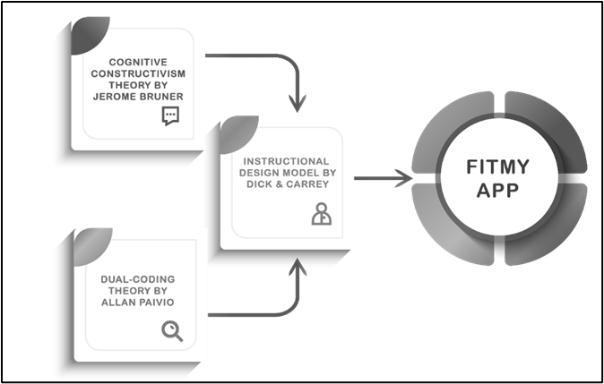
Figure 4. Theoretical Framework of Research

The first version of Dick and Carey Model (2006) was developed in 1978 but the recent version was constructed in 2006. The Dick and Carey Model (2006) was chosen as a systematic instructional design for the whole study to design and develop the FitMy App in educating and assisting university students in maintaining their health. Meanwhile, designing and developing the FitMy App also influenced the adoption of relevant theories which include the Cognitive Constructivism Theory and the Dual-Coding Theory. The Cognitive Constructivism Theory by Jerome Bruner (1960) is used to emphasize the need for students to engage actively in physical activities through the FitMy App by repeating the instructions of the exercises suggested in the application. Cognitive constructivism utilizes interactive teaching strategies in the FitMy App to create meaningful contexts that help students construct new knowledge based on their own experiences in performing physical activity. Besides, the Dual-Coding Theory by Allan Paivio (1971) is used to enable students to use different types of stimuli that consist of both, verbal and nonverbal (visual), to assist students in more efficiently encoding information in their brains, thereby making it possible for them to retrieve that information easily at a later time. The dual-coding theory is referred to as a concept learning model, and it helps the researcher identify and simplify the information by including the visual elements in FitMy App for the appeal of instruction and explicit lesson ideas for students.

3 Methodology/Materials

3.1 Research Design

This study employs descriptive research in the quantitative approach for its quantitative primary data, which consists of a survey questionnaire that was administered to the respondents to identify their health consciousness and examine their evaluation of the usability of the user interface (UI) and user experience (UX). Data from the questionnaire was analyzed using descriptive statistics. Data collected were used to design and develop the UI and UX of the FitMy App in educating and assisting university students in maintaining a healthy lifestyle. In addition, the quantitative secondary data consists of various articles, journals, books, and theses from other researchers. The use of secondary data enabled the researcher to identify systematically recent scholarly literature to clarify the research objectives and questions of this study. Figure 5 shows the flowchart of the research design in this study.

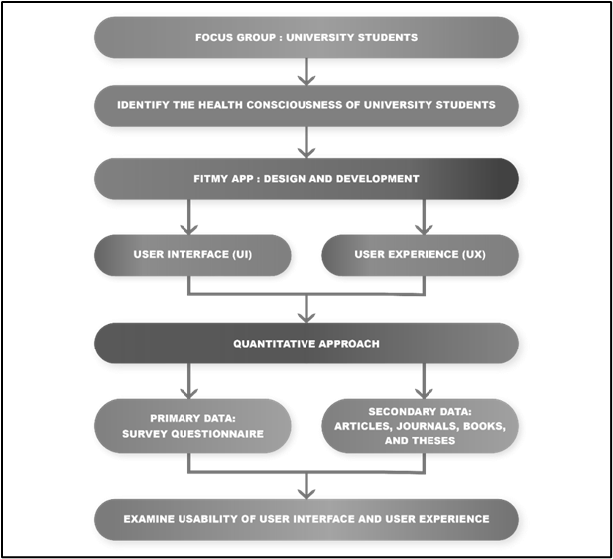
Figure 5. Flowchart of Research Design

3.2 Research Sampling

Respondents were selected using simple random sampling from one faculty at the university that represents an entire population. The use of simple random sampling is to allow for unbiased data collection and arrive at unbiased conclusions. This is in line with Noor et al. (2022) who stated that simple random sampling ensures unbiased, representative, and equal probability of the population. Two hundred (200) respondents were involved from the Faculty of Education, Universiti Teknologi Mara (UiTM), Puncak Alam Campus. The selected respondents are to provide their feedback for all the items in the questionnaire to answer the research questions of this study.

3.3 Research Instrument

The researcher used a survey questionnaire as the instrument in this study. The questionnaire was distributed to 200 respondents from the Faculty of Education, Universiti Teknologi Mara (UiTM), Puncak Alam Campus. Feedback gathered was used for analysis. Items in the questionnaire were tested for validity by conducting a pilot test in the formative evaluation before the questionnaires were distributed to the research respondents during the summative evaluations. The researcher has developed a set of survey questionnaires comprising 40 items categorized into four (4) sections.

The questionnaire is divided into four (4) sections, namely: Section A: Demographic Data, Section B: Health Consciousness Data, Section C: Evaluation of User Interface (UI), and Section D: Evaluation of User Experience (UX). The questionnaire was adapted from Tamura et al. (2021), Tsou and Curran (2018), Pin (2015), and Alanzi (2022), which contained closed-ended questions with multi-choice answers. Table 1 shows the descriptions in the sections of the questionnaire. A complete set of the questionnaire is attached in the Appendix.

Table 1: Descriptions of the Survey Questionnaire
Section | Description | Sources
Section A Demographic Data | The demographic section is designed to gather respondents' demographic data. It consists of information about the student's gender, level of education, and education program. | -
Section B Health Consciousness Data | This section consists of multiple-choice questions about the health consciousness of university students with multiple answers. | Adapted from (Tamura et al., 2021).
Section C  Evaluation of User Interface | This section consists of questions about evaluating the user interface.  All the questions were constructed as closed-ended items, based on 5 Likert-scale:  (1) Strongly Disagree  (2) Disagree  (3) Neutral  (4) Agree  (5) Strongly Agree | Adapted from (Tsou & Curran, 2018) and (Pin, 2015)
Section D  Evaluation of User Experience | This section consists of questions about evaluating the user experience.  All the questions were constructed as closed-ended items, based on 5 Likert-scale:  (1) Strongly Disagree  (2) Disagree  (3) Neutral  (4) Agree  (5) Strongly Agree | Adapted from Alanzi (2022)

3.4 Data Analysis

Feedback gathered from the respondents was statistically analyzed using the Statistical Package for Social Sciences (SPSS) version 23. The data were descriptively analyzed to compute and determine the respondents' health consciousness and evaluation of the user interface (UI) and user experience (UX) of the FitMy App. The data collection was presented in the form of descriptive statistics that were numerical and graphical to summarize the characteristics of a data collection clearly and were analyzed by frequency, percentage, mean, and standard.

3.5 Data Collection

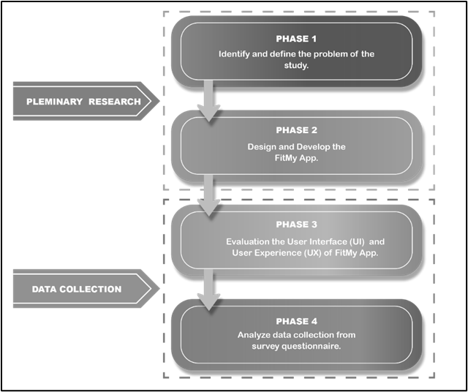
Figure 6. Flowchart of Data Collection

The researcher has developed the data collection flowchart used throughout the research study, as shown in Figure 6. The phase started with a preliminary study. In Phase 1 of the research, the stage involved identifying and defining the problem of physical inactivity among university students. Phase 2 was conducted to design and develop the FitMy App in educating and assisting university students in maintaining a healthy lifestyle. Subsequently, the stage took off for data collection. Meanwhile, in Phase 3, the questionnaires were distributed to the respondents for evaluation of the user interface (UI) and user experience (UX) of the FitMy App. Finally, in Phase 4, all the data from the collected questionnaires were analysed employing descriptive statistics.

4 Results and Findings

4.1 Research Objective 1: To identify the health consciousness of university students in maintaining a healthy lifestyle.

The results of this study show that most university students are moderately conscious of their current health conditions. Although university students are aware and concerned about their health condition, a high percentage of them are conscious about their health while putting efforts into maintaining or improving their eating habits. This indicates that they still lack the understanding and awareness of the importance of maintaining or improving their health conditions by including physical activities or exercising in their daily routines. The findings were supported by the research of Nobles et al. (2020), who reported that evidence-based physical activity guidelines have been in place in many countries, yet knowledge and awareness of key parts of physical activity guidelines are extremely low, leading to a factor of physical inactivity.

Although a substantial number of university students may lack the understanding and awareness of the significance of being physically active to keep fit and healthy, it is meaningful to note that they still put some minor efforts into exercise and contemplate that such activity is moderately important. This is evident when respondents would exercise or get involved in physical activities at least once a week, and it may just be as modest as walking; unfortunately, walking is just not enough and simply not intense enough to be considered an exercise routine as it does not exert excess strain on joints. Besides, walking is a normal part of a university student's life; hence, walking is a necessity and not necessarily a preferred form of physical activity (Aljehani et al., 2022). There is still some optimism, although the findings also suggested that the respondents' attitudes and efforts toward keeping a healthy lifestyle through exercising and getting involved in physical activities regularly on a weekly basis may be at the minimum. However, findings from the feedback also have identified that university students would exercise more than once a week to improve inactivity in their daily routines. Unfortunately, not even half of the respondents, who are university students, would exercise or participate in any physical activities more than once weekly. Thus, it shows that the majority of university students are unaware of the physical activity guidelines and recommendations that are required throughout the week. It is considered only a minority of university students who know the guidelines and recommendations for physical activity (Martines et al., 2019).

Furthermore, as expected from the researcher, analysis has identified that the lack of knowledge and awareness impedes university students' commitment to exercising and participating in physical activities. Hence, more rigorous efforts are urgently needed to improve and encourage students to exercise and be physically active toward leading a healthier lifestyle. Importantly, university students should be engaging in any form of physical activity and should be encouraged to actively participate in exercises or physical activities to achieve a specific goal in a healthy lifestyle. As a result, the students need to recognise the importance of vigorous physical activity in reducing potential risks associated with a sedentary lifestyle (Mahfoudh & Ghabra, 2023). Alongside, university students should limit the amount of time spent being sedentary and replace idle time with physical activity of any level (WHO, 2020).

4.2 Research Objective 2: To design and develop the FitMy App to educate and assist university students in maintaining a healthy lifestyle.

In designing and developing a mobile application, it is essential to constantly keep in mind certain factors to maintain good standards, such as the design of the user interface (UI) and the quality of the user experience (UX). The process of designing and developing the FitMy App in educating and assisting university students in maintaining a healthy lifestyle has adhered to the instructional design model by Dick and Carey (2006). The ten (10) steps in the framework of Dick and Carey's (2006) model have provided guidance, reference, and direction throughout the design phase of the application's instructions, including the descriptions of the steps both discursively and visually. It maintains interconnected components of instruction that work together to enhance learning (Sunaryo et al., 2021).

By planning a unit of instructions in designing and developing the FitMy App using the Dick and Carey (2006) model approach, the researcher constructed a systematic structure of learning in individualized learning for the users. The ten (10) steps from the model are to identify instructional goals, conduct instructional analysis, identify entry behaviours, write performance objectives, develop criterion-referenced tests, develop instructional strategy, develop and select instructional materials, develop and conduct formative evaluation, revise instruction, develop and conduct summative evaluation. These ten (10) steps provided a cohesive and effective tool for designing and developing an organized unit of instruction in the FitMy App to educate and assist university students in maintaining a healthy lifestyle. These steps have facilitated in planning successful and appropriate instruction (Sabri & Abdul, 2020).

The integration of the top features such as video instructor, progress tracking, game challenges, and message chatbot into the FitMy App could enrich university students' learning related to fitness and health. The findings aligned with a previous study by Huang and Ren (2019), which stated that to attract the attention of app users, app developers may include exciting features such as gamification components. Similar to the findings of the study by Figueroa et al. (2023), the interactive design in mobile applications has been proven to be an effective tool for promoting physical activity change that could encourage and reinforce the desired behaviour of the students in performing physical activity. As users, they will not only learn by absorbing information passively in FitMy App but also need to get engaged in active cognitive, affective, and psychomotor skills when performing physical activities.

4.3 Research Objective 3: To examine the usability of the FitMy App in educating and assisting university students in maintaining a healthy lifestyle.

Further into the analysis, it is revealed that the university students provided positive feedback about the typeface, colour, interface design layout, and navigation control of the mobile application. More significantly, the respondents strongly agree with the outcomes of the design and development of the FitMy App. This implies that utilizing the instructional design model by Dick and Carey (2006) in designing and developing the FitMy App not only has generated the right appeal for the application but also has successfully gained the users' acceptance. As Libata et al. (2021) affirmed that Dick and Carey (2006) are an ideal and best instructional design on its applicability and acceptability of the user.

It has also been identified that most of the respondents provided positive feedback on the usage and satisfaction of the FitMy App, as demonstrated in Table 5.17. It indicates that using the Dual-Coding Theory by Allan Paivio (1971) has influenced and stimulated the participants through the learning process of using the FitMy App. The information processing verbal and nonverbal coding systems in learning materials to learn better were increased when they can understand and effectively retrieve or recall information that is kept in long-term memory with the content related to them and their experiences as applicable to their own lives. The variety of information processing in FitMy App also allows relationships between verbal and nonverbal coding systems that are mutually independent and related, which have a positive impact on respondents' learning performance in performing physical activities (Liu et al., 2023).

Upon deeper analysis, it was discerned that most of the respondents consider the FitMy App to be useful, and they are also satisfied with its usability. They consider the mobile application to be useful for their health and well-being, which also improves their access to fitness exercises. They also strongly agree that the FitMy App helps them manage their fitness exercises related to physical activity and can easily find and understand the information needed in the mobile application, as illustrated in Table 5.18. Through the application of the Cognitive Constructivism Theory by Jerome Bruner (1960), its propositions have influenced the respondents' discovery learning when they use the FitMy App. From the theory, new knowledge is constructed by exploring the learners' world and based on their prior knowledge, which consequently could educate and assist them in maintaining a healthy lifestyle. Respondents discover and have a desire to construct their knowledge by transforming the concept in a new way and transferring the prior knowledge to new situations (Stapleton & Stefaniak, 2019).

5 Conclusion

In summary, the researcher comes to the positive conclusion that the results findings of the FitMy App from evaluation of the user interface and user experience have brought the usability of the FitMy App in educating and assisting university students in maintaining a healthy lifestyle. The purpose of this study focused on the design and development of the FitMy application in maintaining a healthy lifestyle among university students. The results showed positive feedback from the participants on the effectiveness and usefulness of the FitMy App in educating and assisting university students in maintaining a healthy lifestyle. The analysis has also proven that technology can assist users with demanding daily routines, such as students at the university level, in maintaining their health. As claimed by Wiesner et al. (2021), with continuous advances in technology, promoting exercise through technology can lead to greater adoption of physical activity, better health outcomes, and improved well-being. Records of physical activities are easily stored, and users can pick up where they left off and can be saved and retrieved on another device. It correlates with previous research by Farrokhi et al. (2021), who stated recent technological advancements have made it easier for users to obtain and monitor simple features and functionalities in fortifying exercising or keeping health records such as personal data recording, action history, and body state. Therefore, the FitMy App gives the impression that the use of technology in creating a mobile application can educate and assist university students in maintaining a healthy lifestyle. To conclude, after analysing all the findings in this study that can be taken into consideration, it shows the FitMy App is an ideal and ultimate technology for university students to maintain a healthy lifestyle with high user demands for the market needs in terms of content, context design and elements in FitMy App. It is part of an overall trend of current technology and app development that impacts and influences university students to maintain a healthy lifestyle.

References (APA)

Alanzi, T. M. (2022). Users' satisfaction levels about mHealth applications in post-covid-19 times in Saudi Arabia. PLOS ONE, 17(5).
Aljehani, N., Razee, H., Ritchie, J., Valenzuela, T., Bunde-Birouste, A., & Alkhaldi, G. (2022). Exploring female university students' participation in physical activity in Saudi Arabia: A mixed-methods study. Frontiers in Public Health, 10.
Alias, N., Ying Ying, C., Kuang Kuay, L., Ahmad, A., Mat Rifin, H., Shahein, N. A., & Baharudin, A. (2022). Physical inactivity and its associated factors among adults in Malaysia: Findings from National Health and Morbidity Survey (NHMS) 2019. International Journal of Public Health Research, 12(01), 1536–1545.
Angosto, S., García-Fernández, J., Valantine, I., & Grimaldi-Puyana, M. (2020). The intention to use fitness and physical activity apps: A systematic review. Sustainability, 12(16), 6641.
Anuar, A., Hussin, N. Z., Maon, S. N., Hassan, N. M., Abdullah, M. Z., Mohd, I. H., & Sahudin, Z. (2021). Physical inactivity among university students. International Journal of Academic Research in Business and Social Sciences, 11(5).
Balapour, A., Reychav, I., Sabherwal, R., & Azuri, J. (2019). Mobile technology identity and self-efficacy: Implications for the adoption of clinically supported Mobile Health Apps. International Journal of Information Management, 49, 58–68.
Barra, D. C. C., Paim, S. M. S., Sasso, G. T. M. D., & Colla, G. W. (2018). Methods for developing mobile apps in health: an integrative review of the literature. Texto & Contexto-Enfermagem, 26.
Body mass index (BMI): Calculation and importance. (2021). WeCapable. https://wecapable.com/body-mass-index-bmi-importance/
Buabeng Andoh, C. (2018). Predicting students' intention to adopt Mobile Learning. Journal of Research in Innovative Teaching & Learning, 11(2), 178–191.
Dirin, A., Nieminen, M., & Laine, T. H. (2023). Feelings of being for mobile user experience design. International Journal of Human–Computer Interaction, 39(20), 4059-4079.
Dual coding theory (Allan Paivio). (2018). InstructionalDesign.org. https://www.instructionaldesign.org/theories/dual-coding/
Edelmann, D., Pfirrmann, D., Heller, S., Dietz, P., Reichel, J. L., Werner, A. M., Schäfer, M., Tibubos, A. N., Deci, N., Letzel, S., Simon, P., & Kalo, K. (2022). Physical activity and sedentary behavior in university students–the role of gender, age, field of study, targeted degree, and study semester. Frontiers in Public Health, 10.
Farrokhi, A., Farahbakhsh, R., Rezazadeh, J., & Minerva, R. (2021). Application of Internet of things and Artificial Intelligence for smart fitness: A survey. Computer Networks, 189, 107859.
Faudzi, M. A., Cob, Z. C., Omar, R., Sharudin, S. A., & Ghazali, M. (2023). Investigating the user interface design frameworks of current mobile learning Applications: A Systematic review. Education Sciences, 13(1), 94.
Figueroa, C. A., Gomez-Pathak, L., Khan, I., Williams, J. J., Lyles, C. R., & Aguilera, A. (2023). Ratings and experiences in using a mobile application to increase physical activity among university students: implications for future design. Universal Access in the Information Society, 1-10.
Granic, A. (2017). Technology in use: The importance of good interface design. 2017 International Conference on Infocom Technologies and Unmanned Systems (Trends and Future Directions) (ICTUS). https://doi.org/10.1109/ictus.2017.8285972
Guo, F., Wang, X.-S., Shao, H., Wang, X.-R., & Liu, W.-L. (2020). How user's first impression forms on mobile user interface?: An erps study. International Journal of Human–Computer Interaction, 36(9), 870–880.
Heale, R., & Noble, H. (2019). Integration of a theoretical framework into your research study. Evidence Based Nursing, 22(2), 36–37.
Huang, G., & Ren, Y. (2020). Linking technological functions of fitness mobile apps with continuance usage among Chinese users: Moderating role of exercise self-efficacy. Computers in Human Behavior, 103, 151–160.
Jayatilleke, B. G., Ranawaka, G. R., Wijesekera, C., & Kumarasinha, M. C. B. (2018). Development of mobile application through design-based research. Asian Association of Open Universities Journal, 13(2), 145–168.
Kljajevic, V., Stanković, M., Đorđević, D., Trkulja-Petković, D., Jovanović, R., Plazibat, K., Oršolić, M., Čurić, M., & Sporiš, G. (2021). Physical activity and physical fitness among university students—a systematic review. International Journal of Environmental Research and Public Health, 19(1), 158.
Liu, J., Lu, C., & Cai, J. (2023). Research on knowledge learning of COVID-19 video viewers: Based on Cognitive Mediation Model. Healthcare, 11(4), 570.
Lubis, M., Sutoyo, E., Azuddin, M., & Handayani, D. (2019). User experience in mobile application design: Utility defined context of use. Journal of Physics: Conference Series, 1361(1), 012043.
Mahfoudh, R., & Ghabra, N. (2023). Study of active design strategies to enhance physical activity in university educational buildings: a case study at King Abdulaziz University. Journal of Umm Al-Qura University for Engineering and Architecture, 14(4), 241–270.
Mahmoud, Mohammad & Badawi, Usama & Hassan, Walaa & Alomari, Yazan & Alghamdi, Fahad & Farag, Tamer. (2021). Evaluation of User Experience in Mobile Applications. Research Gate, 15. 2021.
Makhmudovich, G. A., & Makhmudovich, G. A. (2023). The Use Of Physical Exercises In Order To Improve The Healthy Lifestyle Of Students. Journal of Positive School Psychology, 545-550.
Martins, J., Cabral, M., Elias, C., Nelas, R., Sarmento, H., Marques, A., & Nicola, P. (2019). Physical activity recommendations for health: Knowledge and perceptions among college students (recomendaciones de Actividad Física para la Salud: Conocimiento y percepciones entre estudiantes universitarios). Retos, (36), 290–296.
Meenapriya, M., Gayathri, R., & Priya, V. V. (2018). Effect of regular exercises and health benefits among college students. Drug Invention Today, 10(7).
Mohd Hakim, S. A., Abu Talip, N. K., Wan Chik, W. F., Md Nadzalan, A., Ismail, Z., Jamaludin, M., & Md Razali, M. R. (2021). Physical activity among undergraduate university students during the pandemic covid-19. International Journal of Academic Research in Business and Social Sciences, 11(10).
National Health and Morbidity Survey (NHMS) (2019). NonCommunicable Disease: Risk Factors and Other Health Problems. Malaysia: Institute for Public Health, National Institutes of Health, Ministry of Health; 2020.
Nobles, J., Thomas, C., Banks Gross, Z., Hamilton, M., Trinder-Widdess, Z., Speed, C., Gibson, A., Davies, R., Farr, M., Jago, R., Foster, C., & Redwood, S. (2020). "let's talk about physical activity": Understanding the preferences of under-served communities when messaging physical activity guidelines to the public. International Journal of Environmental Research and Public Health, 17(8), 2782.
Noor, S., Tajik, O., & Golzar, J. (2022). Simple Random Sampling. International Journal of Education & Language Studies, 1(2), 78-82.
Nugroho, A., Santosa, P. I., & Hartanto, R. (2022). Usability evaluation methods of mobile applications: A systematic literature review. 2022 International Symposium on Information Technology and Digital Innovation (ISITDI).
Pan, M., Ying, B., Lai, Y., & Kuan, G. (2022). Status and influencing factors of physical exercise among college students in China: A systematic review. International Journal of Environmental Research and Public Health, 19(20), 13465.
Pham, N., & Zhao, Y. (2018). The Role of User Interface Design in a Digital Document Reader. Sweden: KTH Royal Institute of Technology.
Phongtraychack, A., & Dolgaya, D. (2018). Evolution of mobile applications. MATEC Web of Conferences, 155, 01027.
Pin, T. Y. (2015). Evaluation Of Design Guidelines: Questionnaire Design For Evaluating Children Educational App (Doctoral dissertation, Faculty of Engineering and Science, Universiti Tunku Abdul Rahman).
Pinchot, J. (2020). User Experience (Ux) Design Concepts for Mobile App Development Courses. Issues In Information Systems, 21(4).
Pires, I. M., Marques, G., Garcia, N. M., Flórez-Revuelta, F., Ponciano, V., & Oniani, S. (2020). A research on the classification and applicability of the Mobile Health Applications. Journal of Personalized Medicine, 10(1), 11.
Portal MyHealth. (2021, October 27). Obesity in adult. http://www.myhealth.gov.my/en/obesity-in-adult/
Putra, D. O., & Setiawan, A. (2020). The importance of user experience analysis in the design of an education information system application. Proceedings of the 1st Borobudur International Symposium on Humanities, Economics and Social Sciences (BIS-HESS 2019).
Raja, R., & Nagasubramani, P. C. (2018). Impact of modern technology in education. Journal of Applied and Advanced Research.
Sabri, S., & Abdul, M. (2020). Integration of Dick and Carey design in string ensemble class instructional material design. International Journal of Innovation, Creaivity and Change, 14(11), 359-388.
UI/UX branding: Key player in creating brand identity. InvoZone. (2023). https://invozone.com/blog/uiux-design-a-key-player-in-creating-brand-identity/
Saleem, F., Bashaar, M., Hassali, M., Haque, N., Iqbal, Q., Ahmad, A., ... & Hashemi, T. (2018). Assessment of barriers to physical activities among university students in Malaysia. Pharm Pharmacol Int J, 6(6), 468-73.
Sakitha, A. J., Reshma, R. K., & Sony, V. (2020). User's Perspective about Mobile Fitness Applications. International Journal of Recent Technology and Engineering, 8(6), 3368-3373.
Sandu, P., Chereches, R. M., Baba, C. O., Revnic, R. N., & Mocean, F. (2018). Environmental influences on physical activity – Romanian youths' perspectives. Children and Youth Services Review, 95, 71–79.
Silva, R. M. F., Mendonça, C. R., Azevedo, V. D., Memon, A. R., Noll, P. R. E. S., & Noll, M. (2022). Barriers to high school and university students' physical activity: A systematic review. PlOS ONE, 17(4).
Stapleton, L., & Stefaniak, J. (2019). Cognitive constructivism: Revisiting Jerome Bruner's influence on instructional design practices. TechTrends, 63, 4-5.
Statista. (2022) Annual number of mobile app downloads worldwide 2021. https://www.statista.com/statistics/271644/worldwide-free-and-paid-mobile-app-store-downloads/
Sunaryo, S., Nasbey, H., & Amelia, H. (2021). Learning media development using transformative learning&nbsp; strategy android application as a distance learning support&nbsp; on static fluid. Jurnal Penelitian & Pengembangan Pendidikan Fisika, 7(1), 61–72.
Tamura, A., Shimura, K., & Inoue, Y. (2021). A survey of health awareness and physical activity among Japanese&nbsp; &nbsp; &nbsp; &nbsp; &nbsp; undergraduate rehabilitation students. Journal of Physical Therapy Science, 33(2), 106–111.
Tan, K. L. (2019). Factors influencing physical inactivity among adults in Negeri Sembilan, Peninsular Malaysia. Med J Malaysia, 74(5), 389-93.
Tsou, M. H., & Curran, J. M. (2008). User-centered design approaches for web mapping applications: A case study with USGS hydrological data in the United States. International perspectives on maps and the Internet, 301-321.
World Health Organization. (2020). WHO guidelines on physical activity and sedentary behaviour. https://www.who.int/publications-detail-redirect/9789240015128
Yang, Y., & Koenigstorfer, J. (2021). Determinants of fitness app usage and moderating impacts of education-, motivation-, and gamification-related app features on Physical Activity Intentions: Cross-sectional survey study. Journal of Medical Internet Research, 23(7).
Yadav, T. (2021). Analysis of the second language learning and teaching through cognitive constructivism. International Journal of Modern Agriculture, 10(2), 4429-4433.
Yazid, M. A., & Jantan, A. H. (2017). User experience design (UXD) of mobile application: An implementation of a case study. Journal of Telecommunication, Electronic and Computer Engineering (JTEC), 9(3-3), 197-200.
Yu, Q., Che, X., Ma, S., Pan, S., Yang, Y., Xing, W., & Wang, X. (2018). A hybrid user experience evaluation method for mobile games. IEEE Access, 6, 49067–49079.

Appendix

Instruments of Survey Questionnaire

SECTION A: DEMOGRAPHIC

Direction: Please read each question carefully and tick your answer.
- Gender
Male
Female

- Level of Education
Pra-Diploma
Diploma
Degree
Master
PhD

- Education Program
Undergraduate
Postgraduate

SECTION B: HEALTH CONSCIOUSNESS
Adapted from (Tamura et al., 2021)

Direction: Please read each question carefully and tick your answer.
- How are you currently feeling about your health condition?
Very healthy
Moderately Healthy
Neither
Not very healthy
Not at all healthy

- Do you have any current concerns about your health condition?
Yes
No

- If you have any, which of the following best describes your concerns?
Maintenance or improvement of a physical activity habit
Maintenance or improvement of eating habits
Maintenance or improvement of a sleep habit
None
Other

- Do you like doing exercise or physical activities?
Very much
Moderately
Neither
Not very much
Not at all

- Do you like doing exercise or physical activities?
Very much
Moderately
Neither
Not very much
Not at all

- If you participate in exercise or a physical activity more than 1 time per week, what type of activity is it?
Jogging
Strecthing
Competitive Sports
Walking
Yoga
None
Other

- How often do you exercise or participate in physical activities each week?
Everyday
None
1 time per week
2-4 times per week
1 time per month
2-4 times per month

- If you participate in exercise or physical activity more than 1 time per week, what is its purpose?
Improvement of health
Improvement of inactivity
Rehabilitation
Diet
None
Other

- If you do not participate in exercise or a physical activity during the week, why not?
Lack of knowledge and awareness of exercise
Lack of self-motivation
Lack of encouragement and support from other
Non-enjoyment of exercise
Insufficient time of exercise
Poor health condition (including injuries)
Other

SECTION C: EVALUATION OF USER INTERFACE
Adapted from (Pin, 2015) and (Tsou & Curran, 2018)

Evaluation of prototype interface characteristics.
Please rate your level of agreement with each statement.
(1) Strongly Disagree
(2) Disagree
(3) Neutral
(4) Agree
(5) Strongly Agree

Typeface | (1) | (2) | (3) | (4) | (5)
- The typeface size of the text is appropriate.
- The typeface type used is easy to read.
- The typeface used is consistent and understandable.
Color | (1) | (2) | (3) | (4) | (5)
- The colors used for the interface design layout are appropriate.
- The color used for the text is suitable.
- The background color used is comfortable.
Interface Design Layout | (1) | (2) | (3) | (4) | (5)
- The interface design layout is user-friendly and comprehendible.
- The interface design layout is designed to minimize user error.
- The spacing between items on the interface design layout is comfortable.
Navigation Control | (1) | (2) | (3) | (4) | (5)
- It is easy to navigate around.
- User has good control of the interface.
- Design of the buttons menu and icon is simple.
- Buttons menu are reasonably easy to click on.
- Buttons menu and icon are consistent in the same place for each screen.

SECTION D: EVALUATION OF USER EXPERIENCE
Adapted from (Alanzi,2022)

Evaluation of user experience prototype.
Please rate your level of agreement with each statement.
(1) Strongly Disagree
(2) Disagree
(3) Neutral
(4) Agree
(5) Strongly Agree

Usage and Satisfaction | (1) | (2) | (3) | (4) | (5)
- The app was easy to use.
- The operations, actions, and responses are consistent.
- The speed of responses to actions performed is appropriate.
- The information is presented in a logical order without surprises.
- The information in the app was well organized, so I could easily find the information I needed.
- It was easy for me to learn to use the app.
- I feel comfortable using this app in social settings.
- I like the interface of the app.
- I would like to use this app again.
- Overall, I am satisfied with this interface app.
Usefulness | (1) | (2) | (3) | (4) | (5)
- The app would be useful for my health and well-being.
- The app improved my access to fitness exercises.
- The app helped me manage my fitness exercise effectively.
- The information in the app was well organized, so I could easily find the information I needed.

