**The Role of AI in General English and Business English:**

**A Systematic Review of Recent Advancements (2021-2024)**

Yi Wei1, Yirong Zhang1, Hongyuan Ding1, Jiayi Wang2,

Ming Zhang2, Geetha Subramaniam3, Wu Meng1,3

1 School of Information Science and Technology, Sanda University, Shanghai, China

2 School of Foreign Languages, Sanda University, Shanghai, China

3 Faculty of Education, Languages, Psychology and Music, SEGi University, Selangor, Malaysia

**Abstract**

*The exploration of the application of information technology in the fields of General English and Business English has emerged as a crucial area of research. This systematic literature review examined 32 indexed research articles published between 2021 and 2024, focusing on the application of machine learning, deep learning, ChatGPT, and other algorithms in these domains. The main aim of this review is to assess the current academic development in the optimization of General English and Business English learning in the context of AI technology The findings underscored that the utilization of information technology was minimal in listening. In contrast, significant and effective applications of deep learning, machine learning, ChatGPT, and other algorithms were observed in speaking, writing, and translation works. Notably, the highest level of interest was noted by researchers in China, with Asian researchers accounting for 91% of the contributions*. *In contrast, General English exhibited broader applicability, encompassing a diverse target population. This research ultimately provides valuable insights for researchers and educators, guiding the development of innovative educational practices in the context of language learning.*

***Keywords: General English, Business English, Information Technology, AI Applications,*** ***Language Learning,*** ***Educational Practices***

1. **Introduction**

In the era of globalization, the significance of English language learning has become increasingly paramount, particularly concerning Business English and its practical applications (Yang & Qi, 2022). The expansion of international trade and communication necessitates proficiency in English for individuals aiming to engage in the global market effectively. Business English not only enhances employability but also facilitates cross-border collaboration and negotiation, thereby reinforcing English's status as a lingua franca in modern business contexts.

Furthermore, information technology has significantly advanced, overcoming many limitations inherent in traditional educational models. A considerable number of individuals lacked access to systematic teaching or the opportunity to reside and study in English-speaking countries. However, not everyone possesses the financial resources to hire professionals for skill assessment (Yang & Qi, 2022).

These disparities underscored the urgent need for innovative educational approaches that leveraged technology, thereby promoting broader access to quality education and personalized learning experiences. For instance, the integration of online learning platforms and mobile applications has created opportunities for self-directed learning, enabling learners to acquire language skills at their own pace.

Despite advancements in technologies such as deep learning, machine learning, and ChatGPT, research aimed at optimizing English learning methodologies remains limited. Therefore, a systematic literature review (SLR) was conducted to identify, select, and evaluate relevant studies focused on enhancing English learning through information technology.

This SLR analysis mainly aims to assess current academic contributions by addressing three specific research questions (RQs) as below:

RQ1: Do the targets of English learning optimization differ based on their countries and identities?

RQ2: How does information technology currently assist in optimizing English learning?

RQ3: How do machine learning, deep learning, and ChatGPT contribute to enhancing language learning outcomes in General English and Business English?

1. **Literature Review**

The advent of large language models, such as ChatGPT, has revolutionized assistance in English language learning, including speaking, writing, and translation capabilities (Ghio, 2024). This technological leap has significantly shaped modern educational approaches. In the domain of academic early warning, deep learning, machine learning algorithms, and large language models have demonstrated commendable performance (Wu et al., 2024), particularly in the domain of Business English. Recently, empirical studies have begun to explore the nuances of learner interactions with these models. For instance, Zheng and Zhao (2021) applied machine learning to analyze students' facial expressions during English lessons, discovering that learners exhibited lower accuracy in expressions of confusion. This finding suggests that technology could help identify and address moments of students difficulty in real time.

In evaluating feedback mechanisms, Taskiran et al. (2022) compared the effectiveness of feedback from teachers and algorithms. Their study indicated that while teacher feedback was slightly more effective, algorithmic feedback served as a valuable supplement, particularly in providing immediate and scalable responses. Additionally, Sel et al. (2022) enhanced machine translation performance by implementing deep learning models that replaced traditional feedforward network layers with full attention mechanisms, resulting in improved word-level attention and translation accuracy.

Moreover, the integration of deep learning with virtual reality has been utilized to simulate authentic English conversation scenarios at the university level, as demonstrated by Luo et al. (2022). This approach has shown an increase in learner engagement and interest, further underscoring the benefits of innovative technology in language education.

Information technology has also been pivotal in the domain of Business English. Chen et al. (n.d.) developed a self-directed learning system that incorporates a BP neural network model, facilitating online learning, testing, and interaction to support student autonomy. Technological advancements, such as edge computing and 5G, have been strategically applied to enhance the speed and efficiency of Business English translation systems. For example, Hu and Wu (n.d.) proposed a low-latency translation framework that leverages these technologies, significantly improving response times and user experience. In 2021, an AI speech recognition architecture utilizing deep neural network feature fusion methods, which aids in recognizing spoken Business English, making language learning more accessible and interactive was designed (Xu et al.,2021)

Despite these advancements, the current application of information technology in both general English and Business English remains relatively limited. Thus, it is crucial to understand the overall research landscape and analyze the adaptability of different algorithms across various fields by assessing current academic developments in terms of General English and Business English learning in the context of information technology. Additionally, exploring whether there are differences in the utilization of these technologies among diverse nationalities and demographic groups is essential. Such an analysis could provide valuable insights into the effectiveness and accessibility of language learning tools, highlighting areas for potential enhancement and broader implementation.

1. **Methodology**

**3.1 Eligibility Criteria**

Through a systematic literature review, this study explored the relationship between information technology and the learning of both general and business English. This examination was crucial for identifying how effectively information technology could enhance English learning outcomes, thereby informing educators about potential strategies for integrating technology into their teaching practices. To achieve this goal, various selection criteria were established, as outlined in Table 1. These criteria included the relevance of the studies to learning outcomes, the rigor of the methodologies employed, and the overall impact of the findings on educational practices. By applying these criteria, the review ensured a comprehensive understanding of the role of information technology in facilitating English language learning.

Table 1. Selection Criteria of Papers

|  |  |
| --- | --- |
| **Selection Criteria** | **Criteria Description** |
| 1. Research Focus | Studies examining the relationship between information technology and General English or Business English. |
| 2. Publication Years | Research published from 2021 to 2024. |
| 3. Text Availability | Full text is available for use during the research. |

**3.2 Screening and Study Selection Process**

This study focused on papers published between 2021 and 2024 utilizing the Preferred Reporting Items for Systematic Reviews and Meta-Analyses (PRISMA) framework to filter studies that met the inclusion criteria. This timeframe was chosen to capture the most recent advancements and trends in General and Business English, particularly regarding artificial intelligence. The search keywords included terms such as "General English," "Business English," and "Artificial Intelligence". Initially, 673 papers were identified. Following a screening process based on titles and keywords, 569 papers were excluded. Subsequently, 72 papers were removed due to content irrelevance. Ultimately, this systematic literature review included 32 papers (see Fig. 1).

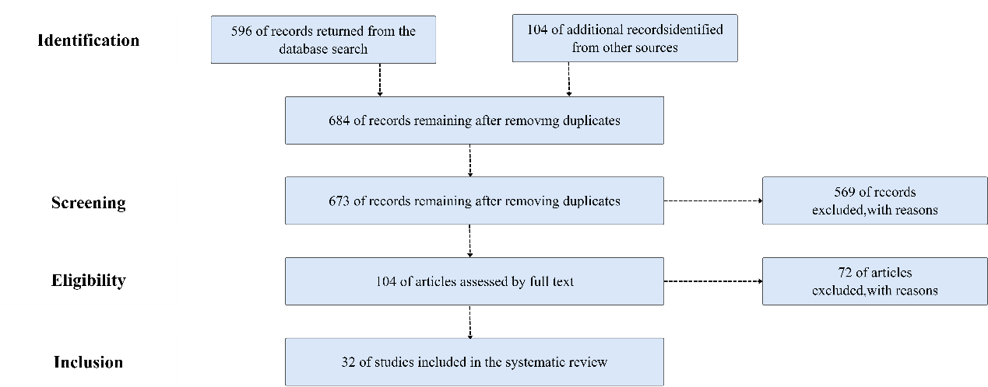

Fig.1 Paper Screening Process Flow Chart

Finally, this systematic literature review analyzed 32 major articles published between 2021 and 2024 to explore the application of information technology in both General and Business English. The selection of this recent four-year period is particularly relevant due to the emergence of large language models, such as ChatGPT, which spurred significant research integrating these models with English learning. The findings revealed that the majority of the papers were published in 2022 and 2023, coinciding with the initial proliferation of large language models in academic discourse. In contrast, only six papers were published in 2021 and three in 2024 (see Table 2).

Table 2. Number of Papers Published

|  |  |
| --- | --- |
| **Year** | **Number of Papers Published (%)** |
| 2021 | 6 (19%) |
| 2022 | 12 (38%) |
| 2023 | 11(34%) |
| 2024 | 3 (9%) |

**4. FINDINGS AND DISCUSSION**

This SLR focuses on the role and impact of information technologies such as machine learning, deep learning, ChatGPT, and other algorithms on both General and Business English learning. These technologies have revolutionized how language learning is approached, providing personalized, data-driven insights that optimize learner outcomes. In the following sections, the discussion will unfold according to the research questions, systematically exploring the application and effectiveness of these technological advancements in different contexts of English learning.

**4.1 English Learning Optimization Based on Countries and Identities**

This section answers RQ 1: Do the targets of English learning optimization differ based on their countries and identities?

The SLR analysis aimed to perform a comparative analysis of application users by examining the literature, in terms of geographical output and demographics. The focus was on identifying which countries and specific demographic groups currently exhibit the highest demand for English language learning resources. By analyzing the characteristics and contexts of the research articles, the review sought to uncover trends in educational needs and preferences among diverse populations. This dual approach not only highlighted variations in demand across different regions but also provided insights into how educational strategies can be tailored to meet the needs of specific learner groups better.

The review encompassed authors from a total of 11 countries, classified into three categories based on regional characteristics: China, Asia, and other countries. As shown in Figure 2, authors from China constituted the majority, accounting for 63% of the total, while Asian authors represented a significant portion at 91%. A small number of authors from non-Asian countries, such as Brazil, Australia, and Canada, were also included. This analysis shows that the emphasis on English language learning was notably highest among Asian countries, as most countries in Asia are non-English-speaking. China, being the world's second-most populous country, displayed the greatest commitment to English language acquisition. Conversely, no European countries were represented among the authors, likely due to the prevalence of the English-speaking population in the region.

Fig.2 Author Nationality Comparison

As depicted in Figure 3, the target population in the literature surveyed for this review is predominantly learners. Particularly within the domain of Business English, learners constitute more than half of all the subjects under investigation. In stark contrast, university students were not the target audience for Business English studies. Researchers are only the secondary focus, with only one article dedicated to teachers. This observation indicates that Business English, being a highly applied discipline, is more suited to professionals with specific needs rather than being generally applicable. However, the disparity among the four groups is significantly reduced for General English, with all demographics demonstrating considerable interest in General English studies.

Fig.3 The Use of Different Groups of People in Different Subjects

The literature identified four distinct target populations: learners, university students, researchers (See Fig.4), and educators. Among these groups, learners represented the largest segment, with a total of 13 studies, accounting for over one-third of the overall research. This was followed by researchers comprising approximately one-quarter of the total, while the numbers for educators and university students were notably smaller. This distribution underscores the emphasis placed on understanding the needs and experiences of learners, suggesting that educational strategies and technological applications are primarily tailored to support this demographic category.

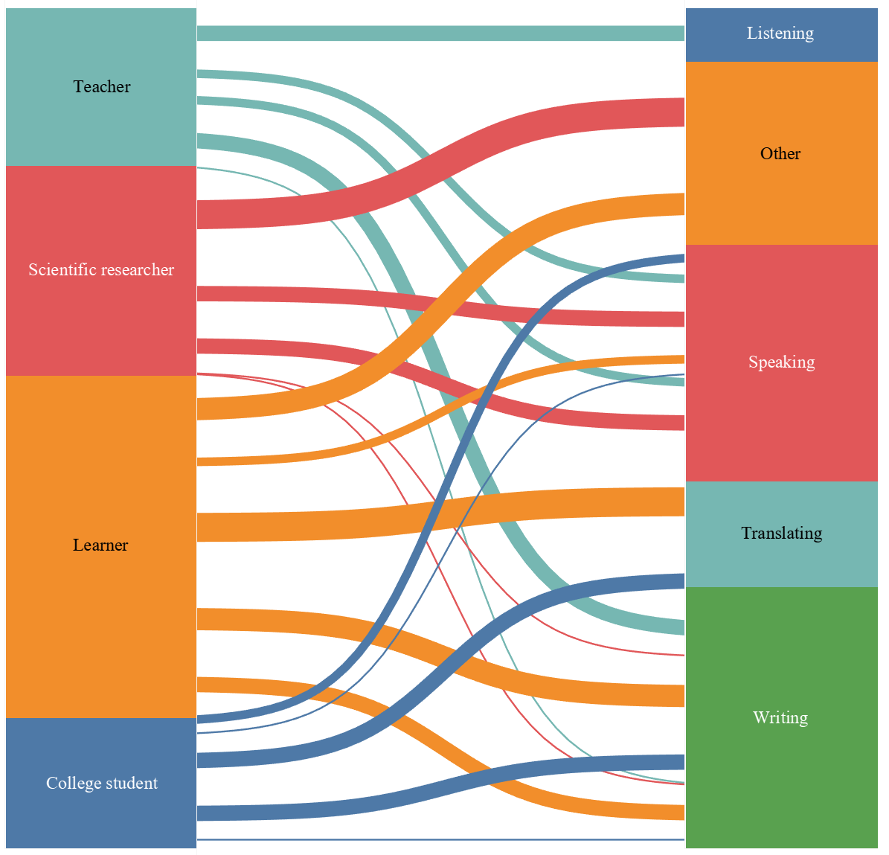

Fig.4 The Use of Different Groups of People in Different Fields

A further analysis was done focused on learners, where the highest demand was identified in speaking, followed by writing and other areas, with needs for listening and translating being comparatively lower. Specifically, autonomous learners expressed a desire for machine learning and deep learning algorithms to facilitate efficient and real-time corrections of their speech. This preference highlights the critical role of interactive technology in enhancing language proficiency, particularly in the speaking domain, where immediate feedback can significantly improve learning outcomes.

For researchers, deep learning, machine learning, and ChatGPT were most prominently utilized in writing tasks. This trend underscores the increasing reliance on advanced algorithms to enhance the quality and efficiency of academic writing. The literature indicated an equal volume of research focused on translating and speaking applications among this group, suggesting that while writing remains a primary focus, there is also recognition of the importance of effective communication and translation skills in research contexts.

In comparison, the volume of literature concerning educators and university students was relatively limited. Within this subset, the "other" category emerged as the most frequently addressed aspect, suggesting a broader concern for overall learning efficiency and conditions. Notably, there was an absence of research focusing on listening skills within this demographic. However, there was a marked demand for speaking and writing skills, which can benefit significantly from the integration of machine learning, deep learning, and ChatGPT. These technologies facilitate more efficient communication and writing processes, ultimately optimizing the quality of written outputs and enhancing the effectiveness of verbal exchanges.

Overall, the findings suggest that Chinese researchers exhibit the highest level of engagement in this field, with ordinary learners constituting the largest group studied. This trend underscores the significance of ordinary learners in language acquisition research while also highlighting a lack of attention toward educators and higher education students. Such an imbalance indicates a need for further exploration of the roles and perspectives of these latter groups, as their contributions could enrich our understanding of effective language learning strategies and pedagogical approaches in the context of artificial intelligence and technology-enhanced education.

* 1. **Performance in Listening, Speaking, Writing and Translating**

This section answers RQ 2: How does information technology currently assist in optimizing English learning?

This systematic literature review examined both general English and business English, with general English accounting for 64% and business English comprising 36% of the studies analyzed. The distribution of studies reveals distinct focuses within each domain, emphasizing the need for targeted research in language learning optimization.

As illustrated in Figure 5, writing occupies the largest proportion in general English studies, followed by speaking. This trend is not surprising, as writing necessitates rigorous application of grammatical rules, prompting learners to dedicate significant attention to mastering grammar. In general English learning, writing serves as a critical measure of a learner's ability to construct sentences and apply grammatical structures accurately. Speaking, while second in focus, remains a major concern for learners, particularly those from non-native English-speaking countries. The absence of an immersive language environment often complicates the achievement of pronunciation accuracy, fluency, and intonation, making speaking a central focus of language instruction.

Interestingly, a portion of the studies examined learners' facial expressions, revealing that accuracy decreased when learners exhibited negative emotions (Zheng and Na, 2021). This suggests a connection between emotional status and language learning outcomes, indicating that emotional well-being could influence speaking performance and overall learning efficiency. Other studies explored factors related to learning efficiency more broadly, further highlighting the importance of addressing learners' emotional and cognitive needs (Wang, 2023). Translating accounted for only 6% of the studies, and listening for 3%. The low emphasis on translation in general English learning can be attributed to the fact that learners typically focus more on direct language acquisition rather than inter-language translation skills.

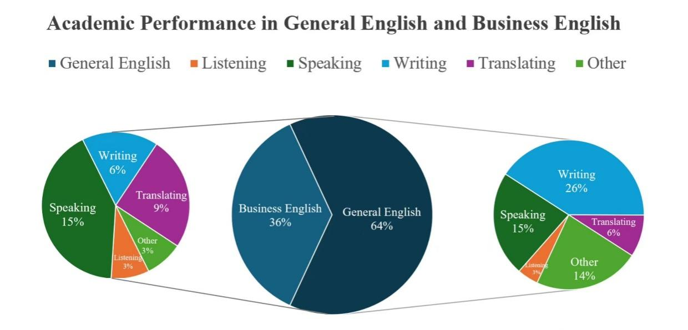

Fig.5 Academic Performance in General English and Business English

The majority of studies concentrated on speaking, with translating being the next most commonly examined area. This trend aligns with the practical and applied nature of business English, where effective communication and accurate translation are essential skills. In the business context, the ability to clearly express and comprehend the needs of both parties is critical for successful negotiations, transactions, and partnerships. Conversely, writing and listening were less frequently emphasized in the research. This could be attributed to the fact that business English typically does not require extensive academic or highly personalized writing. Instead, communication in business often relies on formal, standardized text-based exchanges, which diminishes the focus on writing as a core skill. Furthermore, the formalized nature of business communication, often conducted via written correspondence or structured presentations, reduces the demand for listening skills. Some studies examined multiple language competencies simultaneously (Chen et al., n.d.). At the same time, a small subset focused on designing and evaluating comprehensive language learning systems that integrate various aspects of English proficiency (Xu, 2021). This indicates a growing interest in holistic approaches to business English education, aiming to address learners' broader communicative needs.

In comparison, it became evident that both general and business English exhibited a significant number of studies focused on speaking, while research on listening was considerably less prevalent. This disparity can be closely linked to the specific demands of information technology in language education. Listening skills require relatively fewer technological resources as audio functionalities can effectively assist learners in enhancing their listening abilities through various platforms. In contrast, the area of speaking benefits significantly from technological advancements, particularly for learners lacking access to native speakers or professionals for pronunciation correction. As such, information technology offers valuable tools and applications that can help these learners improve their spoken English.

Furthermore, notable differences emerged in the focus of research within the "Other" category. An analysis of the literature revealed that general English studies paid greater attention to learners' overall learning experiences, while business English research was less comprehensive in this regard. This suggests that the field of business English may benefit from a broader exploration of learners' holistic educational contexts.

Overall, the number of studies focused on general English was nearly double that of business English, indicating a significant disparity in research emphasis between the two fields. This divergence was further reflected in the application of information technology, showcasing distinct priorities. General English predominantly concentrated on writing skills, suggesting a strong emphasis on developing critical thinking and effective communication through written expression. In contrast, Business English exhibited a greater focus on speaking skills, highlighting the importance of verbal communication in professional contexts. This differential application underscores the unique demands of each domain, necessitating tailored approaches to integrate technology effectively into language learning.

**4.3 Comparative Analysis of Different Algorithm Models**

This section answers RQ 3: How do machine learning, deep learning, and ChatGPT contribute to enhancing language learning outcomes in General English and Business English?

This literature review identified machine learning, deep learning, and ChatGPT as the predominant choices among researchers in both General English and Business English. Consequently, a comparative analysis of the applications of these methodologies, along with other algorithms, was undertaken to highlight their effectiveness and impact on enhancing language learning outcomes. By analyzing the diverse applications of these algorithms, the review sought to provide insights into their contributions to the evolving landscape of English language education.

Table 3. Number of Algorithms Used in Different Aspects

|  |  |  |  |  |
| --- | --- | --- | --- | --- |
|  | **Aspect** | **Algorithm** | **Number** | **Paper** |
| General English | Listening | Other | 1 | (Hu, 2021) |
| Speaking | Machine Learning | 2 | (Darwin et al., 2024),  (Yu et al., 2022) |
| Deep Learning | 2 | (Ghio, 2024),  (Luo, 2022) |
| ChatGPT | 2 | (Ghio, 2024),  (Drajati et al., 2023) |
| Writing | Machine Learning | 4 | (Wiwanitkit, 2024),  (Taskiran and Goksel, 2022), (Nazari et al., 2021),  (Darwin et al., 2024) |
| Deep Learning | 2 | (Liu, 2023),  (Nugroho et al., 2024) |
| ChatGPT | 4 | (Nugroho et al., 2024),  (Drajati et al., 2023),  (Peres, 2024),  (Song and Song, 2023) |
| Translating | Deep Learning | 2 | (Sel and Hanbay, 2022),  (Wang, 2023) |
| Business English | Listening | Other | 1 | (Dhivya et al., 2023) |
| Speaking | Machine Learning | 1 | (Xu and Xiao, 2022) |
| Deep Learning | 3 | (Xu, 2021), (Duan, 2022)  (Yang and Qi, 2022) |
| Other | 2 | (Xu, 2021),  (Dhivya et al., 2023) |
| Writing | Deep Learning | 2 | (Zenni and Andrew, 2023),  (Zhu, 2021) |
| Translating | Machine Learning | 1 | (Zheng, 2022) |
| Deep Learning | 2 | (Xu, 2021),  (Zheng, 2022) |
| Other | 1 | (Hu and Wu, n.d.) |

As illustrated in Table 3, a range of algorithms was utilized for listening in both general English and business English studies, including Particle Swarm Optimization (PSO) (Hu, 2021). In the speaking domain, machine learning and deep learning exhibited extensive applications. While General English incorporated ChatGPT to enhance the effectiveness of interviews and communication outcomes (Drajati et al., 2023), Business English leveraged edge computing algorithms to improve speech recognition capabilities significantly. In terms of writing, all three algorithm categories were employed. However, only deep learning algorithms were used in Business English to detect topic deviations in essays, assisting learners in producing higher-quality academic papers (Zenni and Andrew, 2023).

Notably, the studies reviewed did not utilize ChatGPT for translation where deep learning algorithms emerged as the most frequently applied method. The Backpropagation Neural Network (BPNN) algorithm was the most frequently utilized deep learning model. In the study conducted by Liu et al., (n.d.) the BPNN algorithm was employed to design a syntactic analysis model aimed at improving learners' grammatical proficiency in writing (Liu et al., n.d.). Similarly, Liu et al. (n.d.) developed a self-directed learning system for business English that incorporated the BP neural network model to facilitate online learning, thereby enhancing the educational experience for users (Liu et al., n.d.).

This SLR examined a total of six machine-learning algorithms, as depicted in Figure 6. Among these, Natural Language Processing (NLP) was identified as the most frequently utilized algorithm, particularly within the writing domain, where it played a crucial role in enhancing learners' critical thinking skills (Darwin et al., 2024). Signal processing and decision tree algorithms each constituted 20% of the total usage, demonstrating significant contributions to the overall design and evaluation of educational systems. Conversely, other algorithms were employed less often; for instance, the RankNet model found specific applications in speaking recognition tasks (Nugroho et al., 2024).

Fig.6- The Use of Different Algorithms in Machine Learning

A comparative analysis revealed that business English did not incorporate ChatGPT in the domains of listening, speaking, writing, or translating. This lack of usage can be attributed to the specialized nature of business English, which requires an in-depth understanding of specific grammatical structures and vocabulary that ChatGPT may not sufficiently cover. In contrast, general English saw a more frequent application of ChatGPT, particularly in writing and speaking tasks. For example, Nugroho et al. (2024) found that students utilized ChatGPT for translation, enhancing writing accuracy and efficiency while also expressing concerns about potential inaccuracies and academic dishonesty (Nugroho et al., 2024). Consequently, learners are encouraged to regard AI tools like ChatGPT as supplementary resources rather than complete solutions for their language learning needs.

In summary, the applications of machine learning, deep learning, and ChatGPT exhibit significant differences between general English and business English. Notably, ChatGPT was not utilized in business English learning, reflecting the specialized requirements of this domain. Furthermore, while machine learning and deep learning technologies were employed in various capacities, their application in listening skills was present in both general and business English, indicating a commonality in the necessity for effective auditory comprehension across different contexts. This disparity highlights the distinct educational priorities and technological integration strategies that characterize each area of English language learning.

1. **CONCLUSION AND RECOMMENDATION**

To explore the integration of information technology in General English and Business English, a systematic literature review was conducted. The findings indicate that the majority of the studies reviewed were published in 2022 and 2023, reflecting the burgeoning interest following the advent of ChatGPT. Moreover, a comprehensive analysis was conducted on various aspects of English learning, including listening, speaking, writing, translating, and other areas. It was observed that information technology is least utilized in listening. In contrast, in speaking, writing, and translating, there is considerable and effective integration of deep learning, machine learning, ChatGPT, and other algorithms. In other areas, researchers have analyzed the relationship between overall learning efficiency, learning status, and accuracy rates, discovering that accuracy decreases when learners are in a low emotional state. Comparative analysis among different nationalities and identities revealed that Chinese researchers exhibit the highest level of interest, with Asian researchers accounting for over 90%. The primary target audience selected is general learners; Business English, due to its specialized nature, often targets learners and researchers. In contrast, General English, with its universal applicability, encompasses a diverse range of target populations.

**5.1 Contribution**

This comprehensive review provides researchers and educators with an enhanced understanding of the current integration of information technology within the domains of General English and Business English. It specifically highlighted algorithms deemed most effective for applications in listening, speaking, writing, and translating. The synthesis of findings elucidated the efficacy of various technological interventions, revealing critical insights into optimal pedagogical strategies for language learning and instruction in the digital age. By systematically analyzing diverse applications of information technologies, the review underscored the transformative potential of algorithms in enhancing educational outcomes. Moreover, it contributed to the ongoing discourse on best practices in language instruction, emphasizing the necessity for adaptive and innovative teaching methods that effectively leverage technology to address the evolving demands of learners. This multifaceted approach aimed not only to enhance language proficiency but also to prepare learners for an increasingly interconnected world.

**5.2 Limitation**

This review encompassed publications from 2021 to 2024, revealing certain limitations in its scope that may have resulted in incomplete insights. Future research should prioritize enhancing the accuracy and comprehensiveness of deep learning and machine learning algorithms within the General English domain, as well as innovating models tailored to diverse language learning characteristics. Furthermore, it is imperative to address and reduce the academic inaccuracies associated with ChatGPT, thereby enhancing its credibility in academic contexts and establishing relevant regulations to mitigate researchers' over-reliance on this technology. In the realm of Business English, increasing the computational power and algorithmic capabilities of ChatGPT to acquire more specialized terminology would facilitate a more efficient and effective language learning experience for professionals. Additionally, it is essential to encourage greater participation from non-native speakers in this research area, fostering a collaborative effort to advance innovative educational approaches and contribute to a more inclusive understanding of language learning dynamics.

**Acknowledgment**

This work was supported in part by the Shanghai Municipal Key Course Project in Higher Education (AI+ Course) under Grant A020201.24.608, in part by the Sanda University Innovation and Entrepreneurship Training Program under Grant s202411833019.

**REFERENCES**

Chen, Z., Lian, Y., & Lin, Z. (n.d.). *Research on business English autonomous learning based on artiﬁcial intelligence and improved BP network model*.

Darwin, Rusdin, D., Mukminatien, N., Suryati, N., Laksmi, E. D., & Marzuki. (2024). Critical thinking in the AI era: An exploration of EFL students’ perceptions, benefits, and limitations. *Cogent Education*, *11*(1), 2290342. https://doi.org/10.1080/2331186X.2023.2290342

Dhivya, D. S., Hariharasudan, A., Ragmoun, W., & Alfalih, A. A. (2023). ELSA as an Education 4.0 Tool for Learning Business English Communication. *Sustainability*, *15*(4), 3809. https://doi.org/10.3390/su15043809

Drajati, N. A., Rochsantiningsih, D., & Agung, S. (2023). Intertextuality in Pre-service Teachers’ Argumentative Essay in Raising AI: Practices and Beliefs. *REGISTER JOURNAL*, *16*(2).

Duan, W. (2022). Research on Scoring of Business English Oral Training Based on Deep Neural Network. *Scientific Programming*, *2022*, 1–8. https://doi.org/10.1155/2022/9193454

Ghio, A. (2024). Democratizing academic research with Artificial Intelligence: The misleading case of language. *Critical Perspectives on Accounting*, *98*, 102687. https://doi.org/10.1016/j.cpa.2023.102687

Hou, R. (2022). Application of Decision Tree Algorithm Based on Data Mining in English Teaching Evaluation. *Wireless Communications and Mobile Computing*, *2022*, 1–10. https://doi.org/10.1155/2022/5717895

Hu, B. (2021). English Listening Teaching Model in Flipped Classroom Based on Artificial Intelligence Fusion Control Algorithm. *Mathematical Problems in Engineering*, *2021*, 1–14. https://doi.org/10.1155/2021/6005359

Hu, R., & Wu, K. (n.d.). *Edge computing and 5G based low‐delay business English translation framework*.

Liu, L. (n.d.). *Classification of English Educational Resources Information Based on Mobile Learning Using Cognitive Web Service*. *19*(2).

Liu, Q. (2023). Text Complexity Analysis of Chinese and foreign academic English writing via mobile devices based on neural network and deep learning. *Library Hi Tech*, *41*(5), 1317–1332. https://doi.org/10.1108/LHT-11-2021-0383

Luo, X. (2022). Practice of Artificial Intelligence and Virtual Reality Technology in College English Dialogue Scene Simulation. *Wireless Communications and Mobile Computing*, *2022*, 1–9. https://doi.org/10.1155/2022/4922675

Nazari, N., Shabbir, M. S., & Setiawan, R. (2021). Application of Artificial Intelligence powered digital writing assistant in higher education: Randomized controlled trial. *Heliyon*, *7*(5), e07014. https://doi.org/10.1016/j.heliyon.2021.e07014

Nugroho, A., Andriyanti, E., Widodo, P., & Mutiaraningrum, I. (2024). Students’ appraisals post-ChatGPT use: Students’ narrative after using ChatGPT for writing. *Innovations in Education and Teaching International*, 1–13. https://doi.org/10.1080/14703297.2024.2319184

Peres, F. (2024). Health literacy in ChatGPT: Exploring the potential of the use of artificial intelligence to produce academic text. *Ciência & Saúde Coletiva*, *29*(1), e02412023. https://doi.org/10.1590/1413-81232024291.02412023en

Sel, İ., & Hanbay, D. (2022). *Fully Attentional Network for Low-Resource Academic Machine Translation and Post Editing*.

Song, C., & Song, Y. (2023). Enhancing academic writing skills and motivation: Assessing the efficacy of ChatGPT in AI-assisted language learning for EFL students. *Frontiers in Psychology*, *14*, 1260843. https://doi.org/10.3389/fpsyg.2023.1260843

Tang, J. (2023). Artificial intelligence-based needs analysis for english specific purposes in digital environment. *Learning and Motivation*, *83*, 101914. https://doi.org/10.1016/j.lmot.2023.101914

Taskiran, A., & Goksel, N. (2022). AUTOMATED FEEDBACK AND TEACHER FEEDBACK: WRITING ACHIEVEMENT IN LEARNING ENGLISH AS A FOREIGN LANGUAGE AT A DISTANCE. *Turkish Online Journal of Distance Education*, *23*(2), 120–139. https://doi.org/10.17718/tojde.1096260

Wang, R. (2023). RETRACTED ARTICLE: Research on effectiveness of college english blended teaching mode under small private online course based on machine learning. *SN Applied Sciences*, *5*(2), 55. https://doi.org/10.1007/s42452-023-05278-y

Wang, Y. (2023). Artificial Intelligence Technologies in College English Translation Teaching. *Journal of Psycholinguistic Research*, *52*(5), 1525–1544. https://doi.org/10.1007/s10936-023-09960-5

Wiwanitkit, S., & Wiwanitkit, V. (2024). Correspondence on ‘Is ChatGPT a “Fire of Prometheus” for Non-Native English-Speaking Researchers in Academic Writing?’ *Korean Journal of Radiology*, *25*(1), 120. https://doi.org/10.3348/kjr.2023.0971

Wu, M., Subramaniam, G., Zhu, D., Li, C., Ding, H., & Zhang, Y. (2024). Using Machine Learning-based Algorithms to Predict Academic Performance—A Systematic Literature Review. *2024 4th International Conference on Innovative Practices in Technology and Management (ICIPTM), 1–8.* https://doi.org/10.1109/ICIPTM59628.2024.10563566

Xu, X., & Xiao, K. (2022). Oral Business English Recognition Method Based on RankNet Model and Endpoint Detection Algorithm. *Journal of Sensors*, *2022*, 1–13. https://doi.org/10.1155/2022/7426303

Xu, Y. (2021). Research on Business English Translation Architecture Based on Artificial Intelligence Speech Recognition and Edge Computing. *Wireless Communications and Mobile Computing*, *2021*(1), 5518868. https://doi.org/10.1155/2021/5518868

Yang, Q. (2022). Analysis of English Cultural Teaching Model Based on Machine Learning. *Computational Intelligence and Neuroscience*, *2022*, 1–9. https://doi.org/10.1155/2022/7126758

Yang, X., & Qi, S. (2022). Interactive Design of Business English Learning Resources Based on EDIPT Multimodal Model. *Computational Intelligence and Neuroscience*, *2022*, 1–9. https://doi.org/10.1155/2022/1264847

Yu, Y., Han, L., Du, X., & Yu, J. (2022). An Oral English Evaluation Model Using Artificial Intelligence Method. *Mobile Information Systems*, *2022*, 1–8. https://doi.org/10.1155/2022/3998886

Zenni, R. D., & Andrew, N. R. (2023). Artificial Intelligence text generators for overcoming language barriers in ecological research communication. *Austral Ecology*, *48*(7), 1225–1229. https://doi.org/10.1111/aec.13417

Zhao, B. (2022). A Design Model of English Auxiliary Teaching System Using Artificial Neural Networks. *Mobile Information Systems*, *2022*, 1–11. https://doi.org/10.1155/2022/8694532

Zheng, P. (2022). Multisensor Feature Fusion-Based Model for Business English Translation. *Scientific Programming*, *2022*, 1–10. https://doi.org/10.1155/2022/3102337

Zheng, Z., & Na, K. S. (2021). A Data-Driven Emotion Model for English Learners Based on Machine Learning. *International Journal of Emerging Technologies in Learning (iJET)*, *16*(08), 34. https://doi.org/10.3991/ijet.v16i08.22127

Zhu, Y. (2021). Off-Topic Detection of Business English Essay Based on Deep Learning Model. *Mobile Information Systems*, *2021*, 1–9. https://doi.org/10.1155/2021/5051667