**Nursing Students’ Perceptions on Professional Identity for Nursing Health Education Course**

Wang Siyun12, Haliza Binti Idris2, Xie Ru3

*1 School of Nursing, Sichuan College of Traditional Chinese Medicine, Mianyang, Sichuan, China*

*2 Faculty of Education, Languages, Psychology & Music, SEGi University, SEGi University, Kota Damansara, Petaling Jaya, Selangor*

*3 School of Nursing, The First Affiliated Hospital of Jinan University, Guangzhou, Guangdong, China*

**ABSTRACT**

Following the change in human lifestyle and behavior, the disease spectrum has changed. Systematic health education activities have gained more attention and recognition. In China, for the last decade, colleges and universities have paid more attention to the importance of health education courses in nursing science. As a humanities-based nursing course, students' professional nursing values are a key consideration in course design and teaching practice. However, it remains unclear whether this course impacts students' professional identity and which aspects of professional identity are influenced. This study analyzes nursing students' professional identity following the Nursing Health Education course and discusses the necessity of implementing this course in nursing education. From December 2021 to February 2022, data were collected using the Chinese Version of the Nurses’ Career Identity Scale (NCIS). A total of 582 nursing students who participated in the course were surveyed at a vocational college, and 24 students were individually interviewed. For data analysis, we used the SPSS 26.0 software package and employed content analysis. Based on the analysis and results, the study highlights that professional education is a crucial stage in the formation of nursing students’ professional identity. The Nursing Health Education course contributes to fostering a positive professional identity among nursing students. Nursing faculty should act as role models and support students in clarifying their personal and professional values.

**Keywords:** Professional identity, Health Education, Nursing course, Nursing students, humanity course, vocational education

# 1. INTRODUCTION

## 1.1 Background

Since World War II, with the improvement in behavioral science, health education has developed rapidly. Systematic health education activities have gained more attention. Nurses, as an important part of the health service system, should play a pivotal role in the system. Health education for nurses garnered attention in the 1980s (Syred, 1981). Consequently, more developed countries introduced health education into the nursing discipline, with Hong Kong, Taiwan, the United States, and Canada at the forefront (Bastable, 1998). These countries have health education courses in medical schools and made them compulsory for public health and nursing students.

According to the seventh national census, China has a large population of 1.443 billion people (National Bureau of Statistics, 2021). With the rapid development of China’s economy and the substantial improvement of living standards, the demand for health services is increasing. Health needs are moving from the treatment of diseases to comprehensive health. In July 2019, the Healthy China Action (2019–2030), as a national policy, was issued by the National Health Commission of the People's Republic of China (National Healthy Action Promotion Committee, 2019). This issue detailed the planning of the health work in the next decade, guiding health-related areas, with health education of nurses becoming one of the core competencies. The issue will broaden the nursing profession and trigger an important revolution in nursing teaching courses and teaching content in China.

With changes in health policies and the evolving trends in nursing science, health promotion and disease prevention have become new focal areas in nursing practice. However, in China, school education has long emphasized disease education, primarily focusing on the diagnosis and treatment of illnesses. Therefore, prevention-related courses are scarce, prompting nursing students to consider their role as helping doctors to cure diseases rather than promoting health. They also regard the important work of nurses merely as operational skills in a hospital. This deficiency of prevention-related courses may affect the formation of the professional self-concept of nursing students; other studies suggest that this is the most important factor affecting the level of professional identity (Gao, 2012). Many nursing students believe that nurses do not have decision-making rights and initiative in clinical practice because they do not have prescription rights and are not independent (Ding et al., 2007). If nurses' work is solely viewed as subordinate to doctors, their value becomes limited. Consequently, they may lack the enthusiasm to learn and the professional identity necessary for the discipline.

Enhancing professional identity and understanding the true essence of nursing will empower nursing students to serve more people effectively in practice. China is placing increasing emphasis on professional identity in nursing education. This study was conducted to explore the impact of the course on students' professional identity and learning values, with the aim of improving the course further.

## 1.2 Research problem and research gap

Professional identity is one of the key contributions of nursing humanities courses and serves as a core value in nursing education. Empirical research has demonstrated that humanities courses can enhance the professional identity of diploma students (Lan et al., 2022). However, the impact of nursing health education, as a new course in China, on nursing students' professional identity has not yet been confirmed by studies. This research aims to explore the value of the course in fostering students' professional identity.

## 1.3 Research questions

RQ1: What is the student's Nurse’s Career Identity Scale (NCIS) score after completing the course?

RQ2: How does a nursing health education course affect the development of professional identity among nursing students?

# 2. LITERATURE REVIEW

Professional identity, which originated from ego identity, is an essential concept in psychology. In the nursing field, professional identity includes skills and functions; knowledge, values, and ethics; personal identity; group identity; and the influence of the context of care (Fitzgerald, 2020). Some scholars consider that it should also encompass self-efficacy, professional values, self-determination, professional identification, and grasp of the role, among other aspects (Yukie & Katsuya, 2006). They developed the Nurse’s Professional Identity Scale based on these concepts. Regardless of the conceptual definition and components, it is fundamentally about nursing values. Previous research has proven that professional identity plays an important role in an individual’s career development (Gao et al., 2011). In nursing, professional identity refers to an affection for nursing and the perception of the value of nursing work. Recently, improving professional identity has been regarded as a critical strategy to stabilize the nursing workforce because it helps increase nurses’ retention rates (Cowin et al., 2008; Deppoliti, 2008) and improve the quality of care (Hensel & Laux, 2014; Jahanbin et al., 2012). Conversely, a lack of professional identity may discourage nursing students from choosing nursing as a lifelong career. This deficiency can also cause job burnout, high turnover rates, and impact the stability of nursing teams (Chen et al., 2015). Johnson et al. (2012) indicated that the formation of professional identity begins before nursing education and develops throughout a nurse’s career. Professional values should be promoted and sustained from the student phase to the professional nurse phase over time (Bijani et al., 2019). Previous research has suggested that integrating educational interventions into courses to assist and engage students in professional identity development is effective (Kay et al., 2019). Therefore, it is necessary to establish identity formation as an educational objective (Cruess et al., 2019). This is why nursing educators should prioritize professional identity in course design.

Nursing health education is a discipline that combines nursing science and health education. It aims to promote healthier lifestyles and living environments by improving various health aspects, helping people establish healthy behaviors, and elevating overall health levels. Nurses working in clinics and communities are the closest healthcare staff to patients; therefore, they are uniquely positioned to help patients adopt healthy behaviors. Owing to its interprofessional nature and inclusion of multiple disciplines, teaching and learning in this field pose challenges for both teachers and students. On the one hand, it demands advanced skills and competencies from nurses; on the other hand, it requires redefining the nurse's role within healthcare and healthcare work. This may alter nurses' perceptions of their profession. Although the course is beneficial for nursing professional competency, only a few nursing schools offer it. This is largely due to the lack of frameworks for teaching materials, syllabi, and curriculum design in China (Dai & Tian, 2016). While most clinical nurses recognize their role as health education providers, they often lack the necessary professional knowledge (Yu & Liu, 2017). As a nursing humanities course, this program should simultaneously improve students' skill competencies and enhance their understanding of humanities. In other words, the humanities component may be more critical than competency in the course's overall contribution. Professional identity is one of the key elements of nursing humanities, making it a primary focus for nursing educators. However, most nursing courses in China prioritize skill competencies over humanities. Within the course, researchers and educators discuss various teaching approaches and levels of satisfaction, such as service-learning patterns (Tang, 2003), participatory teaching methods (Chen et al., 2010), reflective learning, group discussions (Mo et al., 2011), anchor teaching methods (Qiao & Wu, 2017), and experiential teaching methods (Geng et al., 2018). However, research on professional identity within the context of this course remains lacking.

This research focuses on describing nursing students’ professional identity within the course and exploring how the course affects their professional identity, as well as identifying the key factors in professional identity formation. The findings aim to assist nursing teachers in designing and implementing the new course effectively.

# 3. RESEARCH METHODOLOGY

## 3.1 Design and Participants

A quantitative and qualitative approach was used in this study. The criteria for selecting the sample were as follows: 1) participants must have completed the course, including all teaching content and assignments; 2) participants must be nursing or midwifery majors; and 3) participants must be at the vocational education level. In the final class, we sent a link to the questionnaire to all participants and explained the objectives of the study. Participants provided their consent to participate, and we assured them of the confidentiality of their personal information. Additionally, we conducted semi-structured interviews individually with 24 volunteers, ensuring a private interview environment. Each participant was unaware of the interviews conducted with others.

## 3.2 Instruments

We used the Nurse’s Career Identity Scale (NCIS), a 21-item scale developed by the Department of Nursing, University of Tokyo. The instrument is widely used in Japan, Sweden, and other countries. The Japanese version of the NCIS was translated into Chinese by Zhao (Zhao et al., 2010). The scale encompasses seven dimensions: self-efficacy, career value, grasp of the role, self-determination, professional identification, influence on the organization, and influence on patients. Each item was rated on a 7-point Likert scale, ranging from 1 (totally disagree) to 7 (entirely agree). Total scale scores range from 21 to 147, with higher scores indicating stronger professional identity. The Cronbach's alpha value for the overall scale was found to be .84, while for the subscales, it ranged from .69 to .84. The content validity of the scale was reported as .92.

In semi-structured interviews, we asked the following questions:

(a) After finishing the course, what do you think is the meaning of nursing work? Please talk about it.

(b) What have you learned about the nurse’s role through this course? Do you now understand the responsibilities of a nurse?

(c) After completing this course, what changes do you notice in

yourself, such as in your knowledge and values?

## 3.3 Ethical aspects

The study was approved by the IRB of the First Affiliated Hospital of Jinan University (approval No. KY-2021-072). Participants consented to participate in the study, and we assured them of the confidentiality of their personal information. Before the interview, the purpose of the study, voluntary participation, and confidentiality were explained to the participants. All participants provided informed consent to be audio recorded after being informed of their rights to confidentiality, anonymity, and voluntary participation.

## 3.4 Data collection

We collected data from December 2021 to February 2022. To ensure the response rate, we displayed the QR code of the questionnaire at the end of the NHEHP course. A total of 582 responses were collected, resulting in 565 valid questionnaires of NCIS.

## 3.5 Data analysis

To analyze the data, we used SPSS 26.0 software. All quantitative data were calculated as means and presented as M±SDM \pm SD. A t-test was used to analyze grade differences, with P<0.05P < 0.05 considered significant. The interviews were recorded and transcribed verbatim. Two researchers (Researcher 1 and Researcher 2) familiarized themselves with the data and generated main themes from students' responses using mind-mapping for induction and integration, ultimately forming topics and sub-topics. The data were then interpreted and revised by other researchers and students who participated in the interviews.

# 4. RESULTS

## 4.1 Quantitative findings

A total of 565 nursing students responded to the NCIS survey. Table 1 presents the demographic characteristics of the participants. The average age of the participants was 18.68 years, ranging between 17 and 27 years. Most participants were female (n=511n=511, 90.4%). Among them, 79 (14%) were in their first grade, and 486 (86%) were in their fourth grade. Due to the extremely uneven ratio of gender and age, no significant differences were found between these two variables. Bivariate analysis showed no significant correlations between the NCIS scale and grade.

Table 2 shows that the mean value for the NCIS was 103.10 (n=565, SD=16.23). Further, professional value (M=5.04, SD=0.89) and self-concept (M=5.14, SD=0.92) ranked high.

**Table 1 Correlation between NCIS and participants’ characteristics**

|  |  |  |  |  |
| --- | --- | --- | --- | --- |
| **Demographics** | N (%) | NCIS (M±SD) | *t*-test/F-test | *P* value |
| **Age(years)** |  |  |  |  |
| <18 | 10 | 105.50±7.76 |  |  |
| 18–27 | 555 | 103.05±16.34 |  |  |
| **Gender** |  |  |  |  |
| Male | 54 | 108.07±19.40 |  |  |
| Female | 511 | 102.57±15.79 |  |  |
| **Grade** |  |  | -0.383 | 0.702 |
| Year 1 | 79 | 103.75±18.52 |  |  |
| Year 4 | 486 | 102.99±15.84 |  |  |

NCIS=Nurse’s Career Identity Scale，M=mean, SD = standard deviation

**Table 2 Descriptive statistical measures of the NCIS factors**

|  |  |  |  |  |  |
| --- | --- | --- | --- | --- | --- |
| **NCIS** | **Ranking** | **M(n)** | **SD** | **Theoretical score range** | **Average scoring rate (%)** |
| self-efficacy | 5 | 4.94(3) | 0.98 | 1–7 | 70.57% |
| professional value | 2 | 5.04(3) | 0.89 | 1–7 | 72.00% |
| self-determination | 7 | 4.65(3) | 1.01 | 1–7 | 66.43% |
| professional identification | 3 | 5.02(4) | 0.98 | 1–7 | 71.71% |
| grasp of the role | 1 | 5.14(3) | 0.92 | 1-7 | 73.43% |
| influence on the organization | 6 | 4.40(2) | 1.05 | 1-7 | 62.86% |
| influence on the patients | 4 | 4.99(3) | 1.06 | 1-7 | 71.29% |
| Total |  | 103.10 | 16.23 | 21–147 | 70.14% |

NCIS=Nurse’s Career Identity Scale, M=mean, n=number of entries,

SD = standard deviation.

## 4.2 Qualitative findings

Table 3 lists the general information of the interview volunteer: 3 male and 21 female students participated, aged between 18 and 21 years.

**Table 3 General information of the interview volunteer**

|  |  |  |  |  |  |
| --- | --- | --- | --- | --- | --- |
| Number | Educational background | Age | Gender | Grade | Area |
| No. 1 | Vocational education | 19 | Female | Year 4 | Nursing |
| No. 2 | Vocational education | 18 | Female | Year 4 | Nursing |
| No. 3 | Vocational education | 19 | Female | Year 4 | Nursing |
| No. 4 | Vocational education | 19 | Male | Year 4 | Nursing |
| No. 5 | Vocational education | 18 | Male | Year 4 | Nursing |
| No. 6 | Vocational education | 18 | Female | Year 4 | Nursing |
| No. 7 | Vocational education | 18 | Female | Year 4 | Nursing |
| No. 8 | Diploma | 19 | Female | Year 1 | Midwife |
| No. 9 | Vocational education | 19 | Female | Year 4 | Nursing |
| No. 10 | Vocational education | 18 | Female | Year 4 | Nursing |
| No. 11 | Vocational education | 21 | Female | Year 4 | Nursing |
| No. 12 | Vocational education | 18 | Female | Year 4 | Nursing |
| No. 13 | Vocational education | 18 | Female | Year 4 | Nursing |
| No. 14 | Vocational education | 19 | Male | Year 4 | Nursing |
| No. 15 | Vocational education | 18 | Female | Year 4 | Nursing |
| No. 16 | Vocational education | 18 | Female | Year 4 | Nursing |
| No. 17 | Diploma | 19 | Female | Year 1 | Midwife |
| No. 18 | Diploma | 19 | Female | Year 1 | Midwife |
| No. 19 | Diploma | 20 | Female | Year 1 | Midwife |
| No. 20 | Diploma | 20 | Female | Year 1 | Midwife |
| No. 21 | Diploma | 19 | Female | Year 1 | Midwife |
| No. 22 | Diploma | 19 | Female | Year 1 | Midwife |
| No. 23 | Vocational education | 18 | Female | Year 4 | Nursing |
| No. 24 | Vocational education | 19 | Female | Year 4 | Nursing |

The diploma is a 3-year program; Vocational education is a 5-year program.

We used Colaizzi's 7-step method in phenomenology as the coding strategy, extracting three themes containing nine viewpoints.

### 4.2.1 New understanding of nursing work after learning the course

*Viewpoint 1: The importance of nursing work is no longer limited to following the doctors.*

“When I am an intern at community hospitals, I repeat the same dull work, such as taking blood pressure and filling a prescription; it’s so boring. But for now, I know there are various things I can do, such as health education.” (Student No. 9)

“I used to feel that the midwife was a mother, just giving birth to the child, not taking care of the mother’s mood and needs. Since I learned this course, I knew midwives have much more work, and this work is very meaningful.” (Student No.20)

*Viewpoint 2: After recognizing the role of a nurse, students have new perspectives about nurses.*

“I love to teach others. It can bring me confidence when I go on the platform (to give science popularisation education) ... I used to dislike nursing, but now I don’t. ” (Student No.11)

“It provides an entirely new understanding (with the nurse); (nursing) is complex and tiring but sacred. ” (Student No.17)

“I once thought that (besides nursing knowledge) nothing was important at all for me, but while taking this course, I found there are a lot of things I need to learn. ” (student No.18)

“I feel that I need to learn more... It will be a long process, and I have so much to learn in the process.” (Student No.19)

*Viewpoint 3: There is a new understanding of the essence of nurse work.*

“I used to hold the one-sided view that nursing is only about the nursing technical operation. However, after finishing this course, I find that communication with patients can also help patients a lot.” (Student No.16)

“As a medical staff, health education is an indispensable part of our work, which might improve patients’ trust. This course could help me devote myself to nursing.” (Student No.24)

“I thought working in a big hospital was guarding the ICU or the emergency department every day. But after taking this course, I recognized that nurse work should be more than that; it is not only technology and operation.” (Student No. 5)

### 4.2.2 Evaluation and Experience of the Course

*Viewpoint 1: NHEHP course is ‘useful.'*

“... how to make them know more about healthy living habits and healthy diet, which can help them prevent the disease.” (Student No.1)

“... now I can answer others’ questions about health... that was very useful in life, and they said I finally worked after learning nursing for so many years.” (Student No.11)

*Viewpoint 2: The NHEHP course is an essential part of nursing.*

“I take for granted that health education simply goes through the motions, whether the patients understand it or not...Health education is our job responsibility. Without this course, I wouldn’t know the importance and complexity of health education.” (Student No.2)

“After completing this course, I realized the importance of health education for the nursing profession. By studying this course, we can know how to carry out health education in detail.” (Student No.4)

*Viewpoint 3: This course provides methodological guidance on how to apply knowledge rather than simply absorbing it.*

“In my opinion, other classes repeat what the book says, which is very boring and rigid knowledge. In this class, I feel that I can gain more knowledge, and it is more practical.” (Student No.20)

“This course is close to life. In college, it is best to put what you learn to use.” (Student No.19)

*Viewpoint 4: This course is interesting and provides real-life examples.*

“Those examples in lessons are more vivid and real, and let us transfer our thoughts more quickly.” (Student No. 3)

“I think boring or not is mainly due to the teacher, if you take examples from your own life experiences, it’s the best way.” (Student No. 4)

### 4.2.3 Review of the teacher

*Viewpoint 1: The teacher was impressive and interesting.*

“I feel good humor in class; it’s very attractive; the class and atmosphere are also good.” (Student No. 20)

“I like the teacher’s class, especially because she speaks more vividly and reflects the patient’s psychological diversification through her own experience (smile) and then combines something in the textbook. The teacher is also more flexible and humorous.” (Student No. 4)

“I think the teacher is very suitable for health education. During the lecture, she spoke very well.” (Student No. 5)

*Viewpoint 2: The teacher used other methods to help us understand this course*

“She does not like to use such technical terms, but with the young people’s idiom, we can understand what she says.” (Student No. 7)

“The teacher’s spoken style is special and is very distinctive from someone else, and we have a very deep impression.” (Student No. 11)

## 5. DISCUSSION

The professional identity scores of nursing students in this study are at a medium level. Meanwhile, the qualitative findings can explain how this course affects the students’ professional identity and why they appreciated it.

### **5.1 Understanding the nurse's role and responsibility should be considered in course content**

The highest dimension score of NCIS indicates a greater understanding of the roles and responsibilities of nurses, suggesting that the course content and teaching design should focus on how students comprehend and agree with the nurse’s role and responsibilities. Understanding responsibility and accountability is a key element in forming professional identity (Rhodes et al., 2012), and the development of these attributes is largely associated with classroom learning (Simmonds et al., 2020). Before clinical practice and internships, students often perceive the nurse's role through movies or imagination, which may not provide a clear understanding. Educators should implement workplace simulations or other methods to redefine the nurse’s role and improve professional identity.

### **5.2 This course encourages students to realize the professional value**

Professional values influence nurses’ attitudes and decision-making (Schmidt, 2016). These values form the foundation of a nurse’s professional identity and are an integral part of professional socialization. They guide nurses’ long-term growth and development and are essential for delivering high-quality nursing care.

Some students from medical families have a clear understanding of the nursing profession, while most students lack knowledge about clinical work. Their perception of nurses mainly stems from television or literary works, where the portrayal of nurses significantly differs from reality. Society often views nurses as subordinate to doctors and lacking distinct professional characteristics.

Contrary to medical doctors, whose main purpose is to cure diseases, nurses can play a more significant role in maintaining health and preventing diseases. In China, clinicians mainly focus on developing disease treatment programs and have daily contact with patients for a limited period. Consequently, patients may struggle to fully understand doctors, leading to poor treatment outcomes; this can occasionally result in conflicts between patients and doctors. With the improvement of nursing education, nurses need to do more than just follow orders; they should understand the rationale behind each treatment step. As nurses spend the most time with patients, they can help patients better understand treatment information, thereby improving trust between nurses and patients.

In addition, during the course, some ethnic minority students created hand-painted posters or short videos in their native languages. Through this process, students were able to recognize and discover their talents, which will contribute to their nursing practice in ethnic areas in the future. The works of three ethnic minority students are shown in Figures 1–3.

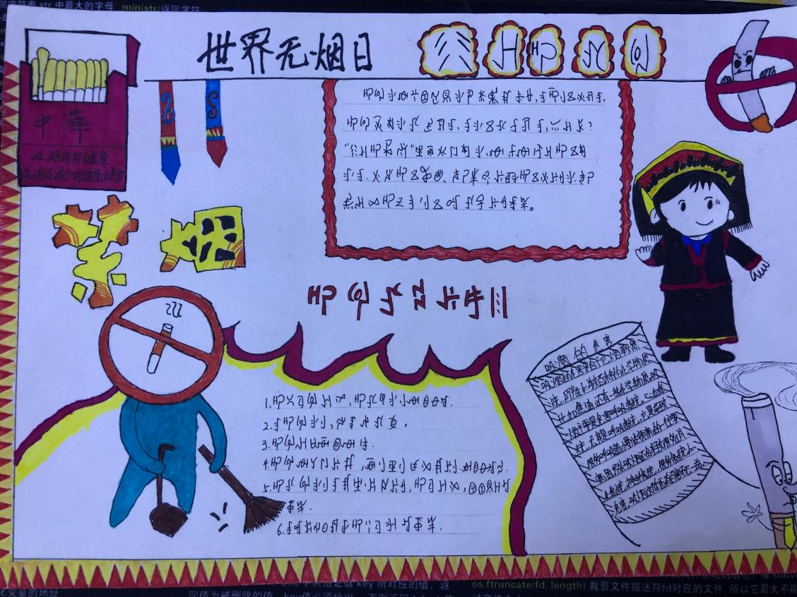

Fig 1. Poster about World No Tobacco Day ( Chinese - Yi）

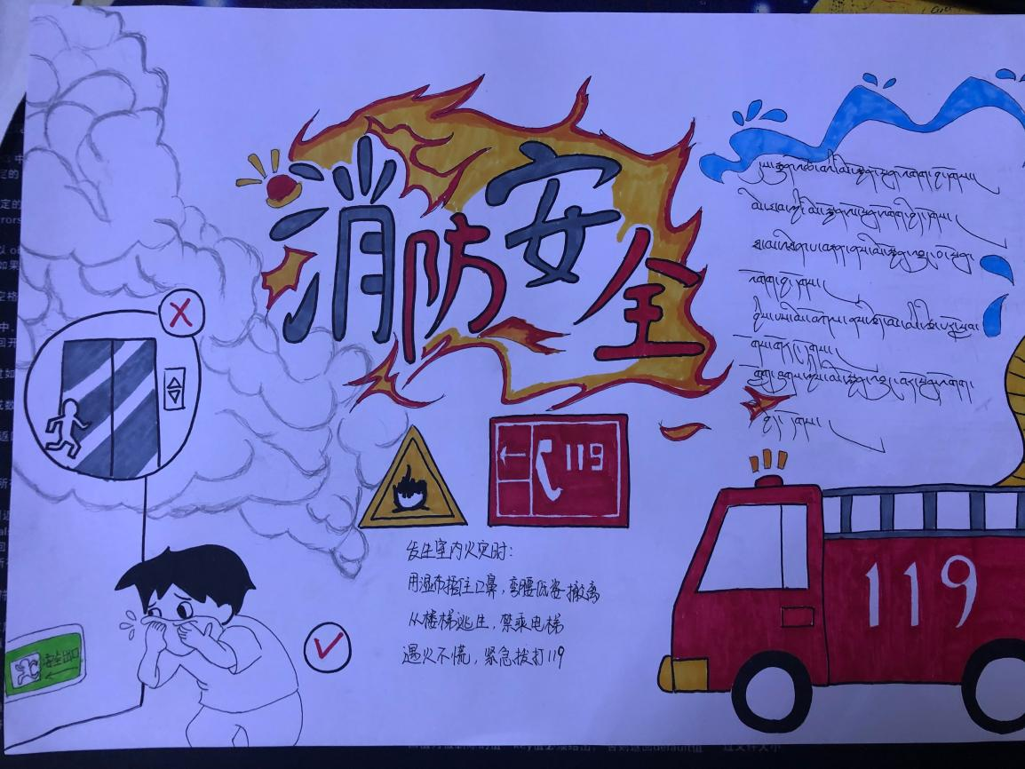

Fig 2. Poster about fire safety (Chinese - Tibetan)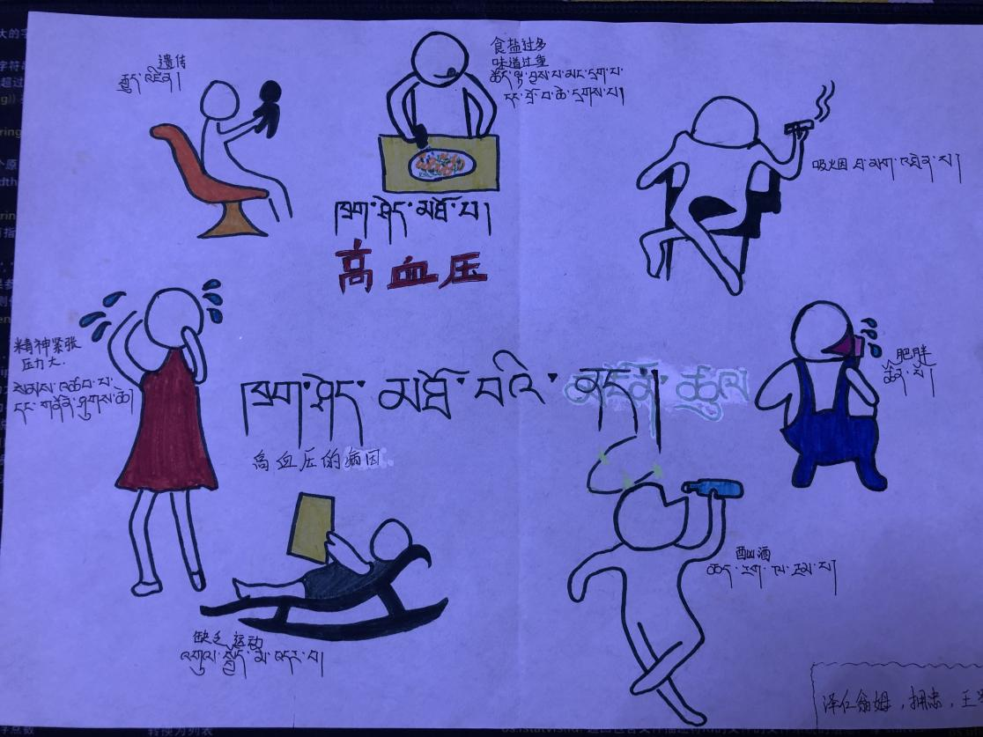

Fig 3. Poster about the cause of hypertension (Chinese-Tibetan)

### **5.3 Recognise the importance of nursing academic education**

With the improvement of nursing education standards, nurses have gained more medical knowledge. However, the clinical work of nurses has not changed significantly. It has been suggested that there is a need to improve nursing academic qualifications. Research indicates that educational background affects the professional identity of nurses. Nurses with a bachelor’s degree or higher tend to have a lower professional identity compared to those with a college degree (Yuan et al., 2018). Nursing students with higher educational backgrounds have greater professional expectations; however, the gap between their expected outcomes and the reality of clinical nursing practice significantly undermines their sense of personal achievement and reduces their professional identity.

Students learned about the application of medical professional knowledge in the classroom through the NHEHP course. As health conditions are related to individual lifestyles and behavioral cognition, this course is designed to enhance student’s ability to use different health education methods by following people’s aptitudes. Nurses need to use various methods of communication and health education as they encounter different people. However, this can be both challenging and creative. Nurses are affirmed by patients through effective health education. Meanwhile, conducting health education requires extensive knowledge of medicine, indicating the necessity of improving the education of nurses and their professionalism.

### **5.4 Improve social recognition of the nursing profession**

The development of a nurse’s professional identity is primarily influenced by their profession’s collective professional identity (Browne et al., 2018). Nowadays, most people still consider nurses as caregivers with a low level of education. They do not recognize nursing as a scientific profession; consequently, they look down on nursing in comparison to medicine.

Many nursing students also aspire to become hospital administrators or support staff rather than clinical nurse specialists because they lack an understanding of professional nursing values. Professional nursing practice is possible if nurses can be aware of their professional values act accordingly (Lyneham & Levettjones, 2016), and represent the profession. In addition to the clinical care of patients, a nurse should apply specialty knowledge and skills to help people. Goodolf and Godfrey (2021) posit that professional identity in nursing, which denotes a sense of oneself and a relationship with others, is influenced by the characteristics, norms, and values of the nursing discipline, resulting in individual thinking, acting, and feeling like a nurse. If nurses contribute positively to others, society may better understand their role in public health.

## 5.5 Teachers’ role model should be the focus of nursing education

The current research on nurses’ career identity in China focuses on their professional identity level and influential factors. Studies have shown that the level of professional identity of clinical nurses is generally low (Shen et al., 2018). Van (2015) found that students in China constructed their professional identity mainly through clinical experience, faculty role models, and the caring culture of their nursing school. It is usually clinical faculty and nurse educators who are the first nursing role models for students. Therefore, the low professional identity of clinical teachers may negatively impact nursing students’ career identity.

Schmidt (2016) found that nursing students’ core professional nursing values began to develop before they started the nursing program. These values may have developed in elementary and secondary schools when participating in daily activities, during family experiences with illness, or through previous experiences in healthcare or other settings. Meanwhile, nursing students’ understanding of the professional nursing role is closely linked to their self-concept (Browne et al., 2018). Individual nursing identity can change with professional activities and responsibilities, ongoing education, and individual experiences and expectations.

In this research, the course instructors, who also serve as developers and designers, demonstrate an understanding of and passion for nursing's professional value. During the class, students presented real clinical cases through role-playing to discuss and reflect on situations involving acceptable and unacceptable behaviors that a nurse might encounter and how to handle such situations. The instructor adopted the perspective of a professional nurse to provide explicit guidance, helping students recognize professional values and facilitating the development of their professional identity.

As students mentioned,

...this course serves as a kind of career enlightenment (Student No.20)

I didn’t like nursing before, but now I quite like it. (Student No.11)

In a study on the effect of medical students' clinical practice on their professional identity (Helmich, 2010), participants attributed poor interpersonal relationships, negligence in respecting patient privacy, and weaknesses in accepting professional responsibilities and providing altruistic care to negative role models. We believe that the primary requirements for becoming a nursing teacher include a master’s or doctoral degree or sufficient clinical experience. However, we suggest that professional identity and passion should be given greater importance. Therefore, education authorities and clinical managers should consider incorporating professional identity as a key criterion in the recruitment of college teachers and clinical faculty.

## 5.6 Limitations

There are notable limitations to this study, as students’ professional identity was only analyzed at the end of the course, and the results of the level of nurses’ career identity lack comparative analysis.

## 6. CONCLUSION

The research provides insights into the effects of the NHEHP course on changes in the development of the professional identity of nursing students. The results suggest that students can acquire specialist medical knowledge from this course; therefore, it may help them understand the contribution of nurses to public health. By providing health education to help people understand diseases or maintain health, nurses can feel the value of their profession and be respected by society. Simultaneously, providing health education is based on extensive knowledge, which helps nursing students realize the importance of academic education and stimulate their learning enthusiasm. Moreover, nurse faculties should serve as role models and assist students in clarifying their personal and professional values, which is essential in nursing education to improve retention for the future healthcare workforce. Therefore, the NHEHP course helps nursing students understand the professional value of nursing and thus operationalize a clear understanding of their professional identity. In addition, more attention should be given to nurses’ roles, professional impressions, and responsibilities in teaching practice, as this could enhance students’ professional identity through teachers serving as role models.

Introducing novice nurses to expert nurses facilitates the professional values of new nurses (Sibandze & Scafide, 2018). In nursing school, nursing educators are experts, and nursing students are novices; enhancing students’ professional identity should require teachers’ professional impression.

## REFERENCES

Bastable, S. B. (1998). Nurse as educator: Principles of teaching and learning. *The American Journal of Nursing,* 98 (6), 16L.

Bijani, M., Tehranineshat, B., & Torabizadeh, C. (2019). Nurses’, nursing students’, and nursing instructors’ perceptions of professional values: a comparative study. *Nursing Ethics*, 26(3), 870–883.

Browne, C., Wall, P., Batt, S., Bennett, R. (2018). Understanding perceptions of nursing professional identity in students entering an Australian undergraduate nursing degree. *Nurse Education in Practice,* pp. 32, 90–96. DOI: 10.1016/j.nepr.2018.07.006

Chen, L., Jin, S., & Li, A. (2010). Application effect of participatory teaching method in "Nursing and Health Education." *Nursing Journal of Chinese People's Liberation Army*, *27*(12A), 1822-1823.

Chen, H.Z., Zhang, C.Y., Ban, J.J., Zhang, P.( 2015). Research status quo and related factors of nurses’ professional identity. *Modern Clinical Nursing* 14 (7), 77–80. DOI: 10.3969/j.issn.1671-8283.2015.07.021

Chen, J.F.(2011). Study on the mode of community nursing practice curriculum and its evaluation by nursing postgraduates in China. *Central South University*, Hunan.

Cowin, L. S., Johnson, M., Craven, R. G., Marsh, H. W.(2008). Causal modeling of self-concept, job satisfaction, and retention of nurses. *International Journal of Nursing Studies,* 45 (10), 1449–1459. DOI:10.1016/j. ijnurstu.2007.10.009

Cruess, S. R., Cruess, R. L., & Steinert, Y. (2019). Supporting the development of a professional identity: General principles. *Med Teach*, *41*(6), 641-649. <https://doi.org/10.1080/0142159X.2018.1536260>

Deppoliti, D.(2008). Exploring how new registered nurses construct professional identity in hospital settings. *The Journal of Continuing Education in Nursing,* 39 (6), 255-262. DOI:10.3928/00220124-20080601-03

Ding, X.F., Xia, H.H., Zhang, M.(2007). Discussion and research on prescribing rights of nurses in China. *Modern Medicine & Health,* 23 (12), 1875-1876. DOI: 10.3969/j.issn.1009-5519.2007.12.134

Fitzgerald A. (2020). Professional identity: A concept analysis. *Nursing forum*, 55(3), 447–472. DOI: org/10.1111/nuf.12450

Gao, H.(2012).An investigation of professional identity and related factors in nursing students and nurses. *Fudan University*, Shanghai.

Gao, Y., Qiao, Z. H., Song, H. T.(2011). Review of research on career identity. *Journal of Beijing Normal University (Social Sciences)* 4. DOI:10.3969/j.issn.1002-0209.2011.04.006

Geng, H., Li, B., Wang, Y., & Dou, D. (2018). The application research of experiential teaching in "health education." *New curriculum research*(01), 19-21.

Goodolf, D. M, Godfrey, N.(2021). A think tank in action: Building new knowledge about professional identity in nursing. *Journal of Professional Nursing,* 37 (2), 493–499. DOI:10.1016/j.profnurs.2020.10.007

Hensel, D., Laux, M.(2014). Longitudinal study of stress, self-care, and professional identity among nursing students. *Nurse Education,* 39 (5), 227-231. DOI:10.1097/ NNE.0000000000000057

Jahanbin, I., Badiyepeyma, Z., Sharif, F., Ghodsbin, F., Keshavarzi, S.(2012). The impact of teaching professional self-concept on clinical performance perception in nursing students. *Life Science Journal*, 4 (9). DOI: 10.7537/marslsj090412.100

Johnson, M., Cowin, L. S., Wilson, I.(2012). Professional identity and nursing: Contemporary theoretical developments and future research challenges. *International Nursing Review,* 59 (4), 562–569. DOI:10.1111/j.1466-7657.2012.01013.x

Kay, D., Berry, A., & Coles, N. A. (2019). What Experiences in Medical School Trigger Professional Identity Development? *Teaching and Learning in Medicine*, *31*(1), 17–25. <https://doi.org/10.1080/10401334.2018.1444487>

Lan, Y., Yao, Z., & Zhao, S. (2022). An Empirical Study of "Curriculum Humanities" to Promote the Professional Identity of Higher Education Nursing Students. *Modern vocational education*.

Lyneham, J., Levettjones, T.(2016). Insights into registered nurses’ professional values through the eyes of graduating students. *Nurse Education in Practice,* 17, 86-90. DOI: 10.1016/j.nepr.2015.11.002

Helmich, E., Derksen, E., Prevoo, M., Laan, R., Bolhuis, S., Koopmans, R.(2010). Medical students’ professional identity development in an early nursing attachment. *Medical Education,* 44 (7), 674-682. DOI：10.1111/j.1365-2923.2010.03710.x

Mo, W., Zhang, P., Wu, Y., Li, J., He, P., & Hu, L. (2011). Application of the teaching of health education. *Journal of Nursing Administration*, *11*(07), 505–507.

National Bureau of Statistics. (2021). The Seventh National Census Bulletin (Second) - National population situation. Retrieved from

http://www.stats.gov.cn/tjsj/tjgb/rkpcgb/qgrkpcgb/202106/t20210628_1818821.html.

National Healthy Action Promotion Committee. (2019). National Healthy Action (2019-2030), Retrieved from

http://www.nhc.gov.cn/guihuaxxs/s3585u/201907/e9275fb95d5b4295be8308415d4cd1b2.shtml.

Nehari, M., Bender, H.(1978). Meaningfulness of a learning experience: A measure for educational outcomes in higher education. *Higher Education,* 7 (1), 1-11.

Qiao, C., & Wu, W. (2017). Application and effect of Anchor teaching approach in nursing health education. *China Higher Medical Education*(04), 74–75. <https://doi.org/10.3969/j.issn.1002-1701.2017.04.037>

Rhodes, M. K., Schutt, M. S., Langham, G. W., & Bilotta, D. E. (2012). The journey to nursing professionalism: a learner-centered approach. *Nurs Educ Perspect*, *33*(1), 27-29. <https://doi.org/10.5480/1536-5026-33.1.27>

Schmidt, B.J.(2016). Core professional nursing values of baccalaureate nursing students who are men. *Nursing Ethics,* 23 (6), 674-684. DOI: 10.1177/0969733015579310

Sibandze, B. T., & Scafide, K. N. (2018). Among nurses, how does education level impact professional values? A systematic review. *International Nursing Review*, *65*(1), 65-77.

Simmonds, A., Nunn, A., Gray, M., Hardie, C., Mayo, S., Peter, E., & Richards, J. J. N. E. T. (2020). Pedagogical practices that influence professional identity formation in baccalaureate nursing education: A scoping review. *Nurse Education Today, 93*, 104516.

Shen, Z., Zhong, Z., Zheng, F.(2018). Relationship between nurses’ moral distress and professional identity. *Nursing Journal of Chinese People's Liberation Army,* 35 (18), 34-38. DOI: 10.3969/j.issn.1008-9993.2018.18.007

Syred, M. (1981). The abdication of the role of health education by hospital nurses. *Journal of Advanced Nursing,* 6 (1), 27-33. DOI: 10.1111/j.1365-2648.1981.tb03092.x

Tang, Y. (2003). Applying the service learning pattern to the Nursing Health Education course teaching. *Chinese Journal of Nursing*, *38*(05), 327–329.

Van, I.K. (2015). The impact of a nursing program on the formation of nursing students’ professional identity. PhD Thesis. *The Chinese University of Hong Kong*. ProQuest LLC, Missouri, USA.

Wang, C.(2005). Discussion about teaching system of health education of nursing. *Journal of Nursing Science*, (17), 58-59, DOI: 10.3969/j.issn.1001-4152.2005.17.029

Yuan, C., Cao, Y., Xu, X.(2018). Influence of health-related information in the media on professional identification of new nurses. *Journal of Nursing Science,* 33(8), 48-50. DOI: CNKI:SUN:HLXZ.0.2018-08-019

Yukie, T., Katsuya, K.(2006). Research on quality improvement of nursing using nursing information. Quality improvement of risk management and nursing. Development of carrier identity scale (revision) in nursing. Tokyo, *The University of Tokyo*, 105-114

Zhao, H., Lu, T., Zhang, C.(2010). Testing for Reliability and Validity of Chinese Version of The Nurse's Career Identity. Chinese Nursing Management, 10(11), 49-51. DOI: 10.3969/j.issn.1672-1756.2010.11.018