## A Study on Socio-affective Strategies, Reading Motivation and Reading Comprehension of Chinese EFL Undergraduates

Han Zhihua, Kamalanathan M. Ramakrishnan

SEGi University, Kota Damansara, Petaling Jaya, Selangor, Malaysia, [877829401@qq.com](mailto:877829401@qq.com)

[Kamalanathanramakrishnan@segi.edu.my](mailto:Kamalanathanramakrishnan@segi.edu.my)

# ABSTRACT

*Pressure to perform well on various academic reading comprehension tasks is regularly placed on Chinese EFL undergraduates. Academic reading comprehension is associated with reading motivation and strategy use. Nonetheless, there is still a significant lack of research on the relationships among socio-affective strategies (SAS), reading motivation, and reading comprehension, as well as how the former two factors affect the reading comprehension of Chinese EFL undergraduates, which is the research aim of this paper. This study employs a quantitative research method, distributing questionnaires to 150 Chinese EFL undergraduates in a public university in Neimeng, China. The quantitative data was analyzed with the help of the software SPSS 25.0 and Smart PLS 3.4. Results show that Chinese EFL undergraduates obtained medium levels of SAS usage, reading motivation, and reading comprehension. SAS and reading motivation have a significant and mutual relationship. Reading motivation has a significant relationship with reading comprehension. Socio-affective strategies indirectly affect the reading comprehension of Chinese EFL undergraduates, with reading motivation as a full mediator. The study's results provide instructors with suggestions on how to teach SAS in Chinese EFL reading classes effectively and how to modify college English reading curriculum programs to activate university students' reading motivation to read better. The study provides ways to improve reading comprehension levels among Chinese EFL undergraduates, promote college English teaching methods by emphasizing students' reading motivation, and affect the development trend of Chinese college English curriculum reform.*

*Keywords: socio-affective strategies, reading motivation, reading comprehension, college English*

# INTRODUCTION

In a globalized world, English proficiency, particularly reading comprehension, is a critical skill for academic success and career development of students (Rionaldi, 2023). Improving undergraduates' English reading skills is crucial for fostering globally competitive talents in China. Proficiency in reading comprehension among undergraduates not only enhances academic performance but also facilitates access to advanced knowledge and global academic networks, which are essential for national development world (Zhang, 2024). Research indicates that strong English reading skills are directly linked to students' ability to engage with international literature and participate in global discourse, thereby enhancing their employability and career prospects (Low et al., 2020).

In Inner Mongolia, an economically underdeveloped region, the situation is particularly pressing. College students in this region often face challenges in reading comprehension, and most of them fail to pass the College English Test Band 4 (CET-4) or Band 6 (CET-6) for the first time, because reading comprehension scores constitute a large part portion of the total score in these exams, which makes it difficult for students to reach the passing score of 425 points (Fan & Zeng, 2016). Improving reading comprehension abilities is essential for bridging regional disparities, empowering students in Inner Mongolia Region to compete on equal footing with peers from more developed areas in China (Dong et al., 2020). Moreover, enhanced English proficiency especially reading comprehension, can facilitate Inner Mongolia’s integration into national and international cultural and economic exchanges, driving regional development and fostering a more equitable future (Wu, 2023). Thus, this study aims to explore

some factors which may influence the students’ reading comprehension proficiency in Inner Mongolia Autonomous Region.

A plethora of prior investigations has highlighted the significant role that reading strategies play in enhancing the ability of students to understand and interpret texts more effectively. For instance, certain scholarly investigations have emphasized that critical reading techniques or metacognitive reading strategies could significantly enhance students’ reading comprehension (Islamy et al., 2018; Kung & Aziz, 2020). Brevik's research further stated that regular use of known reading strategies, rather than solely new strategies instruction, can be highly effective in developing students’ reading comprehension abilities (Brevik, 2019). However, regarding socio-affective strategies, one type of reading strategies, little research has been done on how these strategies, involving social interactions and reading feelings in reading process, affect students’ reading achievements in China, especially in Inner Mongolia (Yu, 2020).

Furthermore, most researchers found that reading motivation acted as a catalyst and could active students to actively participate in reading activities and enhance their reading outcomes (Marlinton et al., 2023; Fauzi et al., 2022; Indrayadi, 2021; Toste et al., 2020). In addition, Namazi et al. (2022) also mentioned that Chinese students learning English need a boost in reading motivation and use better reading strategies to improve their reading skills. However, few studies have investigated whether or not socio-affective strategies could be connected to students’ reading motivation, and together further affect reading comprehension abilities among EFL undergraduates in China, especially in the Inner Mongolian Region. Therefore, this study is zooming in on that connection—how socio-affective strategies and reading motivation work together to affect reading comprehension abilities among Chinese EFL undergraduates. The purpose of this study is to help develop proficient readers and enhance the effectiveness of reading strategies instruction. This study proposes the following research questions.

**RQ1:** What is the perceived level of Chinese EFL undergraduates’ socio-affective strategies’ usage, reading motivation, and reading comprehension?

**RQ2:** Do students’ socio-affective strategies have any meaningful connection with their reading comprehension level?

**RQ3:** Do students’ socio-affective strategies have any significant relationship with their reading motivation?

**RQ4:** Is students' reading motivation significantly related to their reading comprehension level? **RQ5:** Is reading motivation a mediator between socio-affective strategies and reading comprehension level among Chinese EFL undergraduates?

# LITERATURE REVIEW

The exploration into reading comprehension in the Inner Mongolia Autonomous region of China, also referred to as Neimenggu in Chinese, constitutes a complex subject that encompasses a multitude of educational and sociocultural factors. Some pertinent literatures offer valuable perspectives on the educational environment, literacy progression, and pedagogical approaches that indirectly inform the understanding of reading comprehension.

One significant aspect of education in Inner Mongolia is the historical context of literacy and higher education development. Aktamov (2023)’s study highlighted the efforts made in the 1950s and 1960s to improve literacy rates as a strategic goal for regional development following the establishment of the Inner Mongolia Autonomous Region in 1947. The focus on literacy was pivotal for individual educational attainment and the socio-economic advancement of the region as a whole (Aktamov, 2023). This historical context is essential for comprehending the contemporary educational practices and challenges associated with improving students’ reading comprehension.

Furthermore, the research conducted by Li et al (2022) examined the dimension of information literacy among nursing undergraduates in Inner Mongolia, highlighting the significance of literacy competencies within professional education. The results indicated that multiple factors, including educational background and socio-economic standing, considerably affected information literacy, which was intricately linked to reading comprehension abilities (Li et al., 2022). In addition, another study illustrated that the blended teaching paradigm favorably influenced students' learning habits and language proficiencies within the realm of English language education in Inner Mongolia, which was essential elements of reading comprehension (Xue, 2023). By cultivating an engaging educational atmosphere, such teaching methodologies can augment students' capacity to effectively understand and analyze texts. Furthermore, the historical attempts at reforming the Inner Mongolian writing system reflected the complexities of language education in a multilingual context, which may also affect reading comprehension outcomes among students in Inner Mongolia Region (Wang, 2020).

In summary, although the existing literature provides valuable insights into the educational context, literacy development, and innovative teaching methods that may influence students’ reading comprehension abilities in Inner Mongolia Region, there is still a scarcity of specific studies directly examining students’ reading comprehension in this area, especially intertwined with socio-affective strategies and reading motivation. The interplay of them is critical for understanding and improving students’ reading comprehension achievements in this region.

The subsequent sections primarily address the theoretical underpinnings and the conceptual framework pertinent to the study. The relevant literature concerning the three variables encompassed in this study was discussed: socio-affective strategies, reading motivation, and reading comprehension. Furthermore, recent research regarding the interrelations among these three variables were also elucidated.

## Social Cognitive Theory and Self-Determination Theory

Two theories were used in this study to provide the theoretical underpinnings for the conceptual framework, the research questions, and the research goal: sociocultural theory and self- determination theory. Vygotsky (1978) proposed the Sociocultural Theory (SCT), which Lantolf and Thorne (2006) later brought to the study of second language learning. Sociocultural elements are vital to human cognitive development (Guenin-Carlut, 2023). Vygotsky emphasized that scaffolding and cooperation with more capable people are essential for early learning. Learners acquire knowledge through collaboration with knowledgeable people and internalize learning at the individual level (Talenta & Himawati, 2023). Based on Vygotsky’s (1978) SCT, socio-affective strategies during the reading process promote the internalization of external behaviors and the growth of ability through interaction with others and helping each other through communication among students.

Deci and Ryan (2020) proposed the Self-Determination Theory (SDT), which sought to explore people's needs, motivations, and psychological well-being in a social context related to relatedness, competence, and autonomy. When people feel connected, competent, and self- controlled, they are more likely to be healthy mentally and willing to do challenging tasks. SDT could provide theoretical support to explore students' reading behavior. Students are motivated and interested in reading activities when all three psychological needs are met in the reading class (Hsu, 2018). Therefore, SDT could describe how needs-based support affects students' motivation and engagement in the reading process.

Students need support from the teacher and collaborative learning among peers in the reading activities (Lietaert et al., 2015). According to Ryan and Deci (2020), SDT highlights the significance of intrinsic and extrinsic motivation, which is interpreted as a source of energy that

stimulates students' interest in engaging in reading activities (Ryan & Deci, 2020).

## Socio-affective Reading Strategies

Reading strategies are divided into six categories (Oxford, 1990), among which affective and social strategies are included. Some literature combined affective and social strategies as one called socio-affective strategies (Pryla, 2020). This study mainly focused on socio-affective strategies in the reading process, including affective and social strategies.

According to Oxford (2017), affective strategies enable students to identify their mood and anxiety levels, talk about their feelings, reward themselves for a reading task well done, take a deep breath, and engage in positive self-talk. Affective strategies in reading practices allow students to recognize their emotions and anxious feelings, express their sentiments, reward them for finishing a reading assignment successfully, and engage in talking to themselves positively (Oxford, 2017). Furthermore, Rahman et al. (2021) stated affective strategies not only help students manage their emotional aspects of reading process and navigate their reading experiences more effectively. This highlights the importance of affective strategies in fostering resilience and enhancing comprehension during reading tasks.

Social strategies help students collaborate with others and comprehend the language as well as the target culture, such as asking questions to gain verification, seeking clarification on a confusing question, asking for assistance with a language task, speaking with a native speaker, and comprehending cultural and social norms (Oxford, 2017). Social strategies assist students in working with other students to improve their understanding of the target language and culture. These strategies include talking to native speakers, asking questions to clarify unclear points, getting help from others in reading tasks, and understanding some conventions related to society and culture (Oxford, 2017). Social strategies are crucial for readers since they encourage

students to participate in group reading activities (Fadila et al., 2024), which was further supported by Bermillo and Merto (2022), who found that cooperative learning tasks significantly motivate learners to participate in group reading exercises, leading to improved reading comprehension. Their study highlighted the importance of social interaction in enhancing reading skills.

## Reading Motivation

Reading motivation is a multi-dimensional construct that includes components such as goal orientation, interests in reading material, and the disposition towards specific reading tasks, which underscores the importance of both intrinsic and extrinsic factors in shaping students' reading behaviors and attitudes (Toste et al., 2020). Moreover, some researchers emphasized that reading motivation encompasses the beliefs and values that influence a reader's engagement and effort in reading tasks (Kheang et al., 2024). This aligns with the notion that reading motivation not only merely affects the act of reading but also involves the underlying intentions and emotional connections that students have with texts (Damaianti, 2021). Furthermore, McBreen and Savage (2021) stated that reading motivation reflects the extent of an individual's intention to engage with a specific text in a given context, highlighting the habitual nature of reading motivation and suggesting that consistent engagement can lead to stronger reading habits and comprehension skills (McBreen & Savage, 2021).

Intrinsic and extrinsic motivation are the two categories in terms of motivation. Intrinsic motivation, according to Alizadeh (2016), is the drive to perform a pleasant task. Intrinsic motivation arises from within the students and is driven by their desire to learn what they find important. They learn voluntarily without needing external rewards, as their need to learn is innate. Zaccone and Pedrini (2019) described extrinsic motivation involves a desire that arises from external factors, such as rewards or recognition, or avoiding punishment, which can influence students' decisions to enroll in educational programs. They emphasize that while

extrinsic motivators can be effective, they may not sustain long-term engagement.

## Reading Comprehension and Relations with SAS and RM

Reading comprehension depends on how individuals connect the concepts they already know and how they interpret the text's meaning (Latifa & Manan, 2018). Gilakjani and Sabouri (2016) stated that reading comprehension necessitated readers to understand the meaning of a book rather than deriving meaning from each phrase or word. They added that the interpretation of the text in the reader's mind and their past knowledge come together to produce reading comprehension. Sua (2021) asserted that readers felt it easy to read texts with prior knowledge due to their improved comprehension of the material presented. These claims make it abundantly evident that reading comprehension entails how the text interacts with the students' prior information to help them comprehend the material more thoroughly.

## Relations between SAS and Reading Comprehension

Previous research has stressed the role that socio-affective techniques play in reading comprehension. Many researchers stated that reading strategies help readers deal with reading problems in academic materials, aid English language learners in understanding material more effectively, and positively impact students' reading levels and proficiency. Socio-affective reading strategies also activate students in studying English texts, helping them overcome difficulties through self-encouragement and enhancing reading achievement by fostering positive teacher-student relationships in EFL classrooms. Additionally, these strategies engage students in reading activities, highlighting their benefits in teaching and learning (Mandasari & Oktaviani, 2018; Hakim & Suniar, 2019; Indriana, 2019).

Some researchers asserted that readers frequently used socio-affective strategies to tackle reading challenges in academic materials. To help students improve their reading abilities,

teachers need to provide them with socio-affective strategies, as meaning is decoded through context, social environment, and personal interaction. Other researchers emphasized that training socio-affective strategies in the classroom helps EFL teachers better understand each student and provide tools to help them control their reading process. EFL learners who express their feelings and communicate with others achieve better reading performance using these strategies (Amani et al., 2021; Erni, 2021; Fatemipour & Nasrin, 2021; Jairo Faustino, 2022).

## Relations between Reading Motivation and Reading Comprehension

Many researchers assert that motivation is the most indispensable internal component affecting language learning success. They highlight the importance of motivation, emphasizing its significant influence on students' engagement and success in reading achievements (Purnama et al., 2019; Haerazi et al., 2019; Jibriil & Sueb, 2022). Students of all ages demonstrated a clear correlation between reading motivation and reading comprehension level. Higher reading motivation among students is typically associated with improved academic reading comprehension, while those with low motivation often face greater reading challenges that hinder their academic performance. Reading motivation impacts students' reading behaviors, leading to extensive reading and enhanced comprehension. Highly motivated readers are more likely to focus on academic reading assignments and achieve higher academic outcomes. This pattern is also seen in undergraduates, where highly motivated undergraduates obtained better reading skills, reading accomplishments, and overall course scores (Wigfield et al., 2016; Logan, 2023; Bergey et al., 2017).

## The Conceptual Framework

Previous researchers asserted that reading motivation could affect reading comprehension performance (Purnama et al., 2019; Haerazi et al., 2019; Abdillah & Sueb, 2022). Furthermore, reading strategies significantly affected EFL students' reading performance (Indriana, 2019;

Erni, 2021; Fatemipour et al., 2021). However, reading comprehension ability and reading strategies were not significantly related, such as in the studies conducted by Alsamadani (2022), Meniado (2016), and Hoang (2016). This mixed research result prompted this study to explore whether socio-affective strategies have relationships with reading comprehension performance under the effects of reading motivation.

According to Oxford (2017), socio-affective strategies can foster the cultivation of affective factors, such as motivation, interests, and attitude, which can form mutual reinforcement to help improve reading abilities. Therefore, this study proposes a conceptual framework (Figure 1). The framework shows that reading motivation plays a role as a mediator in the relationship between socio-affective strategies and reading comprehension of Chinese EFL undergraduates.

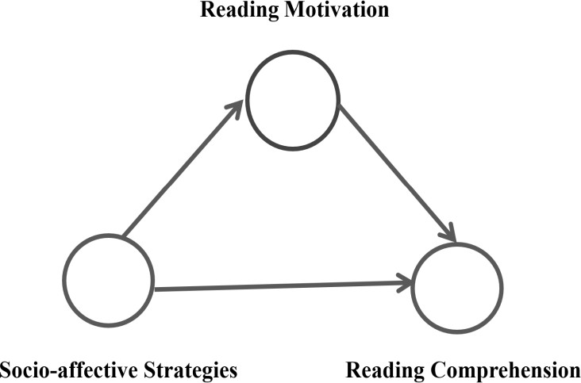

## Figure 1: The Conceptual Framework of the Study

Socio-affective strategies are the independent variable. Reading comprehension is the dependent variable, and students' reading test scores could measure their reading comprehension levels. Reading motivation is a mediating variable. The framework suggests that socio-affective strategies positively affect reading motivation, which in turn positively

affects reading comprehension levels. Additionally, socio-affective strategies may directly and

significantly affect students’ reading comprehension levels. The purpose of this study was to investigate the relationship between socio-affective strategies and reading comprehension among Chinese EFL undergraduates. At the same time, reading motivation was taken as a mediator in this framework.

# 2. RESEARCH METHODOLOGY

This section introduces the research design, sampling, sample and instruments. It also illustrates the process for collecting data and analyzing it.

## Research Design

Research design is the framework or blueprint for conducting a study. It outlines the methods and procedures for collecting, analyzing, and interpreting data to answer specific research questions or test hypotheses and the research designs can be broadly categorized into three main types: quantitative or qualitative research design and mixed-methods research design (Creswell & Creswell, 2017). A well-constructed research design ensures the validity, reliability, and ethical rigor of the study, serving as a roadmap that guides researchers through the research process (Andrade, 2018).

In this study, the quantitative research design was employed and it is a systematic approach used to investigate phenomena by collecting and analyzing numerical data. It is often associated with objective measurement, statistical analysis, and the use of standardized tools or instruments (Ahsanah & Utomo, 2020). A descriptive approach was used to investigate the participants' reported proficiency with socio-affective strategies, reading motivation, and reading comprehension by SPSS 25.0. The potential relationships among three variables were examined by software SmartPLS 3.4.

## Sampling and Sample

The sampling method refers to the process of selecting a subset of individuals from a larger population to estimate characteristics of the whole population and this method is crucial in research as it allows researchers to draw conclusions about a population without needing to study every individual (Liu et al., 2022). In this study, the simple random sampling was employed, which is one of the most fundamental sampling methods and ensures that every individual in the population has an equal chance of being selected, helping to eliminate bias and allows for the generalization of results to the entire population (Apawu, 2022). This method can be implemented using various techniques such as lottery methods, random number generators, or drawing names from a hat. By using the simple random sampling approach, 150 second-year EFL undergraduates as the sample of the present study was selected, who were non-English majors from a public university in Inner Mongolia, China. These participants were required to complete the questionnaires and a reading comprehension test in the study.

## Instruments

The Socio-affective Strategy Use Questionnaire (SSUQ) was adapted from Strategies Applied in Reading Proposed by Oxford (1990), from which only affective and social strategies were extracted to design SSUQ in the present study. The SSUQ contains 15 questions, and it is designed to look into how students in a reading class use socio-affective strategies to regulate their emotions and cooperate with others to improve their reading comprehension ability. The reading motivation questionnaire was derived from questionnaires revised by Naomi (2012), including intrinsic motivation (10 questions) and extrinsic motivation (10 questions). The reliability of the two study questionnaires was examined. Every variable has a Cronbach's alpha value of more than 0.7, suggesting good internal consistency and strong reliability in the study data. The reading comprehension test paper was derived from the CET-4 exam paper, and the total mark was 100. A reading test was conducted to assess the participants' overall reading

comprehension ability.

## Data Gathering Procedure

After being informed of the research purpose, 150 participants completed the two sets of questionnaires in a "Questionnaire Star" in the data gathering phase. After they finished answering the questionnaires, they were required to take the reading comprehension test in the classroom within the stipulated time. Due to some unusual values found in the other three questionnaires, 147 valid questionnaires were gathered.

## Data Analysis

The validity and reliability of the participants' motivation to read and their use of socio-affective strategies were assessed. The mean value and standard deviation of each variable were tested by descriptive statistics operated in the SPSS 25.0 version. To determine whether there were any significant relationships among the three variables in this study, socio-affective strategies, reading motivation, and reading comprehension performance, the structural model was tested by using Partial Least Squares Structural Equation Modeling, abbreviated as PLS-SEM, which was operated in the Smart PLS 3.4 software.

# RESULTS AND DISCUSSIONS

The findings of the study are presented in this section, followed by a discussion. The results of RQ1 are explained by descriptive statistics in SPSS 25.0. PLS-SEM was employed to examine the relationships among the socio-affective strategies, reading motivation, and reading comprehension, their mutual effects, and the mediating effects by the software of Smart PLS

3.4. The structural equation model was used to answer RQ2 to RQ5 one by one in this study.

## RQ1: What is the perceived level of Chinese EFL undergraduates’ socio-affective strategies’ usage, reading motivation, and reading comprehension?

* + 1. **The Levels of Socio-affective Strategies (SAS)**

Descriptive statistics were applied to examine non-English major students' socio-affective strategies level in college English reading activities. There were two sub-strategies for SAS, namely social strategies and affective strategies. Oxford (1990) delineates the range of frequency of strategy use with a 5-point Likert-type scale. As shown in Table 1, 4.51-5.0= always or almost always used; 3.51-4.5 =often used; 2.51-3.5 =sometimes used; 1.51-2.5

=seldom used; 1.0-1.5=never or almost never used.

## Table 1: Frequency Scale of Reading Strategy (Oxford:1990)

|  |  |  |
| --- | --- | --- |
| Mean Score | Frequency Scale | Evaluation |
| 4.51-5.0 | High | Always or almost always used |
| 3.51-4.5 |  | Often used |
| 2.51-3.5 | Medium | Sometimes used |
| 1.51-2.5 |  | Seldom used |
| 1.0-1.5 | Low | Never or rarely used |

Table 1 illustrates how a reporting scale may be used to inform teachers and students about the categories of strategies they most frequently employ in reading activities: (1) "High Usage" (3.51–5.0), (2) "Medium Usage" (2.51–3.5), and (3) "Low Usage" (1.0–2.5). Table 2 presents the overall SOARS levels of the students as well as the levels of each sub-strategies.

## Table 2: Students’ Perceptions of Socio-affective Reading Strategies

|  |  |  |  |  |  |
| --- | --- | --- | --- | --- | --- |
|  | N | Minimum | Maximum | Mean | Std. Deviation |
| SocioS | 147 | 2.20 | 4.40 | 3.4041 | .45479 |
| AffectS | 147 | 2.00 | 5.00 | 3.0986 | .71227 |
| SASs | 147 | 2.11 | 4.44 | 3.2683 | .50162 |
| Valid N (listwise) | 147 |  |  |  |  |

*Scale: 1=Strongly Disagree, 2=Disagree, 3=Uncertain 4=Agree, 5=Strongly Agree*

From Table 2, it can be seen that the average score for students' total use of socio-affective strategies was 3.2683, and SD was 0.50162. This indicated that the Chinese EFL undergraduates felt they possessed a medium usage of socio-affective reading strategies. Social strategies, a sub-strategy, showed a 3.4041 mean value (SD=0.45479), indicating a medium usage but higher than the overall level of socio-affective strategies usage, while affective strategies, a sub- strategy recorded a 3.0986 mean value (SD=0.71227), revealing a medium level in using strategies and lower than the overall level of socio-affective strategies usage.

## The Levels of Reading Motivation

The reading motivation in this study had two dimensions, with one being intrinsic motivation and the other being extrinsic motivation. The questionnaire on reading motivation was rated by a five-point Likert Scale and the evaluation criteria range (Table 3) adapted from Jamil and Cell (2016) could be employed in this study as a reference for the level of reading motivation of Chinese EFL undergraduates.

## Table 3: Grade Division of Mean Score

|  |  |
| --- | --- |
| Mean Value | Grade Division of Mean Score |
| 1.0-2.60  2.61-3.40  3.41-5.00 | Low  Moderate High |

The findings of students’ overall levels of reading motivation and levels of each sub-category are shown in Table 4. The mean value for the student's overall level of reading motivation was 3.2801, SD was 0.35330. This indicated that the Chinese EFL undergraduates obtained a medium level of reading motivation. Intrinsic motivation reported a 3.3088 mean value (SD=0.46639), indicating a medium level but higher than the overall level of reading

motivation, while extrinsic motivation, revealed a 3.2391 mean value (SD=0.32256), indicating a medium level, and lower than the overall level of reading motivation.

## Table 4: Students’ Perceptions of Reading Motivation

|  |  |  |  |  |  |
| --- | --- | --- | --- | --- | --- |
|  | N | Minimum | Maximum | Mean | Std.  Deviation |
| IM | 147 | 2.60 | 4.90 | 3.3088 | .46639 |
| EM | 147 | 2.71 | 4.86 | 3.2391 | .32256 |
| RM | 147 | 2.71 | 4.82 | 3.2801 | .35330 |
| Valid N (listwise) | 147 |  |  |  |  |

* + 1. **The Levels of Reading Comprehension**

The section is to investigate Chinese EFL undergraduates' reading comprehension levels in college English reading activities. In China, most educational institutions classify students' academic performance into three levels according to the score rating standards (Zeng, 2017). A score range from 0 to 59 is considered low level, and a score range from 60 to 79 falls into the medium category. A score ranging from 80 to 100 is labeled as high level. The descriptive statistics of reading comprehension scores were calculated using SPSS 25.0, with a mean and standard deviation, and the results are shown in Table 5.

## Table 5: Descriptive Statistics of Reading Comprehension Level

|  |  |  |  |  |  |
| --- | --- | --- | --- | --- | --- |
|  | N | Minimum | Maximum | Mean | Std. Deviation |
| Read Score | 147 | 40 | 99 | 72.96 | 11.52 |
| Valid N (listwise) | 147 |  |  |  |  |

The descriptive statistics for Chinese EFL undergraduates' reading comprehension levels are shown in Table 4.6. The mean score of all the students’ reading comprehension level was 72.96 and SD was 11.52, the 72.96 score was in the range of medium level from 60 to 79. Therefore,

the results showed that students maintained a medium level of reading comprehension (M=72.96, SD=11.52).

## RQ2: Do students’ socio-affective strategies have any meaningful connection with their reading comprehension level?

This question checked whether socio-affective strategies had a significant effect on reading comprehension levels among Chinese EFL undergraduates. Using the Smart PLS 3.4 software, a structural equation model was constructed to investigate the relationships between socio- affective strategies and reading comprehension levels. Based on Shmueli et al. (2016), assessments of path coefficient size and significance were shown in Table 6.

## Table 6: Guidelines of Structural Model Assessment

|  |  |
| --- | --- |
| Path Coefficients Size | 0.32 > β ≥ 0.19 small |
|  | 0.67 > β ≥ 0.32 medium |
|  | β ≥ 0.67 large |
| Path Coefficient Significance | T > 1.96 significant |
|  | P < 0.05 significant |

Figure 2 displays the results of the PLS-SEM algorithm in the structural equation model, in which the path coefficient size and path coefficient significance were shown.

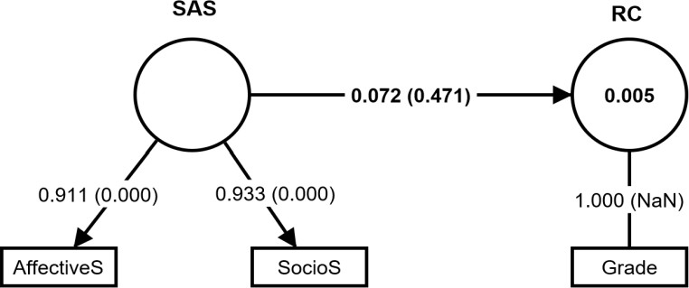

## Figure 2: Path Coefficient of the Structural Model between SAS and RC

Figure 2 showed that the path coefficient between socio-affective reading strategies and reading comprehension was 0.072 (β＜0.19), which was less than 0.19, indicating a very low path coefficient size. Moreover, the bootstrapping was performed to confirm further whether the

small path coefficient size of the relationship between SASs and RC is significant. A p-value of less than 0.05 or 0.001 indicates that the result is significant. The socio-affective strategies' effect on reading comprehension, however, was not significant because the p-value was 0.471, which was more than 0.05. In other words, the students' socio-affective strategies and reading comprehension levels were not significantly and positively related.

## RQ3: Do students’ socio-affective strategies have any significant relationship with their reading motivation?

The purpose of this research question was to determine whether reading motivation and socio- affective strategies are correlated. First, it was looked at how students' socio-affective strategies affected their reading motivation. By employing the Smart PLS software, a structural equation model was created. Figure 3 presents the path analysis findings after the PLS-SEM algorithm was completed.

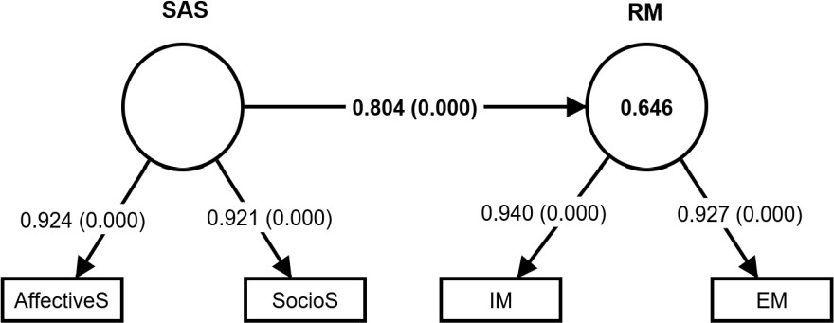

## Figure 3: Path Coefficient of the Structural Model between SAS and RM

Figure 3 revealed that the path coefficient between socio-affective strategies and reading motivation was 0.804 (β＞0.67), which was more than 0.67, indicating that socio-affective

strategies and reading motivation had a large path coefficient size. A higher level of socio- affective strategies usage led to greater reading motivation among Chinese EFL undergraduates. Furthermore, the bootstrapping was performed to confirm further whether the larger path coefficient size of the relationship between RM and RASs is significant. Additionally, Figure

4.2 showed that the p-value was 0.000, less than 0.001, and indicated a very significant impact of socio-affective strategies on students' motivation to read, revealing that the more skillful the participants employ socio-affective strategies, the more motivated they are to read.

Next, it was determined whether students' reading motivation directly affected their use of socio-affective strategies. Smart PLS software was used to create a structural equation model. Figure 4 presents the path analysis results after the PLS-SEM algorithm was finished.

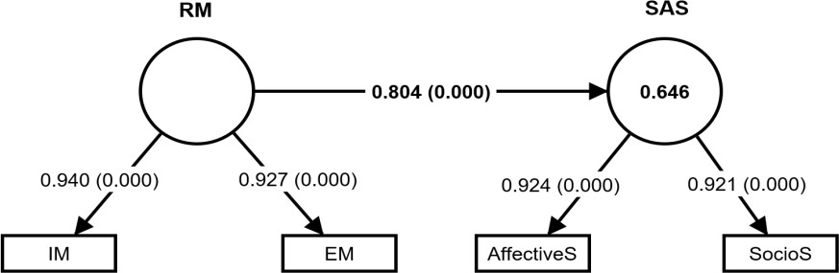

## Figure 4: Path Coefficient of the Structural Model between RM and SAS

In Figure 4, the path coefficient between reading motivation and socio-affective strategies was found to be 0.804 (β＞0.67), with a p-value of 0.000, less than 0.001. This indicates that reading motivation had a largely significant impact on socio-affective reading strategies and that

students with higher motivation employ socio-affective strategies more frequently during their reading process. In conclusion, the results indicate that reading motivation and socio-affective strategies have a significant and positive correlation and are mutually connected.

## RQ4: Is students’ reading motivation significantly related to their reading comprehension level?

The fourth research question focused on the relationship between EFL undergraduates' reading motivation and reading comprehension level. To analyze this relationship, a structural equation model was established in Smart PLS. Figure 5 shows the path analysis findings after a PLS- SEM algorithm was calculated.

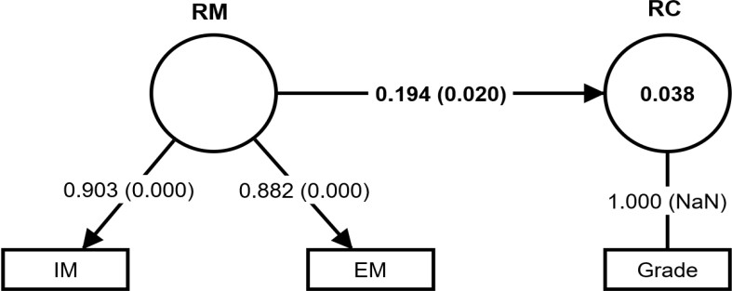

## Figure 5: Path Coefficient of the Structural Model between RM and RC

Figure 5 shows that the path coefficient was 0.194 in the relationship of reading motivation with reading comprehension, which was greater than 0.19, indicating a small path coefficient size between the two variables. This suggests that an increasing level of motivation in reading activities among Chinese EFL undergraduates led to better reading comprehension performance. Furthermore, bootstrapping was performed to confirm further whether the small path coefficient size of the relationship between RM and RC is significant. As can be observed from Figure 4.4, there was a significant relationship between reading motivation and reading comprehension level, with the p-value being 0.020, less than 0.05. In other words, reading motivation directly and significantly affected students' reading comprehension ability.

In addition, reading motivation includes two dimensions: intrinsic motivation and extrinsic

motivation. To determine which one is more predictive of reading comprehension performance, the structural equation models were set up to analyze them in detail. Figures 6 and 7 display

the path analysis findings after a PLS-SEM algorithm was operated with the help of Smart PLS

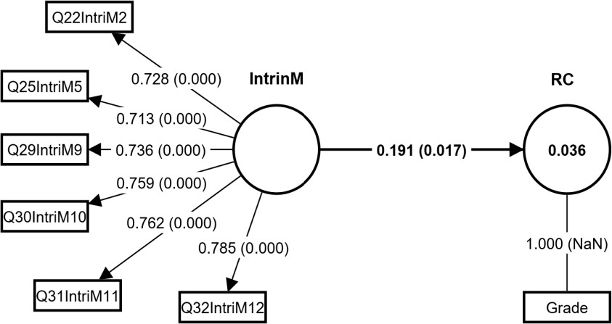

## Figure 6: Path Coefficient of the Structural Model between IM and RC

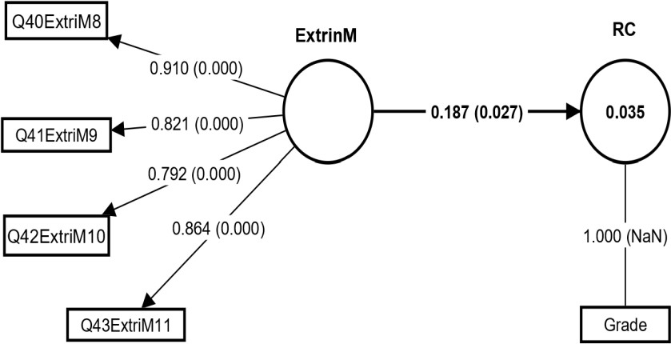

**Figure 7: Path Coefficient of the Structural Model between EM and RC**

The path coefficient from intrinsic reading motivation to reading comprehension was found to be 0.191, and the one from extrinsic reading motivation to reading comprehension was found to be 0.187, as seen in Figures 6 and 7. After conducting the bootstrapping, reading comprehension was significantly impacted by intrinsic and extrinsic motivation respectively.

The p-value between IM and RC was 0.017, and the p-value between EM and RC was 0.027. Extrinsic incentive was found to be the second most significant predictor of reading comprehension, behind intrinsic motivation among Chinese EFL undergraduates.

## RQ5: Is reading motivation a mediator between socio-affective strategies and reading comprehension level among Chinese EFL undergraduates?

The mediation model was established to check whether reading motivation was a mediator between the independent variable (SAS) and dependent variable (RC) by using Smart PLS 3.4. Furthermore, bootstrapping was performed to confirm whether reading motivation was a full or partial mediator in the association from SAS to RC, as shown in Figure 8.

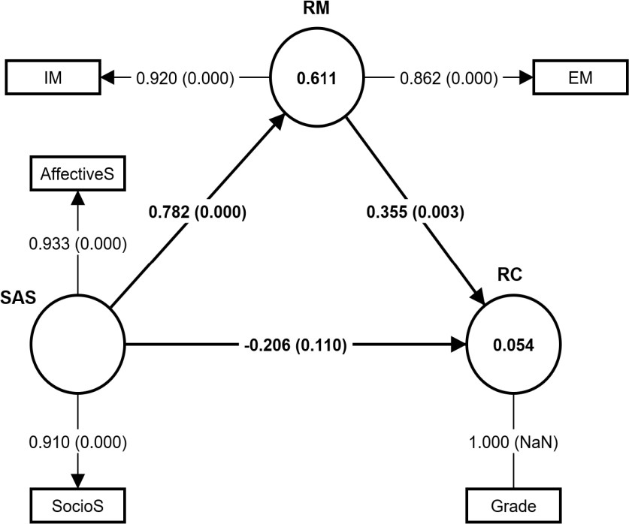

## Figure 8: The Proposed Mediation Structural Model

Figure 8 revealed that reading motivation was significantly impacted by socio-affective strategies among Chinese EFL undergraduates because the path coefficient size was 0.782 and the p-value was 0.000, less than 0.001 (ß=0.782, P=0.000 ＜ 0.001). In addition, reading

motivation significantly affected reading comprehension, since the path coefficient size was

0.355 and the p-value was 0.003, less than 0.05 (ß=0.355, P=0.003＜0.05). However, socio- affective strategies did not significantly, positively, or directly affect students’ reading comprehension level, since the path coefficient size was -0.206 and the p-value was 0.110, more than 0.05 (ß= -0.206, P=0.110＞0.05), as shown in Figure 8. Therefore, it was further confirmed that reading motivation fully mediated the relationship between socio-affective strategies and reading comprehension.

## Discussion

The results of the descriptive analysis for Research Question 1 revealed that Chinese EFL undergraduates achieved an average level of reading comprehension and were moderate users of socio-affective strategies. Additionally, they employed social strategies more frequently than affective strategies. The findings suggest that students were more focused on cooperating with one another during reading activities than on managing their emotional responses while reading. This finding aligns with previous studies, which showed that students were willing to communicate with their classmates and had a spirit of cooperation in reading tasks. Students prefer social strategies for communication to solve reading problems (Mandasari & Oktaviani, 2018; Hakim & Suniar, 2019; Fatemipour & Nasrin, 2021). Other studies found that EFL learners use socio-affective reading strategies at a medium level and engage more actively in reading when expressing their feelings and talking with others. (Zeynali, 2016; Indriana, 2019; Jairo Faustino, 2022).

The results of descriptive analysis of RQ1 revealed that students were moderately motivated to read and the mean value of intrinsic motivation was higher than extrinsic motivation, which was consistent with the answers of RQ4. The RQ4 found that intrinsic and extrinsic motivation were significantly related to reading comprehension, with the students being more intrinsically motivated to read than extrinsically. The findings of RQ1 could give theoretical support to the self-determination theory, which suggests that intrinsic and extrinsic motivation are not

mutually exclusive (Ryan & Deci, 2016). The results of RQ1 also corroborated other research showing that EFL learners read with extrinsic or intrinsic motivation, but intrinsic reasons were more dominant among Chinese EFL learners (Li & Gan, 2022; Wang et al., 2020; Wang, 2019; Wang & Jin, 2021).

The results for RQ2 indicated that socio-affective strategies do not significantly impact reading comprehension. This finding aligns with studies by Hoang (2016), Meniado (2016), and Molla (2015), which also found that students’ reading strategies were not significantly related to their reading comprehension level. However, this finding contradicted other studies' findings, which showed a strong correlation between the general application of reading strategies and reading comprehension level (Rastegar et al., 2017; Par, 2020; Do & Phan, 2021).

Additionally, the finding in RQ2 differs from previous studies that verified the effect and effectiveness of socio-affective strategies on the reading proficiency of EFL students. (Zeynali, 2016; Indriana, 2019; Erni, 2021; Fatemipour et al., 2021). These discrepancies could be due to the differences in the individual’s characters in terms of education, social status, culture, and preferences. Furthermore, many other factors also play essential roles in shaping students' reading progress and outcomes, such as vocabulary storage, reading anxiety and motivation, and content schemata.

The findings of RQ3 revealed that students’ socio-affective reading strategies were mutually and positively correlated with reading motivation. On the one hand, socio-affective strategies were found to positively affect the reading motivation of Chinese EFL undergraduates. It indicated that students who employed socio-affective methods more often exhibited higher reading motivation. On the other hand, reading motivation was found to be a positive predictor of the usage of socio-affective reading strategies, suggesting that students with high motivation levels utilize a more significant number of socio-affective strategies when reading. These findings converged with previous research, which reported that socio-affective strategies positively correlated with EFL learners' extrinsic and intrinsic motivation. (Han, 2021;

Mohammed, 2022; Altumigah & Alkhaleefah, 2022; Alsuhaibani, 2019; Wang et al., 2020). The finding also aligns with previous research showing that a combination of intrinsic and extrinsic reading motivation is positively linked to reading strategy use. This suggests that motivation prompts readers to utilize all available resources, including socio-affective strategies, to enhance their reading comprehension levels (Dison & Shah, 2020; Talwar et al., 2023; Kassem & Alqahtani, 2023).

The findings for Research Question 4 indicated that reading motivation had a direct and positive effect on reading comprehension levels, which was statistically significant. This aligns with previous studies conducted by various researchers. According to them, the most important internal factor influencing reading performance was reading motivation, within which intrinsic motivation was more strongly related to reading accomplishments than extrinsic motivation (Bergey et al., 2017; Purnama et al., 2019; Haerazi et al., 2019; Jibriil & Sueb, 2022; Wigfield et al., 2016).

Finally, the findings for RQ5 echo the findings of RQ2 and revealed that social-affective strategies could not directly predict reading comprehension levels because students in this study did not frequently use socio-affective strategies in reading activities. Their reading motivations were also not very high. However, the findings of RQ5 confirmed that social-affective strategies can indirectly affect reading comprehension through reading motivation as a mediating variable. In other words, reading motivation fully mediated the relationship between social-affective strategies and reading comprehension. Socio-affective strategies alone were not enough to affect complex reading comprehension. Socio-affective strategies should be combined with reading motivation to predict the reading comprehension performance of Chinese EFL undergraduates. Previous studies align with it and have shown that reading motivation mediated the association between reading skills and reading performance, and extrinsic motivation also played a role in motivating students to engage in reading activities or tasks actively. The higher their reading motivation is, the better students perform in both reading strategies and comprehension. Additionally, research on non-English major undergraduates during the

COVID-19 pandemic found that reading strategies and motivation significantly affect reading comprehension ability. (Kanonire, 2022; Maghsoudi, 2021; Kusmartini, 2022).

# CONCLUSION AND IMPLICATIONS

The study examines the relationships among socio-affective strategies, reading motivation, and reading comprehension of Chinese EFL undergraduates. Results showed that participants sometimes use socio-affective strategies at a medium level, with social strategies used more frequently than affective strategies. The reading motivation level was moderate, with intrinsic motivation as the main factor and extrinsic motivation second. Socio-affective strategies had a significant effect on reading motivation, which in turn had a significant effect on reading comprehension levels. Reading motivation played the role of a full mediator of the relationship between socio-affective strategies and reading comprehension levels among Chinese EFL undergraduates.

The study's findings indicated that Chinese EFL undergraduates did not invest significant effort and time in reading activities, as evidenced by their medium levels of strategy use, reading motivation, and reading comprehension. How teachers can help students read more proficiently is a significant issue. This study suggests that universities should offer English reading programs to enhance EFL undergraduates’ motivation and active participation. College English instructors should explicitly incorporate training in socio-affective strategies into the syllabus to help students improve their reading motivation. For instance, teachers can allocate time in the classroom for students to collaborate on reading tasks, encouraging them to ask questions with guidance from teachers or more proficient peers. Additionally, teachers can design group reading activities, both within and outside of reading classes, to help students practice social strategies, foster a sense of teamwork, and learn to cooperate actively, thereby increasing their interest and proficiency in reading. Instructors should also support anxious students with low reading levels by teaching them affective strategies to manage their emotions and reduce reading stress. Encouraging these students through their reading progress and providing

rewards can further enhance their motivation. Affective strategies enable EFL students to express their feelings and communicate effectively with their classmates, ultimately leading to improved performance in reading activities.

Instructors should train students to be strategic readers, knowing when and how to use socio- affective reading strategies effectively. However, mastering and applying socio-affective strategies is a gradual process that requires repeated practice. Instructors should formulate long- term teaching plans and develop students' awareness of socio-affective strategies in the teaching process, cultivating students' habits of selecting, evaluating, and reflecting on these strategies. Instructors are responsible for helping students to become independent and self-regulated learners so that students can use various reading strategies to solve difficulties and doubts by themselves in the reading process and ultimately improve their English reading level.

Furthermore, to guarantee variety and generalization of the research results, the area of subsequent research may be further broadened. It is suggested that further research could explore more affective factors affecting students' reading proficiency, such as reading self- efficacy, reading attitude, reading habits, reading anxiety, and reading stress, with different sources of students. This study only used quantitative research methods, which is relatively simple. In future research, it is recommended to use mixed methodology, combined with qualitative research means, such as interviews and observations, to ensure the comprehensiveness of the study.

## References:

Abdillah, J. A., & Sueb, S. (2022). Students’ learning motivation toward the implementation of blended learning during post-pandemic EFL classroom. *Pioneer: Journal of Language and Literature, 14*(1), 278-297.

Abdillah, J. A., & Sueb, S. (2022). Students’ learning motivation toward the implementation of blended learning during post-pandemic EFL classroom. *Pioneer: Journal of Language and Literature, 14*(1), 278-297.

Ahsanah, F., & Utomo, D. T. P. (2020). The Use of Digital Comic in Developing Student's English Competence. *IDEAS: Journal on English Language Teaching and Learning, Linguistics and Literature, 8*(2), 373-383. <https://doi.org/10.24256/ideas.v8i2.1660>

Aktamov, I. G. & Daiqin. (2023). Higher education system of Inner Mongolia Autonomous Region (people’s republic of China) in 1950s-1960s. *Nauchnyi Dialog, 12*(6), 308-324. <https://doi.org/10.24224/2227-1295-2023-12-6-308-324>

Alizadeh, M. (2016). The impact of motivation on English language learning. *International Journal of Research in English Education, 1*(1), 11–15. [http://ijreeonline.com/article-1-23-](http://ijreeonline.com/article-1-23-en.html) [en.html.](http://ijreeonline.com/article-1-23-en.html)

Alsamadani, H. A. (2022). Developing EFL students' vocabulary and reading comprehension skills within an interactive learning environment. *International Journal of Computer Science & Network Security, 22*(8), 145-152.

Alsuhaibani, Z. (2019). The relationship between female EFL students' use of reading strategies and their reading self-efficacy. *International Journal of Arabic-English Studies (IJAES), 19*(2).

Altumigah, E. S., & Alkhaleefah, T. A. (2022). The relationship between reading self-efficacy and perceived use of reading strategies among Saudi EFL students. *International Journal of Linguistics, 14*(6), 48-76.

Amani Syed Abdul Rahman, S., Rohayu Mohd Yunos, D., Hanim Rahmat, N., Rohani Megat Abdul Rahim, P., & Andria Shirin Anuarudin, A. (2021). Coping with reading difficulty

using socio-affective strategy. *International Journal of Asian Social Science, 11*(2), 129–

136. <https://doi.org/10.18488/journal.1.2021.112.129.136>

Andrade, C. (2018). Internal, external, and ecological validity in research design, conduct, and evaluation. *Indian Journal of Psychological Medicine, 40*(5), 498-499. <https://doi.org/10.4103/ijpsym.ijpsym_334_18>

Apawu, J. (2022). Contemporary preservice mathematics teachers’ technological pedagogical content knowledge levels in perspective: self-reported survey. *Asian Research Journal of Mathematics, 18*(11), 130-147. <https://doi.org/10.9734/arjom/2022/v18i1130431>

Bergey, B. W., Deacon, S. H., & Parrila, R. K. (2017). Metacognitive reading and study strategies and academic achievement of university students with and without a history of reading difficulties. *Journal of Learning Disabilities, 50*(1), 81–94. <https://doi.org/10.1177/0022219415597020>

Bermillo, J. E., & Merto, V. L. T. (2022). Collaborative strategic reading on students’ comprehension and motivation. *European Journal of English Language Teaching, 7*(1). https://doi.org/10.46827/ejel.v7i1.4148

Brevik, L. M. (2019). Explicit reading strategy instruction or daily use of strategies? Studying the teaching of reading comprehension through naturalistic classroom observation in English L2. *Reading and Writing, 32*(9), 2281-2310. [https://doi.org/10.1007/s11145-019-](https://doi.org/10.1007/s11145-019-09951) [09951](https://doi.org/10.1007/s11145-019-09951)

Creswell, J. W., & Creswell, J. D. (2017). Research design: Qualitative, quantitative, and mixed methods approaches. *Sage publications.*

Damaianti, V. S. (2021). Dramatization strategy and junior high school students’ reading motivation. *RETORIKA: Jurnal Bahasa, Sastra, Dan Pengajarannya, 14*(1), 49. https://doi.org/10.26858/retorika.v14i1.18877

Dania, R. & Adha, A. D. (2021). Students’ strategies in reading online authentic materials. *Advances in Social Science, Education and Humanities Research.* <https://doi.org/10.2991/assehr.k.210914.028>

Deci, E. L., & Ryan, R. M. (2016). Optimizing students’ motivation in the era of testing and pressure: A self-determination theory perspective. In Building autonomous learners: Perspectives from research and practice using self-determination theory (pp. 9-29). *Springer Singapore.*

Deci, E. L., & Ryan, R. M. (2020). Intrinsic motivation and self-determination in human behavior. *New York: Plenum.*

Dison, M., & Shah, P. (2020). Reading strategies and reading motivation among secondary level of students in Sarawak. *International Journal of New Technology and Research, 6*(11), 7- 14.

Do, H., & Le Thu Phan, H. (2021). Metacognitive Awareness of Reading Strategies on Second Language Vietnamese Undergraduates. *Arab World English Journal, 12*(1), 90–112. <https://doi.org/10.24093/awej/vol12no1.7>

Dong, Y., Peng, S., Sun, Y., Wu, S. X., & Wang, W. (2020). Reading comprehension and metalinguistic knowledge in Chinese readers: a meta-analysis. *Frontiers in Psychology,*

*10.* <https://doi.org/10.3389/fpsyg.2019.03037>

Erni, E. (2021). Online reading strategy in academic reading by foreign language learners during COVID-19 outbreak. *AL-ISHLAH: Jurnal Pendidikan, 13*(1), 374-386.

Fadila, L., Dalimunthe, S. A., & Siagian, N. (2024). Strategies to Improve English Reading Comprehension. *Fonologi: Jurnal Ilmuan Bahasa dan Sastra Inggris, 2*(3), 16-25. https://doi.org/10.61132/fonologi.v2i3.774

Fan, T., & Zeng, Y. (2016). A review of cognitive diagnostic tests and their application to English reading ability. *China Foreign Language 16*(2), 82-89.

Fatemipour, H., & Nasrin, A. (2021). The relationship among socio-affective language learning strategies, EFL intermediate learners’ language anxiety, and their listening skill. *All Multidisciplinary Journal.*

Fauzi, I., Saman, T. N., Zannah, N., & Winey, B. G. (2022). The relationship between students’ reading motivation and the success to comprehend the English texts. *Journal of English Teaching and Learning Issues, 5*(1), 31. <https://doi.org/10.21043/jetli.v5i1.14959>

Gilakjani, A. P., & Sabouri, N. B. (2016). How can students improve their reading comprehension skills? *Journal of Studies in Education, 6*(2), 229. <https://doi.org/10.5296/jse.v6i2.9201>

Guenin-Carlut, A., White, B., & Sganzerla, L. (2023). The Cognitive Archaeology of Sociocultural Lifeforms. In *Artificial Life Conference Proceedings, 35*(1), 142. MIT Press. <https://doi.org/10.1162/isal_a_00670>

Hakim, L., & Suniar, Y. (2019). Socio-affective strategies in enhancing students' speaking motivation. *Jurnal Basis, 6*(1), 125-133.

<http://ejournal.upbatam.ac.id/index.php/basis/article/view/428>

Han, F. (2021). The relations between motivation, strategy use, frequency, and proficiency in foreign language reading: An investigation with university English language learners in China. *Sage Open, 11*(2), 21582440211008423.

Haerazi, H., Prayati, Z., & Vikasari, R. M. (2019). Practicing contextual teaching and learning (CTL) approach to improve students’ reading comprehension in relation to motivation. *English Review: Journal of English Education, 8*(1), 139-146.

Hoang, N. M. (2016). The relationship between reading strategy use and reading proficiency of Vietnamese students in the UK. *British Council ELT Master’s Dissertation Awards: Commendation.*

Hsu, T. C. (2018). Using a concept mapping strategy to improve the motivation of EFL students in Google Hangouts peer-tutoring sessions with native speakers. *Interactive Learning Environments, 27*(2), 272–285. <https://doi.org/10.1080/10494820.2018.1463268>

Indrayadi, T. (2021). Indonesian EFL learners’ reading motivation. *IJELTAL (Indonesian Journal of English Language Teaching and Applied Linguistics, 5*(2), 335. <https://doi.org/10.21093/ijeltal.v5i2.745>

Indriana, N. R., & Fauziati, E. (2019). Socio-affective strategies used by the students to improve their English speaking skill: A case study in second semester at Muhammadiyah University of Surakarta. *Eprints.ums.ac.id.* <http://eprints.ums.ac.id/id/eprint/76542>

Islamy, G. N., Setiyadi, A. B., & Suka, R. G. (2018). The correlation of students’ critical reading strategies and their reading comprehension achievement at the second grade of SMKN 1 Kotabumi. *U-JET: Unila Journal of English Language Teaching, 7*(5). <https://doi.org/10.23960/ujet.v7i5.201806>

Jamil, M. Y., & Cell, D. Q. E. (2016). Implementation of Six Sigma methodology (DMAIC) for the enhancement of learning & motivation levels of students. *The Online Journal of Quality in Higher Education, 8.*

Jairo Faustino, N. R. (2022). Socio-affective strategies for development of reading skills in English language learning. *Repositorio.upse.edu.ec.* <https://repositorio.upse.edu.ec/handle/46000/8908>

Jibriil Ahmad Abdillah, & Sueb Sueb. (2022). Students’ learning motivation toward the implementation of blended learning during Post-Pandemic EFL classroom. *Pioneer:*

*Journal Of Language And Literature, 14*(1).

Kanonire, T., Lubenko, J., & Kuzmina, Y. (2022). The effects of intrinsic and extrinsic reading motivation on reading performance in elementary school. *Journal of Research in Childhood Education, 36*(1), 1–13. <https://doi.org/10.1080/02568543.2020.1822961>

Kassem, H. M., & Alqahtani, D. A. (2023). Motivation, strategy use, and comprehension in foreign language reading: The case of Saudi EFL learners at the preparatory year. *Journal of Language Teaching and Research, 14*(5), 1290–1301. <https://doi.org/10.17507/jltr.1405.17>

Kheang, T., Chin, P., & Em, S. (2024). Reading motivation to promote students’ reading comprehension: A review study. *International journal of languages and culture, 4*(1):1-

8. doi: 10.51483/ijlc.4.1.2024.1-8

Kung, L. Y., & Aziz, A. A. (2020). An action research on metacognitive reading strategies instruction to improve reading comprehension. *International Journal of English Language and Literature Studies, 9*(2), 86-94.

<https://doi.org/10.18488/journal.23.2020.92.86.94>

Kusmartini, S. E. (2022). Reading motivation and its impact on reading proficiency of engineering students in pandemic COVID-19. *International Journal of Research and Innovation in Social Science, 06*(03), 714–721.

Latifa, N., & Manan, A. (2018). Teaching narrative text by using preview, question, read, state, and test (PQRST) technique. *English Education Journal, 9*(2), 243–260. <https://jurnal.usk.ac.id/EEJ/article/view/11547>

Liu, X., Yan, M., Deng, L., Li, G., Ye, X., & Fan, D. (2022). Sampling methods for efficient training of graph convolutional networks: A survey. *IEEE/CAA Journal of Automatica Sinica, 9*(2), 205-234. <https://doi.org/10.1109/jas.2021.1004311>

Low, H. M., Mohamed, A. R., & Ismail, S. A. M. M. (2020). English reading proficiency of engineering undergraduates in Malaysia: implications on professional training and career development. *Social Education Research, 87-95.*

<https://doi.org/10.37256/ser.122020269>

Li, H., & Gan, Z. (2022). Reading motivation, self-regulated reading strategies and English vocabulary knowledge: Which most predicted students’ English reading comprehension? *Frontiers in Psychology, 13*, 1041870.

Li, Q., & Wang, L. (2021). Assessing the reading skills of Chinese college students. *Journal of Educational Research in China, 22*(4), 55-65.

Lietaert, S., Roorda, D., Laevers, F., Verschueren, K., & De Fraine, B. (2015). The gender gap in student engagement: The role of teachers’ autonomy support, structure, and involvement. *British Journal of Educational Psychology, 85*(4), 498–518. <https://doi.org/10.1111/bjep.12095>

Logan, M. (2023). Interest, attitudes, motivation, and engagement. In young people’s voice in school science: Research from five years in the classroom (pp. 9-37). *Cham: Springer Nature Switzerland.*

Maghsoudi, M., Talebi, S. H., & Khodamoradi, A. (2021). The effect of Iranian EFL learners’ reading motivation on their reading comprehension ability regarding their university fields of study. *Journal of College Reading and Learning, 51*(3), 203-224.

Mandasari, B., & Oktaviani, L. (2018). English language learning strategies: an exploratory study of management and engineering students. *Premise: Journal of English Education and Applied Linguistics, 7*(2), 61-78. <http://dx.doi.org/10.24127/pj.v7i2.1581>

Marlinton, M., Syahri, I., & Mayasari, S. (2023). The efficacy of task-based learning and learning motivation on student’s reading comprehension: a holistic study. *Elsya: Journal of English Language Studies, 5*(2), 250-269. <https://doi.org/10.31849/elsya.v5i2.14082>

McBreen, M., & Savage, R. (2021). The impact of motivational reading instruction on the reading achievement and motivation of students: A systematic review and meta-analysis. *Educational psychology review, 33*(3), 1125-1163. [https://doi.org/10.1007/s10648-020-](https://doi.org/10.1007/s10648-020-09584-4)

[09584-4](https://doi.org/10.1007/s10648-020-09584-4)

Meniado, J. C. (2016). Metacognitive reading strategies, motivation, and reading comprehension performance of Saudi EFL students. *English Language Teaching, 9*(3), 117-129.

Mohammed, G. M. S. (2022). The impact of reading strategies and self-efficacy on reading comprehension: The case of Saudi EFL Learners. *Journal of Language and Linguistic Studies, 18*, 627-639.

Molla, B. (2015). The relationship between reading strategy use and reading comprehension among Ethiopian EFL learners. *International Journal on Studies in English Language and Literature (IJSELL), 3*(9), 34-41.

Namazi, M., Kiany, G. R., Birjandi, P., & Mozaffari, A. (2022). Motivation and reading comprehension: A case of EFL learners in Iranian context. *Cogent Education, 9*(1), 2087462.

Oxford, R. L. (2017). Language learning strategies: Teaching and researching (2nd ed.). *New*

*York: Routledge.*

Par, L. (2020). The relationship between reading strategies and reading achievement of the EFL students. *International Journal of Instruction, 13*(2), 223-238.

Purnama, N. A., Rahayu, N. S., & Yugafiati, R. (2019). Students’ motivation in learning English.

*PROJECT (Professional Journal of English Education), 2*(4), 539.

Rahman, S. A. S. A., Yunos, D. R. M., Rahmat, N. H., Rahim, P. R. M. A., & Anuarudin, A.

A. S. (2021). Coping with reading difficulty using socio-affective strategy. *International Journal of Asian Social Science, 11*(2), 129-136.

Rastegar, M., Kermani, E. M., & Khabir, M. (2017). The relationship between metacognitive reading strategies use and reading comprehension achievement of EFL learners. *Open Journal of Modern Linguistics, 7*(2), 65-74.

Rionaldi, R., & Saputra, B. (2023). Developing an English proficiency test for higher education.

*INTERACTION: Jurnal Pendidikan Bahasa, 10*(2), 817-824. <https://doi.org/10.36232/jurnalpendidikanbahasa.v10i2.4812>

Shmueli, G., Ray, S., Velasquez Estrada, J. M., & Chatla, S. B. (2016). The elephant in the room: Evaluating the predictive performance of PLS models. *Journal of Business Research, 69*(10), 4552-4564.

Sua, M. R. (2021). Cognitive strategies for developing students' reading comprehension skills using short stories. *Revista de Estudios y Experiencias En Educación, 20*(44), 233–253. [https://doi.org/10.21703/0718 5162.v20.n43.2021.014](https://doi.org/10.21703/0718%205162.v20.n43.2021.014)

Talenta, P. I., & Himawati, U. (2023). Reading together, learning together: The impact of literature circles on student engagement in reading. *Jurnal CULTURE (Culture, Language, and Literature Review, 10*(2), 47-56. <https://doi.org/10.53873/culture.v10i2.538>

Talwar, A., Magliano, J. P., Higgs, K., Santuzzi, A., Tonks, S., O’Reilly, T., & Sabatini, J. (2023). Early academic success in college: Examining the contributions of reading literacy skills, metacognitive reading strategies, and reading motivation. *Journal of College Reading and Learning, 53*(1), 58–87. <https://doi.org/10.1080/10790195.2022.2137069>

Toste, J. R., Didion, L., Peng, P., Filderman, M. J., & McClelland, A. M. (2020). A meta- analytic review of the relations between motivation and reading achievement for K–12 students. *Review of Educational Research, 90*(3), 420-456.

<https://doi.org/10.3102/0034654320919352>

Wang, D. (2019). Reading motivation among Chinese college students. *Foreign Language Teaching and Research, 21*(2), 22-36.

Wang, X., Jia, L., & Jin, Y. (2020). Reading amount and reading strategy as mediators of the effects of intrinsic and extrinsic reading motivation on reading achievement. *Frontiers in Psychology, 11*.

Wang, X., & Jin, Y. (2021). A validation of the Chinese motivation for reading questionnaire.

*Journal of Literacy Research, 53*(3), 336-360.

Wigfield, A., Gladstone, J. R., & Turci, L. (2016). Beyond cognition: Reading motivation and reading comprehension. *Child Development Perspectives, 10*(3), 190–195. <https://doi.org/10.1111/cdep.12184>

Wu, X. (2023). A survey of the current reading situation of college students for nationalities and its countermeasures—take Inner Mongolia Minzu University as an example. *Journal of Sociology and Ethnology, 5*(5). <https://doi.org/10.23977/jsoce.2023.050503>

Yu, J. (2020). English reading strategy research: Review and outlook. *Helongjiang Education, 1314*(04), 85-88.

Zaccone, M. C., & Pedrini, M. (2019). The effects of intrinsic and extrinsic motivation on students learning effectiveness. Exploring the moderating role of gender. *International Journal of Educational Management*, *33*(6), 1381-1394. https://doi.org/10.1108/IJEM- 03-2019-0099

Zeng, Y. (2017). Principles and methods of developing the "reading scale" of the Chinese English proficiency scale. *Foreign Language, 10*(5), 2-11.

Zeynali, S. (2016). The effects of socio-affective strategy in the enhancement of reading comprehension among Iranian EFL learners. *International Journal of Language and Linguistics, 4*(2), 9. https://doi.org/10.11648/j.ijll.s.2016040201.12.

Zhang, Z., Yang, Y., & Mao, Z. (2024). The effect of self-identity and positive emotion intervention on college students' English reading study on the correlation between test scores. *International Journal of English Language Studies, 6*(2), 29-37. <https://doi.org/10.32996/ijels.2024.6.2.5>